Morning Service
from
Holy Trinity Church, Jersey

Second Sunday of Advent
5th December 2021

Welcome and Preparation

The Lord of Glory be with you.
All The Lord bless you.

Heaviness may endure for a night:
All But joy comes in the morning.

God has been our refuge and our strength:
All A present help in time of trouble.

The night has passed, and the day lies open before us; let us pray with one heart and mind.

Silence is kept.

As we rejoice in the gift of this new day, so may the light of your presence, O God, set our hearts on fire with love for you.; now and for ever.
All Amen.

Hymn
Advent candles tell their story
as we watch and pray,
longing for the Day of Glory,
‘Come, Lord, soon,’ we say,
pain and sorrow, tears and sadness,
changed for gladness on that Day.

Prophet voices loudly crying,
making pathways clear;
glimpsing glory, self-denying,
calling all to hear.
Through their message – challenged, shaken -
hearts awaken: God is near!

John, the Baptist, by his preaching
and the water poured,
brought to those who heard his teaching
news of hope restored:
‘Keep your vision strong and steady,
and be ready for the Lord’.

Mary’s gift beyond all telling
we recall today:
Son of God within her dwelling,
born to show the way.
Who could guess the final story?
- cross and glory; Easter Day.

Advent candles tell their story
on this Advent Day.
Those who waited for God’s glory:
they prepared the way.
Christ is with us: loving, giving,
in us living, here today!

A Time of Confession

The sacrifice of God is a broken spirit, a broken and contrite heart God will not despise. Let us come to the Lord, who is full of compassion, and acknowledge our transgressions in penitence and faith.

We confess to you our selfishness and lack of love:
Lord, have mercy.
All Lord, have mercy.

We confess to you our fear and failure in sharing our faith:
Christ, have mercy.
All Christ, have mercy.

We confess to you our stubbornness and lack of trust:
Lord, have mercy.
All Lord, have mercy.
Almighty God, who forgives all who truly repent, have mercy upon you, pardon and deliver you from all your sins, confirm and strengthen you in all goodness, and keep you in life eternal; through Jesus Christ our Lord.
All Amen.

Thankfulness

Generous God, you gave us our voices, no two the same, no finer instruments with which to praise you.
All For these we thank you, Lord.

You gave us words and music, particular gifts with which we can wonder, or wound, bless or bore.
All For these we thank you, Lord.

And as your Church you have gathered us. In your community of common folk and complainers, prophets and puzzled people, you have made a place for us.
All For this we thank you, Lord.

So, let what we say and do, what we ponder and decide, be real for us and honest to you, and prepare us for the life of the world, in which you are also praised.
All Amen.

The Collect

O Lord, raise up, we pray, your power and come among us, and with great might succour us; that whereas , through our sins and wickedness we are grievously hindered in running the race that is set before us, your bountiful grace and mercy may speedily help and deliver us; through Jesus Christ our Lord.
All Amen.

The Word of God

Benedictus (The Song of Zechariah)

1 Blessed be the Lord the God of Israel,
who has come to his people and set them free.

2 He has raised up for us a mighty Saviour,
born of the house of his servant David.

3 Through his holy prophets God promised of old
to save us from our enemies,
from the hands of all that hate us,

4 To show mercy to our ancestors,
and to remember his holy covenant.

5 This was the oath God swore to our father Abraham:
to set us free from the hands of our enemies,

6 Free to worship him without fear,
holy and righteous in his sight
all the days of our life.

7 And you, child, shall be called the prophet of the Most High,
for you will go before the Lord to prepare his way,

8 To give his people knowledge of salvation
by the forgiveness of all their sins.

9 In the tender compassion of our God
the dawn from on high shall break upon us,

10 To shine on those who dwell in darkness and the shadow of death,
and to guide our feet into the way of peace. Luke 1.68–79

Glory to the Father and to the Son
and to the Holy Spirit;
as it was in the beginning is now
and shall be for ever. Amen.
Luke 3.1-6
In the fifteenth year of the reign of Emperor Tiberius, when Pontius Pilate was governor of Judea, and Herod was ruler of Galilee, and his brother Philip ruler of the region of Ituraea and Trachonitis, and Lysanias ruler of Abilene, during the high-priesthood of Annas and Caiaphas, the word of God came to John son of Zechariah in the wilderness. He went into all the region around the Jordan, proclaiming a baptism of repentance for the forgiveness of sins, as it is written in the book of the words of the prophet Isaiah,
‘The voice of one crying out in the wilderness:
“Prepare the way of the Lord,
make his paths straight.
Every valley shall be filled,
and every mountain and hill shall be made low,
and the crooked shall be made straight,
and the rough ways made smooth;
and all flesh shall see the salvation of God.” ’

This is the Word of the Lord,
All Thanks be to God.

Hymn
Jesus bids us shine
With a pure, clear light,
Like a little candle
Burning in the night.
In this world is darkness;
So let us shine,
You in your small corner,
And I in mine.

Jesus bids us shine,
First of all for Him;
Well He sees and knows it,
If our light grows dim.
He looks down from heaven
To see us shine,
You in your small corner,
And I in mine.

Jesus bids us shine,
Then, for all around;
Many kinds of darkness
In the world are found -
Sin, and want and sorrow;
So we must shine,
You in your small corner
And I in mine. Susan Warner 1819-1885

Reflections – Fleur Benest

Hymn
Longing for light, we wait in darkness.
Longing for truth, we turn to you.
Make us your own, your holy people,
light for the world to see.

Christ, be our light!
Shine in our hearts.
Shine through the darkness.
Christ, be our light!
Shine in your church gathered today.

Longing for peace, our world is troubled.
Longing for hope, many despair.
Your word alone has power to save us.
Make us your living voice…

Longing for food, many are hungry.
Longing for water, many still thirst.
Make us your bread, broken for others,
shared until all are fed…

Longing for shelter, many are homeless.
Longing for warmth, many are cold.
Make us your building, sheltering others,
walls made of living stone…

Many the gifts, many the people,
many the hearts that yearn to belong.
Let us be servants to one another,
making your kingdom come…. Bernadette Farrell (b. 1957) (SP13)

Let us declare our faith in God.

We believe,
All We believe in one God,
the Father, the Almighty,
maker of heaven and earth,
of all that is,
seen and unseen.
We believe in one Lord, Jesus Christ,
the only Son of God,
eternally begotten of the Father,
God from God, Light from Light,
true God from true God,
begotten, not made,
of one Being with the Father;
through him all things were made.
For us and for our salvation he came down from heaven,
was incarnate from the Holy Spirit and the Virgin Mary
and was made man.
For our sake he was crucified under Pontius Pilate;
he suffered death and was buried.
On the third day he rose again
in accordance with the Scriptures;
he ascended into heaven
and is seated at the right hand of the Father.
He will come again in glory to judge the living and the dead,
and his kingdom will have no end.
We believe in the Holy Spirit,
the Lord, the giver of life,
who proceeds from the Father and the Son,
who with the Father and the Son is worshipped and glorified,
who has spoken through the prophets.
We believe in one holy catholic and apostolic Church.
We acknowledge one baptism for the forgiveness of sins.
We look for the resurrection of the dead,
and the life of the world to come. Amen.

The Peace
God will speak peace to his people, to those who turn to him in their hearts. The peace of the Lord be with you.
All And also with you

Hymn
O come, O come, Emmanuel,
Redeem thy captive Israel,
That into exile drear is gone
Far fro the face of God’s dear Son.

Rejoice, rejoice! Emmanuel
Shall come to thee, O Israel.

O come, thou Wisdom from on high!
Who madest all I earth and sky,
Creating man from dust and clay:
To us reveal salvation’s way.

O come, thou Lord of David’s Key!
The royal door fling wide and free;
Safeguard for us the heavenward road,
And bar the way to death’s abode.

O come, O come, thou Dayspring bright!
Pour on our souls thy healing light;
Dispel the long night’s lingering gloom,
And pierce the shadows of the tomb.

O come, Desire of nations! show
Thy kingly reign on earth below;
Thou Corner-stone, uniting all,
Restore the ruin of our fall.

Rejoice, rejoice! Emmanuel
Shall come to thee, O Israel.

Cologne 1710, based on the ancient Advent Antiphons
Tr T. A. Lacey 1853-1931 and Editors

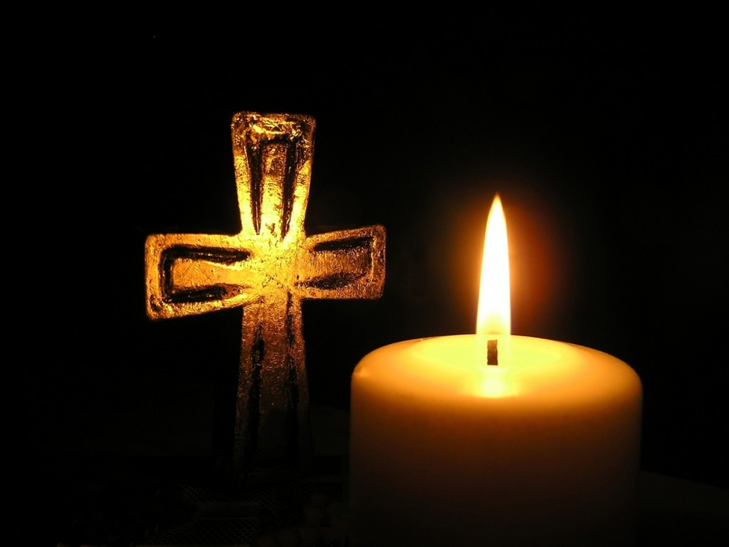
Prayers of Intercession

The response is:

Maranatha,
All Amen, come Lord Jesus.

We draw these and all our prayers together in the words of the Lord’s Prayer, saying,

All Our Father; who art in heaven, hallowed be thy name; thy kingdom come; thy will be done; on earth as it is in heaven. Give us this day our daily bread. And forgive us our trespasses, as we forgive those who trespass against us. And lead us not into temptation; but deliver us from evil. For thine is the kingdom, the power and the glory, for ever and ever.
Amen.

Merciful Father
All give us new life in you, accept our prayers and be with us always.
Amen.

Hymn

Long ago, prophets knew
Christ would come, born a Jew,
come to make all things new,
bear his people’s burden,
freely love and pardon.

Ring, bells, ring, ring, ring!
Sing, choirs, sing, sing, sing!
When he comes, when he comes,
who will make him welcome?

God in time, God in man,
this is God’s timeless plan:
he will come, as a man,
born himself of woman,
God divinely human:

Mary, hail! Though afraid,
she believed, she obeyed.
In her womb God is laid,
till the time expected,
nurtured and protected:

Journey ends: where afar
Bethlem shines, like a star,
stable door stands ajar.
Unborn Son of Mary,
Saviour, do not tarry.

Ring, bells, ring, ring, ring!
Sing, choirs, sing, sing, sing!
Jesus comes, Jesus comes:
we will make him welcome. F Pratt Green (b1903) (A&Mns)

Closing Responses and Blessing

The Lord God almighty is our Father:
All he loves us and tenderly cares for us.
The Lord Jesus Christ is our Saviour;
All he has redeemed us and will defend us to the end.
The Lord, the Holy Spirit is among us:
All he will lead us in God’s holy way.
To God almighty, Father, Son and Holy Spirit,
be praise and glory today and for ever. Amen.

May God the Father, judge all-merciful, make us worthy of a place in his kingdom.
May God the Son, coming among us in power, reveal in our midst the promises of his glory.
May God the Holy Spirit make us steadfast in faith, joyful in hope and constant in love.
And the blessing of God Almighty, the Father, the Son and the Holy Spirit, be with us, now and always.
All Amen.

Go in the peace of Christ.
All Thanks be to God.

Refreshments are served in the Lady Chapel, all are welcome.

