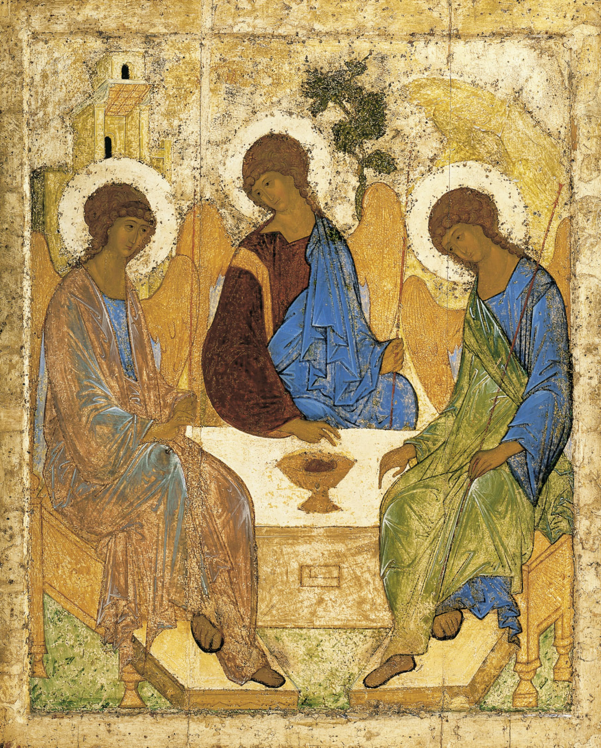
Holy Communion
Trinity Parish Church, Jersey
5th Sunday of Lent
26th March 2023

Welcome and Preparation

The Lord be with you.
All And also with you.

As we rejoice in the gift of this new day, so may the light of your presence, O God, set our hearts on fire with love for you; now and for ever.
All Amen.

Processional Hymn

Christ triumphant, ever reigning,
Saviour, Master, King!
Lord of heaven, our lives sustaining,
hear us as we sing:

Yours the glory and the crown,
the high renown, the eternal name.

Word incarnate, truth revealing,
Son of Man on earth!
power and majesty concealing
by your humble birth:

Suffering servant, scorned, ill-treated,
victim crucified!
death is through the cross defeated,
sinners justified:

Priestly King, enthroned for ever
high in heaven above!
sin and death and hell shall never
stifle hymns of love:

So, our hearts and voices raising
through the ages long,
ceaselessly upon You gazing,
this shall be our song:

Michael Saward (b.1932) (SP267)

Prayer of Preparation

All Almighty God, unto whom all hearts be open, all desires known, and from who no secret are hidden: cleanse the thoughts of our hearts by the inspiration of your Holy Spirit, that we may perfectly love you, and worthily magnify your holy name; through Christ our Lord. Amen.

A Time of Confession

Let us confess our sins in penitence and faith, firmly resolved to keep God’s commandments and to live in love and peace with all.

All Most merciful God, Father of our Lord Jesus Christ, we confess that we have sinned in thought, word and deed. We have not loved you with our whole heart. We have not loved our neighbours as ourselves. In your mercy forgive what we have been, help us to amend what we are, and direct what we shall be; that we may do justly, love mercy, and walk humbly with you our God. Amen.

Choir: Lord have mercy upon us, All: Lord have mercy upon us;
Choir: Lord have mercy upon us;
Choir: Christ have mercy upon us, All: Christ have mercy upon us;
Choir: Christ have mercy upon us;
Choir: Lord have mercy upon us, All: Lord have mercy upon us (repeat).

May the God of love and power forgive you and free you from your sins, heal and strengthen you by his Spirit, and raise you to new life in Christ our Lord.
All Amen.

The Collect

Most merciful God, who by the death and resurrection of your Son Jesus Christ delivered and saved the world: grant that by faith in him who suffered on the cross we may triumph in the power of his victory; through Jesus Christ you Son our Lord, who is alive and reigns with you, in the unity of the Holy Spirit, one God, now and for ever.

All Amen.

The Word of God

Ezekiel 37. 1 - 14

The hand of the Lord came upon me, and he brought me out by the spirit of the Lord and set me down in the middle of a valley; it was full of bones. He led me all round them; there were very many lying in the valley, and they were very dry. He said to me, ‘Mortal, can these bones live?’ I answered, ‘O Lord God, you know.’ Then he said to me, ‘Prophesy to these bones, and say to them: O dry bones, hear the word of the Lord. Thus says the Lord God to these bones: I will cause breath to enter you, and you shall live. I will lay sinews on you, and will cause flesh to come upon you, and cover you with skin, and put breath in you, and you shall live; and you shall know that I am the Lord.’
So I prophesied as I had been commanded; and as I prophesied, suddenly there was a noise, a rattling, and the bones came together, bone to its bone. I looked, and there were sinews on them, and flesh had come upon them, and skin had covered them; but there was no breath in them. Then he said to me, ‘Prophesy to the breath, prophesy, mortal, and say to the breath: Thus says the Lord God: Come from the four winds, O breath, and breathe upon these slain, that they may live.’ I prophesied as he commanded me, and the breath came into them, and they lived, and stood on their feet, a vast multitude.
Then he said to me, ‘Mortal, these bones are the whole house of Israel. They say, “Our bones are dried up, and our hope is lost; we are cut off completely.” Therefore prophesy, and say to them, Thus says the Lord God: I am going to open your graves, and bring you up from your graves, O my people; and I will bring you back to the land of Israel. And you shall know that I am the Lord, when I open your graves, and bring you up from your graves, O my people. I will put my spirit within you, and you shall live, and I will place you on your own soil; then you shall know that I, the Lord, have spoken and will act, says the Lord.’

This is the word of the Lord,
All Thanks be to God.

Romans 8: 6 - 11

To set the mind on the flesh is death, but to set the mind on the Spirit is life and peace. For this reason the mind that is set on the flesh is hostile to God; it does not submit to God’s law—indeed it cannot, and those who are in the flesh cannot please God.
But you are not in the flesh; you are in the Spirit, since the Spirit of God dwells in you. Anyone who does not have the Spirit of Christ does not belong to him. But if Christ is in you, though the body is dead because of sin, the Spirit is life because of righteousness. If the Spirit of him who raised Jesus from the dead dwells in you, he who raised Christ from the dead will give life to your mortal bodies also through his Spirit that dwells in you.

This is the word of the Lord,
All Thanks be to God.

Hymn

Breathe on me, Breath of God,
Till I am wholly Thine,
Until this earthly part of me
Glows with the fire divine.

Breathe on me, Breath of God,
So shall I never die,
But live with Thee the perfect life
Of Thine eternity.

Edwin Hatch (1835-89) (NEH342)

Breathe on me, Breath of God,
Fill me with life anew,
That I may love what Thou dost love,
And do what Thou wouldst do.

Breathe on me, Breath of God,
Until my heart is pure,
Until with Thee I will one will,
To do and to endure.

Gospel Reading

Hear the Gospel of our Lord Jesus Christ according to John;
All Glory to you O Lord.

John 11. 1 - 45

Now a certain man was ill, Lazarus of Bethany, the village of Mary and her sister Martha. Mary was the one who anointed the Lord with perfume and wiped his feet with her hair; her brother Lazarus was ill. So the sisters sent a message to Jesus, ‘Lord, he whom you love is ill.’ But when Jesus heard it, he said, ‘This illness does not lead to death; rather it is for God’s glory, so that the Son of God may be glorified through it.’ Accordingly, though Jesus loved Martha and her sister and Lazarus, after having heard that Lazarus was ill, he stayed two days longer in the place where he was.
Then after this he said to the disciples, ‘Let us go to Judea again.’ The disciples said to him, ‘Rabbi, the Jews were just now trying to stone you, and are you going there again?’ Jesus answered, ‘Are there not twelve hours of daylight? Those who walk during the day do not stumble, because they see the light of this world. But those who walk at night stumble, because the light is not in them.’ After saying this, he told them, ‘Our friend Lazarus has fallen asleep, but I am going there to awaken him.’ The disciples said to him, ‘Lord, if he has fallen asleep, he will be all right.’ Jesus, however, had been speaking about his death, but they thought that he was referring merely to sleep. Then Jesus told them plainly, ‘Lazarus is dead. For your sake I am glad I was not there, so that you may believe. But let us go to him.’ Thomas, who was called the Twin, said to his fellow-disciples, ‘Let us also go, that we may die with him.’
When Jesus arrived, he found that Lazarus had already been in the tomb for four days. Now Bethany was near Jerusalem, some two miles away, and many of the Jews had come to Martha and Mary to console them about their brother. When Martha heard that Jesus was coming, she went and met him, while Mary stayed at home. Martha said to Jesus, ‘Lord, if you had been here, my brother would not have died. But even now I know that God will give you whatever you ask of him.’ Jesus said to her, ‘Your brother will rise again.’ Martha said to him, ‘I know that he will rise again in the resurrection on the last day.’ Jesus said to her, ‘I am the resurrection and the life. Those who believe in me, even though they die, will live, and everyone who lives and believes in me will never die. Do you believe this?’ She said to him, ‘Yes, Lord, I believe that you are the Messiah, the Son of God, the one coming into the world.’
When she had said this, she went back and called her sister Mary, and told her privately, ‘The Teacher is here and is calling for you.’ And when she heard it, she got up quickly and went to him. Now Jesus had not yet come to the village, but was still at the place where Martha had met him. The Jews who were with her in the house, consoling her, saw Mary get up quickly and go out. They followed her because they thought that she was going to the tomb to weep there. When Mary came where Jesus was and saw him, she knelt at his feet and said to him, ‘Lord, if you had been here, my brother would not have died.’ When Jesus saw her weeping, and the Jews who came with her also weeping, he was greatly disturbed in spirit and deeply moved. He said, ‘Where have you laid him?’ They said to him, ‘Lord, come and see.’ Jesus began to weep. So the Jews said, ‘See how he loved him!’ But some of them said, ‘Could not he who opened the eyes of the blind man have kept this man from dying?’
Then Jesus, again greatly disturbed, came to the tomb. It was a cave, and a stone was lying against it. Jesus said, ‘Take away the stone.’ Martha, the sister of the dead man, said to him, ‘Lord, already there is a stench because he has been dead for four days.’ Jesus said to her, ‘Did I not tell you that if you believed, you would see the glory of God?’ So they took away the stone. And Jesus looked upwards and said, ‘Father, I thank you for having heard me. I knew that you always hear me, but I have said this for the sake of the crowd standing here, so that they may believe that you sent me.’ When he had said this, he cried with a loud voice, ‘Lazarus, come out!’ The dead man came out, his hands and feet bound with strips of cloth, and his face wrapped in a cloth. Jesus said to them, ‘Unbind him, and let him go.’
Many of the Jews therefore, who had come with Mary and had seen what Jesus did, believed in him.

This is the Gospel of the Lord,
All Praise to you, O Christ.

Reflections – Fleur Benest

Let us declare our faith in God.

We believe,
All We believe in one God,
the Father, the Almighty,
maker of heaven and earth,
of all that is,
seen and unseen.
We believe in one Lord, Jesus Christ,
the only Son of God,
eternally begotten of the Father,
God from God, Light from Light,
true God from true God,
begotten, not made,
of one Being with the Father;
through him all things were made.
For us and for our salvation he came down from heaven,
was incarnate from the Holy Spirit and the Virgin Mary
and was made man.
For our sake he was crucified under Pontius Pilate;
he suffered death and was buried.
On the third day he rose again
in accordance with the Scriptures;
he ascended into heaven
and is seated at the right hand of the Father.
He will come again in glory to judge the living and the dead,
and his kingdom will have no end.
We believe in the Holy Spirit,
the Lord, the giver of life,
who proceeds from the Father and the Son,
who with the Father and the Son is worshipped and glorified,
who has spoken through the prophets.
We believe in one holy catholic and apostolic Church.
We acknowledge one baptism for the forgiveness of sins.
We look for the resurrection of the dead,
and the life of the world to come. Amen.

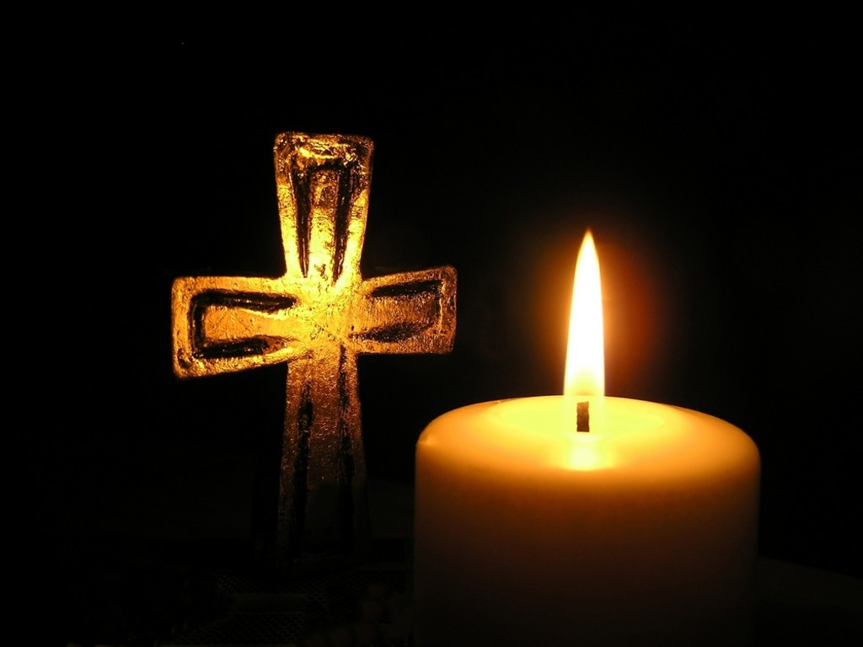
Prayers of Intercession
The response is:
Lord, in your mercy,
All hear our prayer.

Merciful Father
All accept these prayers for the sake of your Son, our Saviour Jesus Christ.
Amen.

The Peace

We are the body of Christ. In the one Spirit we were baptized into one body.
Let us then pursue all that makes for peace and builds up our common life.
The peace of the Lord be with you.
All And also with you

The Offertory Hymn

It is a thing most wonderful,
almost too wonderful to be,
that God’s own Son should come from heav’n
and die to save a child like me.

And yet I know that it is true;
He chose a poor and humble lot,
and wept, and toiled, and mourned, and died,
for love of those who loved Him not.

I cannot tell how He could love
a child so weak and full of sin;
His love must be most wonderful,
if He could die my love to win.

I sometimes think about the cross,
and shut my eyes and try to see
the cruel nails and crown of thorns,
and Jesus crucified for me.

And yet I want to love Thee, Lord;
O light the flame within my heart,
and I will love Thee more and more,
until I see Thee as Thou art.

William Walsham How (1823-97) (HON255)

Preparation of the Table

Blessed are you, Lord God of all creation; through your goodness we have this bread to set before you, which earth has given and human hands have made. It will become for us the bread of life.
All Blessed be God forever.

Blessed are you, Lord God of all creation; through your goodness we have this wine to set before you, fruit of the vine and work of human hands.
It will become for us the cup of salvation.
All Blessed be God forever.

Prayer of Consecration

The Lord is here.
All His Spirit is with us.
Lift up your hearts.
All We lift them to the Lord.
Let us give thanks to the Lord our God.
All It is right to give thanks and praise.

Blessed are you Lord God, our light and our salvation; to you be glory and praise for ever. From the beginning you have created all things and all your works echo the silent music of your praise. In the fullness of time you made us in your image, the crown of all creation.

You give us breath and speech, that with angels and archangels and all the powers of heaven we may find a voice to sing your praise:
All Holy, holy, holy, Lord God of hosts,
Heaven and earth are full of thy glory.
Glory be to thee, O Lord most high.
Blessed is he that cometh in the name of the Lord,
Hosanna, Hosanna, Hosanna in the Highest.

How wonderful the work of your hands, O Lord. As a mother tenderly gathers her children, you embraced a people as your own. When they turned away and rebelled your love remained steadfast. From them you raised up Jesus our Saviour, born of Mary, to be the living bread, in whom all our hungers are satisfied. He offered his life for sinners, and with a love stronger than death he opened wide his arms on the cross.

On the night before he died, he came to supper with his friends and, taking bread, he gave you thanks. He broke it and gave it to them, saying: Take eat;
this is my body, which is given for you; do this in remembrance of me.

At the end of supper, taking the cup of wine, he gave you thanks, and said: Drink this, all of you; this is my blood of the new covenant, which is shed for you and for many for the forgiveness of sins. Do this, as often as you drink it, in remembrance of me.

Great is the mystery of faith:
All Christ has died, Christ is risen, Christ will come again.
Father, we plead with confidence his sacrifice made once for all upon the cross; we remember his dying and rising in glory, and we rejoice that he intercedes for us at your right hand.

Pour out your Holy Spirit as we bring before you these gifts of your creation; may they be for us the body and blood of your dear Son. As we eat and drink these holy things in your presence, form us in the likeness of Christ, and build us into a living temple to your glory.

Bring us at the last with all the saints to the vision of that eternal splendour for which you have created us; through Jesus Christ, our Lord, by whom, with whom and in whom, with all who stand before you in earth and heaven, we worship you, Father almighty, in songs of everlasting praise, singing:
All Blessing and honour and glory and power be yours for ever and ever. Amen.

Let us pray with confidence as our Saviour has taught us:
All Our Father; who art in heaven, hallowed be thy name; thy kingdom come;
thy will be done; on earth as it is in heaven. Give us this day our daily bread. And forgive us our trespasses, as we forgive those who trespass against us. And lead us not into temptation; but deliver us from evil.
For thine is the kingdom, the power and the glory, for ever and ever. Amen.

We break this bread to share in the body of Christ.
All Though we are many, we are one body, because we all share in one bread.

All O Lamb of God, that takest away the sins of the world, have mercy upon us.
O Lamb of God, that takest away the sins of the world, have mercy upon us.
O Lamb of God, that takest away the sins of the world, grant us thy peace.

Jesus is the Lamb of God who takes away the sin of the world.
Blessed are those who are called to his supper:
All Lord, I am not worthy to receive you, but only say the word, and I shall
be healed.

The Communion
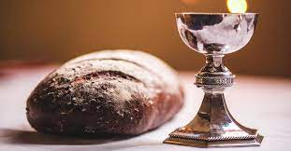
Please come forward to receive bread and wine or a blessing.

Prayer after Communion

Lord Jesus Christ, you have taught us that what we do for the least of our brothers and sisters we do also for you: give us the will to be the servant of others as you were the servant of all, and gave up your life and died for us, but are alive and reign, now and for ever.

All Amen.

All Father of all, we give you thanks and praise, that when we were still far
off you met us in your Son and brought us home. Dying and living, he declared your love, gave us grace, and opened the gate of glory. May we who share Christ’s body live his risen life; we who drink his cup bring life to others; we whom the Spirit lights give light to the world. Keep us firm in the hope you have set before us, so we and all your children shall be free, and the whole earth live to praise your name; through Christ our Lord. Amen.

Hymn
Each new disciple
of the Crucified
is called to bear
the seal of him who died…

O Lord, once lifted
on the glorious tree,
As thou hast promised,
draw us unto thee…

Lift high the cross,
the love of Christ proclaim
till all the world
adores His sacred name!

Come, Christians, follow
where our Saviour trod,
O’er death victorious,
Christ, the Son of God…

Set up thy throne,
that earth’s despair may cease
Beneath the shadow
of its healing peace…

G W Kitchen & M R Newbolt (HON303)

The Blessing

May God the Father; who does not despise the broken spirit, give to you a contrite heart. May Christ, who bore our sins in his body on the tree, heal you by his wounds. May the Holy Spirit, who leads us into all truth, speak to you words of pardon and peace. And the blessing of God almighty, the Father, the Son and the Holy Spirit, be upon you and remain with you, now and always.

Go in peace to love and serve the Lord,
All In the name of Christ. Amen.

Refreshments are served for all in the Lady Chapel

To make an anonymous offertory donation to church,
please scan the QR below. Thank you.

CCL760416

