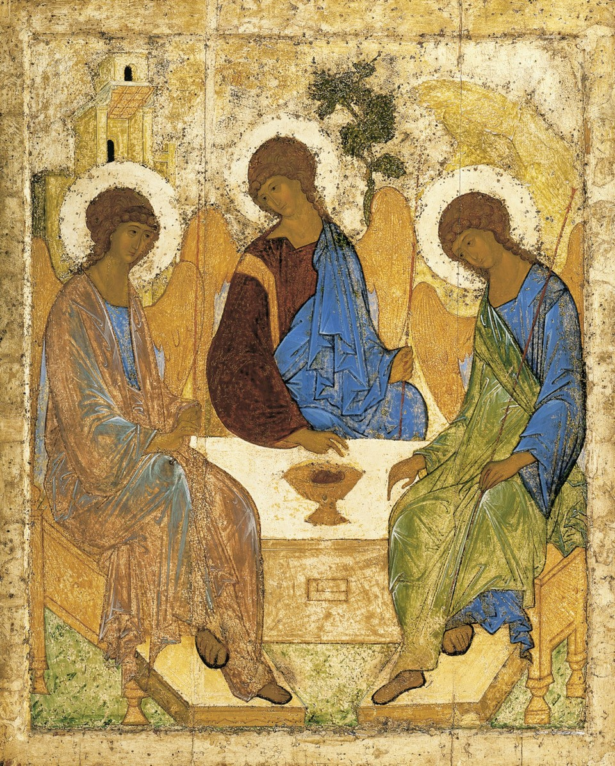
Morning Worship
from
Holy Trinity Church, Jersey
Trinity Sunday
7th June 2020

Welcome and Preparation

Grace, mercy and peace from God our Father and the Lord Jesus Christ
be with you,
All and also with you.

The Lord is here.
All His Spirit is with us.

Hymn
Immortal, invisible, God only wise,
In light inaccessible hid from our eyes,
Most blessed, most glorious,
the Ancient of Days,
Almighty, victorious,
thy great name we praise.

Unresting, unhasting, and silent as light,
Nor wanting, nor wasting, thou rulest in might;
Thy justice like mountains
high soaring above
Thy clouds, which are fountains
of goodness and love.

To all, life thou givest - to both great and small;
In all life thou livest, the true life of all;
We blossom and flourish
as leaves on the tree,
And wither and perish -
but naught changeth thee.

Great Father of glory, pure Father of light,
Thine angels adore thee, all veiling their sight;
All laud we would render:
O help us to see
‘Tis only the splendour
of light hideth thee. W.C. Smith (1824-1908) (NEH377)

A Prayer from St Patrick’s Breastplate

I bind unto myself the Name,
The strong Name of the Trinity;
By invocation of the same.
The Three in One, and One in Three,
Of Whom all nature hath creation,
Eternal Father, Spirit, Word:
Praise to the Lord of my salvation,
Salvation is of Christ the Lord.

All Amen.

A Time of Confession

Sisters and brothers, as we prepare to celebrate, let us call to mind our sins.

Silence is kept

Father, you come to meet us when we return to you: Lord, have mercy.
All Lord, have mercy.
Jesus, you died on the cross for our sins: Christ, have mercy.
All Christ, have mercy.
Spirit, you give us life and peace: Lord, have mercy.
All Lord, have mercy.

Bishop Almighty God, who forgives all who truly repent, have mercy upon you, pardon
and deliver you from all your sins, confirm and strengthen you in all goodness, and keep you in life eternal.

All Amen.

Gloria in Excelsis

Glory to God in the highest, and peace to his people on earth. Lord God, heavenly King, almighty God and Father, we worship you, we give you thanks, we praise you for your glory. Lord Jesus Christ, only Son of the Father, Lord God, Lamb of God, you take away the sin of the world: have mercy on us; you are seated at the right hand of the Father: receive our prayer. For you along and the Holy One, you alone are the Lord, you alone are the Most High, Jesus Christ, with the Holy Spirit, in the glory of God the Father. Amen.

The Collect

Holy God, faithful and unchanging: enlarge our minds with the knowledge of your truth, and draw us more deeply into the mystery of your love, that we may truly worship you, Father, Son and Holy Spirit, one God, now and for ever.

All Amen.

The Word of God

The Canticle: A Song of Judith

All You sent forth your Spirit, O God,
and you continue to show mercy.

- I will sing a new song to my God,
for you are great and glorious, truly strong and invincible.

- May your whole creation serve you, for you spoke and things came to be.

- You sent forth your Spirit and they were formed, for no one can resist your voice.

- Mountains and seas are stirred to their depths;
at your presence rocks shall melty like wax.

- But to those who fear you, you continue to show mercy.

- No sacrifice, however fragrant, can please you,
but whoever fears the Lord shall stand in your sight for ever.

All You sent forth your Spirit, O God,
and you continue to show mercy.

Scripture Reading

Alleluia, alleluia. Glory to the Father, and to the Son, and to the Holy Spirit, one God, who was, and who is, and who is to come, the almighty.
All Alleluia.

Hear the Gospel of our Lord Jesus Christ according to Matthew.
All Glory to you, O Lord.

Matthew 28.16-20 The Commissioning of the Disciples
Now the eleven disciples went to Galilee, to the mountain to which Jesus had directed them. When they saw him, they worshipped him; but some doubted. And Jesus came and said to them, ‘All authority in heaven and on earth has been given to me. Go therefore and make disciples of all nations, baptizing them in the name of the Father and of the Son and of the Holy Spirit, and teaching them to obey everything that I have commanded you. And remember, I am with you always, to the end of the age.’

This is the Gospel of the Lord.
All Praise to you, O Christ.

Address – Bishop Trevor

Music and Reflection, Celebrating Our Life Together

Let us affirm our faith in Jesus Christ the Son of God.
All Though he was divine,
he did not cling to equality with God,
but made himself nothing.
Taking the form of a slave,
He was born in human likeness.
He humbled himself
and was obedient to death,
even the death of the cross.
Therefore, God has raised him on high,
and given him the name above every name:
that at the name of Jesus
every knee should bow,
and every voice proclaim that Jesus Christ is Lord,
to the glory of God the Father.
Amen.

The Peace
Peace to you from God our heavenly Father. Peace from his Son Jesus Christ who is our peace. Peace from the Holy Spirit, the life-giver.

The peace of the Triune God be always with you.
All And also with you.

Hymn

Longing for light, we wait in darkness.
Longing for truth, we turn to you.
Make us your own, your holy people,
light for the world to see.

Christ be our light! Shine in our hearts.
Shine through the darkness.
Christ be our light! Shine in your Church gathered today.

Longing for peace, our world is troubled.
Longing for hope, many despair.
Your word alone has pow’r to save us.
Make us your living voice.

Longing for food, many are hungry.
Longing for water, many still thirst.
Make us your bread, broken for others,
shared until all are fed.

Longing for shelter, many are homeless.
Longing for warmth, many are cold.
Make us your building, sheltering others,
walls made of living stone.

Many the gifts, many the people,
many the hearts that yearn to belong.
Let us be servants to one another,
making your kingdom come.
Bernadette Farrell

Prayers of Intercession

We listen to a sung response:
God to enfold you, Christ to uphold you, Spirit to keep you in heaven’s sight; so
may God grace you, heal and embrace you, lead you through darkness into the
light. (From ‘Love and Anger’, by the Iona Community.)

We draw these and all our prayers together in the words of the Lord’s Prayer, saying,

Our Father; who art in heaven, hallowed be thy name; thy kingdom come; thy will be done; on earth as it is in heaven.
Give us this day our daily bread. And forgive us our trespasses,
as we forgive those who trespass against us. And lead us not
into temptation; but deliver us from evil. For thine is the kingdom, the power and the glory, for ever and ever.
Amen.

Merciful Father
All give us new life in you, accept our prayers and be with us always. Amen.

Hymn
Ye watchers and ye holy ones
Bright Seraphs, Cherubim and Thrones
Raise the glad strain, Alleluya!
Cry out Dominions, Princedoms, Powers,
Virtues, Archangels, Angels’ choirs…
Alleluya, Alleluya, Alleluya
Alleluya, Alleluya!

O higher than the Cherubim,
More glorious than the Seraphim,
Lead their praises, Alleluya!
Thou Bearer of the eternal Word,
Most gracious, magnify the Lord…

Respond, ye souls in endless rest,
Ye Patriarchs and Prophets blest,
Alleluya, Alleluya!

Ye holy Twelve, ye Martyrs strong.
All Saints triumphant, raise the song…

O friends, in gladness let us sing,
Supernal anthems echoing,
Alleluya, Alleluya!
To God the Father, God the Son,
And God the Spirit, Three in One…
Athelstan Riley (1858-1945)(NEH478)

Closing Responses and Blessing

Bishop The Lord bless you and keep you: The Lord make his face to shine upon you, and be gracious to you: the Lord lift up his countenance upon you and give you peace. The Lord God almighty, Father, Son, and Holy Spirit, the holy and undivided Trinity, guard you, save you, and bring you to that heavenly city, where he lives and reigns for ever and ever.
All Amen.

Filled with the Spirit’s power, go in the light and peace of Christ. Alleluia, alleluia.
All Thanks be to God. Alleluia, alleluia.

