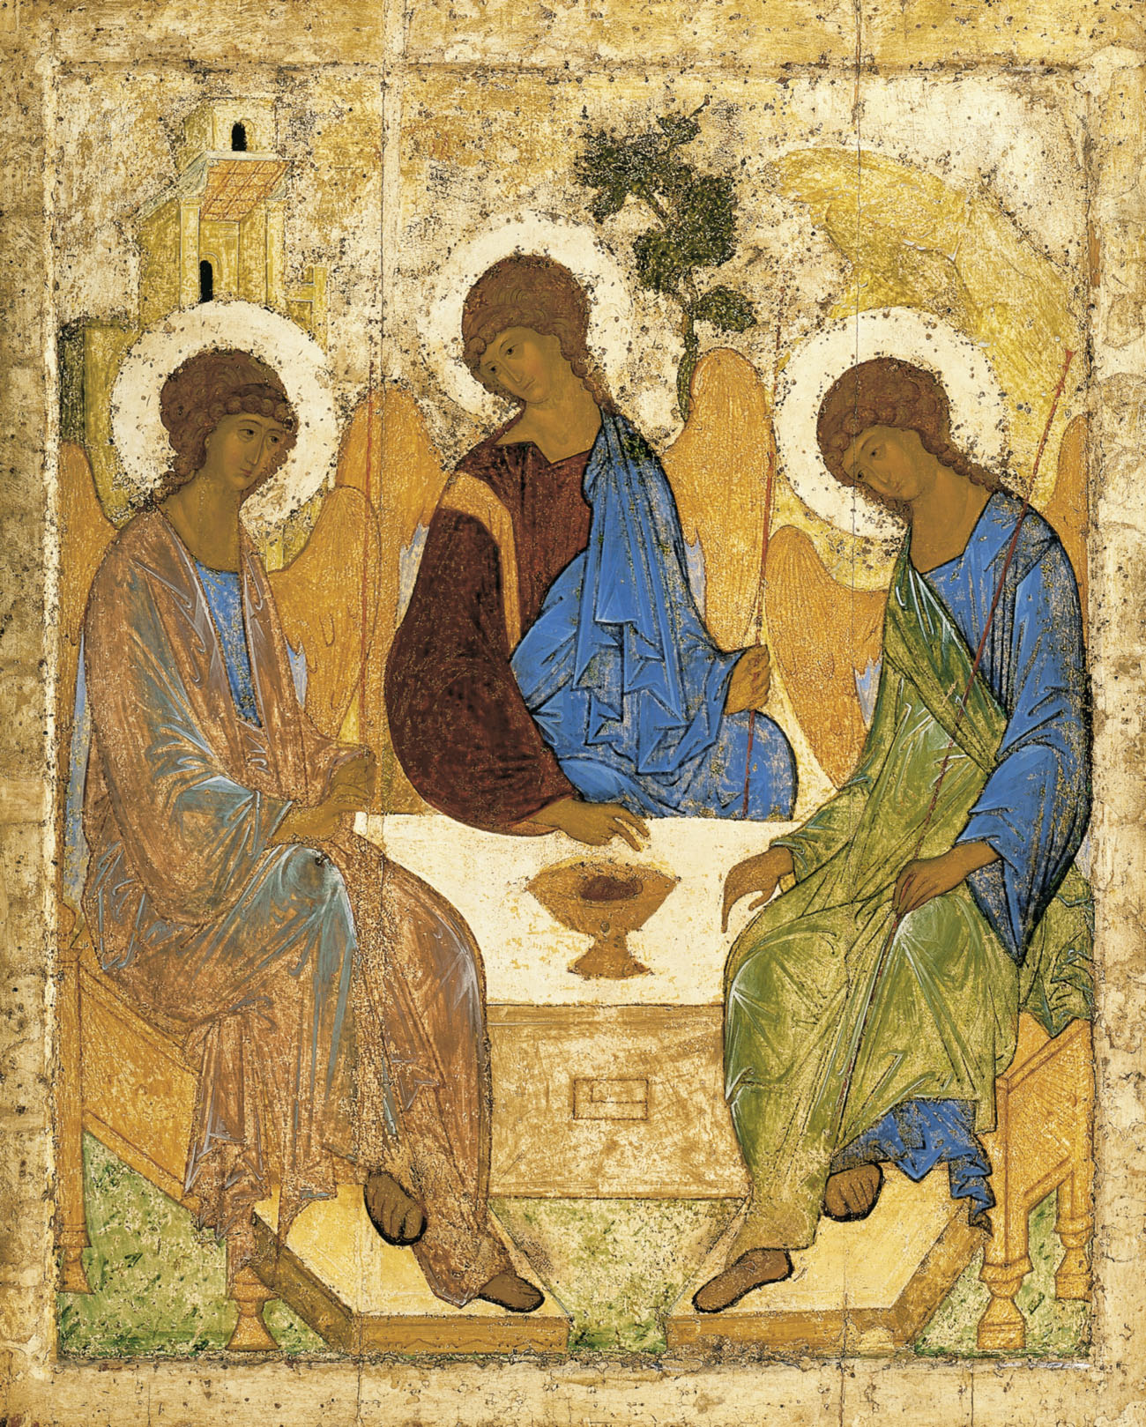
Holy Communion
Trinity Parish Church, Jersey
3rd Sunday of Trinity
20th June, 2021

Welcome and Preparation
The Lord be with you.
All And also with you.

As we rejoice in the gift of this new day, so may the light of your presence, O God, set our hearts on fire with love for you.; now and for ever.
All Amen.

Hymn

He who would valiant be
‘gainst all disaster,
let him in constancy
follow the Master,
There’s no discouragement
Shall make him once relent,
His first avowed intent
To be a pilgrim.

Who so beset him round
With dismal stories,
So but themselves confound -
His strength the more is.
No foes shall stay his might,
Though he with giants fight:
He will make good his right
To be a pilgrim.

Since, Lord, Thou dost defend
Us with Thy Spirit,
We know we at the end
Shall life inherit.
Then fancies flee away!
I’ll fear not what men say,
I’ll labour night and day
To be a pilgrim.
John Bunyan (1628-88) & Percy Dearmer (1867-1936) (NEH372)

A Time of Confession

Let us come to the risen Lord, who is full of compassion, and acknowledge our transgressions in penitence and faith.
Lord Jesus, you raise us to new life.
Lord, have mercy.
All Lord, have mercy.
Lord Jesus, you forgive us our sins.
Christ, have mercy.
All Christ, have mercy.
Lord Jesus, you feed us through the living bread.
Lord, have mercy.
All Lord, have mercy.

May the God of love and power forgive you and free you from your sins, heal and strengthen you by his Spirit, and raise you to new life in Christ our Lord.
All Amen.

The Collect

Almighty God, you have broken the tyranny of sin and have sent the Spirit of your Son into our hearts whereby we call you Father: give us grace to dedicate our freedom to your service, that we and all creation may be brought to the glorious liberty of the children of God: though Jesus Christ our Lord.
All Amen.

The Word of God

Job 38. 1-11
Then the Lord answered Job out of the whirlwind:
‘Who is this that darkens counsel by words without knowledge?
Gird up your loins like a man,
I will question you, and you shall declare to me.
‘Where were you when I laid the foundation of the earth?
Tell me, if you have understanding.
Who determined its measurements—surely you know!
Or who stretched the line upon it?
On what were its bases sunk,
or who laid its cornerstone
when the morning stars sang together
and all the heavenly beings shouted for joy?
‘Or who shut in the sea with doors
when it burst out from the womb?—
when I made the clouds its garment,
and thick darkness its swaddling band,
and prescribed bounds for it,
and set bars and doors,
and said, “Thus far shall you come, and no farther,
and here shall your proud waves be stopped”?

This is the word of the Lord,
All Thanks be to God.

2 Corinthians 6.1-13
As we work together with him, we urge you also not to accept the grace of God in vain. For he says,
‘At an acceptable time I have listened to you,
and on a day of salvation I have helped you.’
See, now is the acceptable time; see, now is the day of salvation! We are putting no obstacle in anyone’s way, so that no fault may be found with our ministry, but as servants of God we have commended ourselves in every way: through great endurance, in afflictions, hardships, calamities, beatings, imprisonments, riots, labours, sleepless nights, hunger; by purity, knowledge, patience, kindness, holiness of spirit, genuine love, truthful speech, and the power of God; with the weapons of righteousness for the right hand and for the left; in honour and dishonour, in ill repute and good repute. We are treated as impostors, and yet are true; as unknown, and yet are well known; as dying, and see—we are alive; as punished, and yet not killed; as sorrowful, yet always rejoicing; as poor, yet making many rich; as having nothing, and yet possessing everything.
We have spoken frankly to you Corinthians; our heart is wide open to you. There is no restriction in our affections, but only in yours. In return—I speak as to children—open wide your hearts also.

This is the word of the Lord,
All Thanks be to God.

Hymn
Will your anchor hold in the storms of life,
when the clouds unfold their wings of strife?
When the strong tides lift, and the cables strain,
will your anchor drift, or firm remain?

We have an anchor that keeps the soul
steadfast and sure while the billows roll;
fastened to the rock which cannot move,
grounded firm and deep in the Saviour’s love!

Will your anchor hold in the floods of death,
when the waters cold chill your final breath?
On the rising tide you can never fail,
while your anchor holds within the veil.

Will your eyes behold through the morning light,
the city of gold and the harbour bright?
Will you anchor safe by the heavenly shore,
when life’s storms are past for evermore?
Priscilla Jane Owens (1829-99) (JP290)

Gospel Reading

Hear the Gospel of our Lord Jesus Christ according to Mark;
All Glory to you O Lord.

Mark 4.35-41
On that day, when evening had come, he said to them, ‘Let us go across to the other side.’ And leaving the crowd behind, they took him with them in the boat, just as he was. Other boats were with him. A great gale arose, and the waves beat into the boat, so that the boat was already being swamped. But he was in the stern, asleep on the cushion; and they woke him up and said to him, ‘Teacher, do you not care that we are perishing?’ He woke up and rebuked the wind, and said to the sea, ‘Peace! Be still!’ Then the wind ceased, and there was a dead calm. He said to them, ‘Why are you afraid? Have you still no faith?’ And they were filled with great awe and said to one another, ‘Who then is this, that even the wind and the sea obey him?’

This is the Gospel of the Lord,
All Praise to you, O Christ.

Reflections – The Rector

Let us declare our faith in God.

We believe,
All We believe in one God,
the Father, the Almighty,
maker of heaven and earth,
of all that is,
seen and unseen.
We believe in one Lord, Jesus Christ,
the only Son of God,
eternally begotten of the Father,
God from God, Light from Light,
true God from true God,
begotten, not made,
of one Being with the Father;
through him all things were made.
For us and for our salvation he came down from heaven,
was incarnate from the Holy Spirit and the Virgin Mary
and was made man.
For our sake he was crucified under Pontius Pilate;
he suffered death and was buried.
On the third day he rose again
in accordance with the Scriptures;
he ascended into heaven
and is seated at the right hand of the Father.
He will come again in glory to judge the living and the dead,
and his kingdom will have no end.
We believe in the Holy Spirit,
the Lord, the giver of life,
who proceeds from the Father and the Son,
who with the Father and the Son is worshipped and glorified,
who has spoken through the prophets.
We believe in one holy catholic and apostolic Church.
We acknowledge one baptism for the forgiveness of sins.
We look for the resurrection of the dead,
and the life of the world to come. Amen.

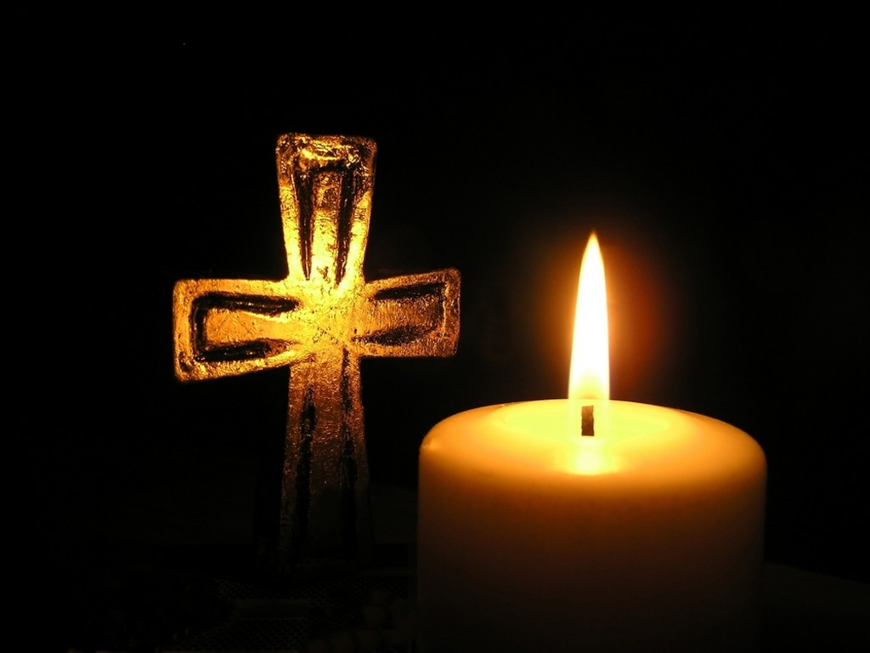
Prayers of Intercession

The response is:
Lord hear us,
All Lord, graciously hear us.

Merciful Father
All give us new life in you, accept our prayers and be with us always.
Amen.

The Peace
The risen Christ came and stood among the disciples and said, ‘Peace be with you.’ Then they were glad when they saw the Lord. Alleluia. The peace of the Lord be with you.
All And also with you

Hymn
My life flows on in endless song;
above earth’s lamentation,
I catch the sweet, though far-off hymn
that hails a new creation.
No storm can shake my inmost calm
while to that Rock I’m clinging.
since love is Lord of heaven and earth,
how can I keep from singing?
Through all the tumult and the strife,
I hear that music ringing.
It finds an echo in my soul.
How can I keep from singing?...
What though my joys and comforts die?
I know my Saviour liveth!
What though the darkness round me close?
Songs in the night he giveth…
The peace of Christ makes fresh my heart,
a fountain ever springing!
All things are mine since I am his!
How can I keep from singing?...
Robert Lowry (1826-1899) and Dors Plenn) (SP296)

Preparation of the Table

Blessed are you, Lord God of all creation; through your goodness we have this bread to set before you, which earth has given and human hands have made. It will become for us the bread of life.
All Blessed be God forever.

Blessed are you, Lord God of all creation; through your goodness we have this wine to set before you, fruit of the vine and work of human hands.
It will become for us the cup of salvation.
All Blessed be God forever.

Prayer of Consecration

The Lord is here.
All His Spirit is with us.
Lift up your hearts.
All We lift them to the Lord.
Let us give thanks to the Lord our God.
All It is right to give thanks and praise.

Blessed are you Lord God, our light and our salvation; to you be glory and praise for ever. From the beginning you have created all things and all your works echo the silent music of your praise. In the fullness of time you made us in your image, the crown of all creation. You give us breath and speech, that with angels and archangels and all the powers of heaven we may find a voice to sing your praise:

All Holy, holy, holy Lord, God of power and might,
heaven and earth are full of your glory.
Hosanna in the highest.
Blessed is he who comes in the name of the Lord.
Hosanna in the highest.

How wonderful the work of your hands, O Lord. As a mother tenderly gathers her children, you embraced a people as your own. When they turned away and rebelled your love remained steadfast. From them you raised up Jesus our Saviour, born of Mary, to be the living bread, in whom all our hungers are satisfied. He offered his life for sinners, and with a love stronger than death he opened wide his arms on the cross. On the night before he died, he came to supper with his friends and, taking bread, he gave you thanks. He broke it and gave it to them, saying: ‘Take eat; this is my body which is given for you; do this in remembrance of me.’ At the end of supper, taking the cup of wine, he gave you thanks, and said: ‘Drink this, all of you; this is my blood of the new covenant, which is shed for you and for many for the forgiveness of sins. Do this, as often as you drink it, in remembrance of me.’

Great is the mystery of faith:
All Christ has died: Christ is risen: Christ will come again.

Father, we plead with confidence his sacrifice made once for all upon the cross; we remember his dying and rising in glory, and we rejoice that he intercedes for us at your right hand.
Pour out your Holy Spirit as we bring before you these gifts of your creation; may they be for us the body and blood of your dear Son.
As we eat and drink these holy things in your presence, form us in the likeness of Christ, and build us into a living temple to your glory.
Bring us at the last with all the saints to the vision of that eternal splendour for which you have created us; through Jesus Christ, our Lord, by whom, with whom and in whom, with all who stand before you in earth and heaven, we worship you, Father almighty, in songs of everlasting praise:
All Blessing and honour and glory and power be yours for ever and ever. Amen.

Let us pray with confidence as our Saviour has taught us:
All Our Father; who art in heaven, hallowed be thy name; thy kingdom come;
thy will be done; on earth as it is in heaven. Give us this day our daily bread. And forgive us our trespasses, as we forgive those who trespass against us. And lead us not into temptation; but deliver us from evil.
For thine is the kingdom, the power and the glory, for ever and ever. Amen.

We break this bread to share in the body of Christ.
All Though we are many, we are one body, because we all share in one bread.

All Lamb of God, you take away the sin of the world: have mercy on us.
Lamb of God, you take away the sin of the world: have mercy on us.
Lamb of God, you take away the sin of the world: grant us peace.

Jesus is the Lamb of God who takes away the sin of the world.
Blessed are those who are called to his supper:
All Lord, I am not worthy to receive you, but only say the word, and I shall
be healed.

The Communion
Please come forward to receive bread or a blessing.
Observe physical distancing at all times and remain standing to receive.

Prayer after Communion
O God, whose beauty is beyond our imagining and whose power we cannot comprehend: show us your glory as far as we can grasp it, and shield us from knowing more than we can bear until we may look upon you without fear; through Jesus Christ our Lord.
All Amen.

All Father of all, we give you thanks and praise, that when we were still far
off you met us in your Son and brought us home. Dying and living, he declared your love, gave us grace, and opened the gate of glory. May we who share Christ’s body live his risen life; we who drink his cup bring life to others; we whom the Spirit lights give light to the world. Keep us firm in the hope you have set before us, so we and all your children shall be free, and the whole earth live to praise your name; through Christ our Lord. Amen.

Hymn

Lord of beauty, thine the splendour
Shown in earth and sky and sea,
Burning sun and moonlight tender,
Hill and river, flower and tree:
Lest we fail our praise to render
Touch our eyes that they may see.

Lord of wisdom, whom obeying
Mighty waters ebb and flow,
While unhasting, undelaying,
Planets on their courses go:
In thy laws thyself displaying,
Teach our minds thyself to know.

Lord of beauty, bid us own thee,
Lord of truth, our footsteps guide,
Till as Love our hearts enthrone thee,
And, with wisdom purified,
Lord of all, when all have known thee,
Thou in all art glorified.
C A Alington (1872-1955) (NEH)

The Blessing

May the Father from whom every family in earth and heaven receives its name strengthen you with his Spirit in your inner being, so that Christ may dwell in your hearts by faith, and that, knowing his love, broad and long, deep and high beyond our knowledge, you may be filled with all the fullness of God; And the blessing of God almighty, the Father, the Son, and the Holy Spirit, be with you now and always.
All Amen.

Go in the peace of Christ.
All Thanks be to God.

