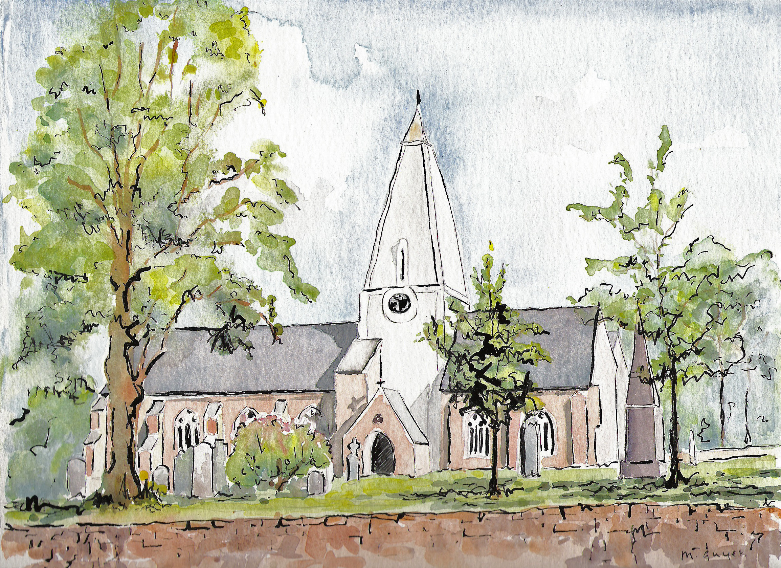
Matins
Holy Trinity Church, Jersey
29th May 2022
Sunday after Ascension

Processional Hymn
Hail him, ye heirs of David’s line,
Whom David Lord did call;
The God incarnate, Man divine,
And crown him Lord of all.

Sinners, whose love can ne’er forget
The wormwood and the gall,
Go spread your trophies at his feet,
And crown him Lord of all.

All hail the power of Jesu’s name;
let angels prostrate fall
bring forth the royal diadem
and crown him Lord of all.

Ye seeds of Israel’s chosen race
Ye ransomed of the fall
Hail him who saves you by his grace
And crown him Lord of all.

Let every tribe and every tongue
To him their hearts enthral,
Lift high the universal song,
And crown him Lord of all
E. Perronet (1726-92) (NEH332)

Welcome and notices

Words of introduction and invitation
Beloved, we are come together in the presence of almighty God and of the whole company of heaven to offer unto him through our Lord Jesus Christ our worship and praise and thanksgiving; to make confession of our sins; to pray, as well for others as for ourselves, that we may know more truly the greatness of God’s love and shew forth in our lives the fruits of his grace; and to ask on behalf of all men such things as their well-being doth require.
Wherefore let us sit or kneel in silence, and remember God’s presence with us now.
Let us humbly confess our sins to Almighty God.
Almighty and most merciful Father; we have erred, and strayed from thy ways like lost sheep. We have followed too much the devices and desires of our own hearts. We have offended against thy holy laws. We have left undone those things which we ought to have done; and we have done those things which we ought not to have done; and there is no health in us. But thou, O Lord, have mercy upon us, miserable offenders. Spare thou them, O God, which confess their faults. Restore thou them that are penitent; according to thy promises declared unto mankind in Christ Jesu our Lord. And grant, O most merciful Father, for his sake; That we may hereafter live a godly, righteous, and sober life, to the glory of thy holy Name. Amen.

Grant, we beseech thee, merciful Lord, to thy faithful people pardon and peace, that they may be cleansed from all their sins, and serve thee with a quiet mind; through Jesus Christ our Lord. Amen.

Our Father; who art in heaven, hallowed be thy name; thy kingdom come; thy will be done; on earth as it is in heaven. Give us this day our daily bread. And forgive us our trespasses, as we forgive those who trespass against us. And lead us not into temptation; but deliver us from evil. For thine is the kingdom, the power and the glory, for ever and ever. Amen.

O Lord, open thou our lips.
And our mouth shall show forth thy praise.
O God, make speed to save us.
O Lord, make haste to help us. (stand)
Glory be to the Father, and to the Son; and to the Holy Ghost;
As it was in the beginning, is now, and ever shall be; world without end. Amen.
Praise ye the Lord;
The Lord’s name be praised.

The Venite
O come, let us’ sing unto the’ Lord: let us heartily rejoice in the’ strength of’ our sal’vation.
Let us come before his’ presence with’ thanksgiving: and shew ourselves’ glad in’ him with’ psalms.
For the Lord is a’ great’ God: and a great’ King above’ all’ gods.
In his hand are all the’ corners of the’ earth: and the strength of the’ hills is’ his’ also.
The sea is his, and’ he’ made it: and his hands pre’pared the’ dry’ land.
O come, let us worship, and’ fall’ down: and kneel be’fore the’ Lord our’ Maker.
For he is the’ Lord our’ God: and we are the people of his pasture, and the’ sheep of’ his’ hand.
Glory be to the Father, and’ to the’ Son: and’ to the’ Holy’ Ghost;
As it was in the beginning, is now and’ ever’ shall be: world without ‘end’. A’men.
Psalm 97

- The Lord is King, the earth may be glad thereof : yea the multitude of the isles may be glad thereof.
- Clouds and darkness are round about him : righteousness and judgement are the habitation of his seat.
- There shall go a fire before him : and burn up his enemies on every side.
- His lightnings gave shine unto the world : the earth saw it and was afraid.
- The hills melted like wax at the presence of the Lord : at the presence of the Lord of the whole earth.
- The heavens have declared his righteousness : and all the people have seen his glory.
- Confounded. E all they that worship carved images, and that delight in vain gods : worship him all ye gods.
- Sion heard of it and rejoiced : and the daughters of Judah were glad because of thy judgements O Lord.
- For thou Lord art higher that all that are in the earth : thou art exalted far above all gods.
- O ye that love the Lord, see that ye hate the thing which is evil : the Lord preserveth the souls of his saints, he shall deliver them from the hand of the ungodly.
- There is sprung up a light for the righteous : and joyful gladness for such as are truehearted.
- Rejoice in the Lord ye righteous : and give thanks for a remembrance of his holiness.

Glory be to the Father, and ‘to the ’Son: and’ to the’ Holy’ Ghost; As it was in the beginning, is now and ’ever’ shall be: world without ‘end’. Amen.
The First Lesson
The first lesson is taken from Ezekiel Chapter 36, verses 24-28

I will take you from the nations, and gather you from all the countries, and bring you into your own land. I will sprinkle clean water upon you, and you shall be clean from all your uncleannesses, and from all your idols I will cleanse you. A new heart I will give you, and a new spirit I will put within you; and I will remove from your body the heart of stone and give you a heart of flesh. I will put my spirit within you, and make you follow my statutes and be careful to observe my ordinances. Then you shall live in the land that I gave to your ancestors; and you shall be my people, and I will be your God.

Here ends the First Lesson.
Benedicite 1-18
O all ye Works of the Lord’ bless ye the’ Lord:
O ye Angels of the Lord’ bless ye the’ Lord:
O ye Heavens’ bless ye the’ Lord: praise him and’ magnify’ him for’ ever.
O ye Waters that be above the Firmament’ bless ye the’ Lord:
O all ye Powers of the Lord’ bless ye the’ Lord:
O ye Sun and Moon’ bless ye the’ Lord: praise him and’ magnify’ him for’ ever.
O ye Stars of Heaven’ bless ye the’ Lord:
O ye Showers and Dew’ bless ye the’ Lord:
O ye Winds of God’ bless ye the’ Lord: praise him and’ magnify’ him for’ ever.
O ye Fire and Heat’ bless ye the’ Lord:
O ye Winter and Summer’ bless ye the’ Lord:
O ye Dews and Frosts’ bless ye the’ Lord: praise him and’ magnify’ him for’ ever.
O ye Frost and Cold’ bless ye the’ Lord:
O ye Ice and Snow’ bless ye the’ Lord:
O ye Nights and Days’ bless ye the’ Lord: praise him and’ magnify’ him for’ ever.
O ye Light and Darkness’ bless ye the’ Lord:
O ye Lightnings and Clouds’ bless ye the’ Lord:
O let the Earth’ bless the’ Lord: yea let it praise him and’ magnify’ him for’ ever.
Glory be to the Father, and’ to the’ Son: and’ to the’ Holy’ Ghost
As it was in the beginning, is now and’ ever’ shall be: world without ‘end’. A’men.

The Second Lesson
The second lesson is taken from John, Chapter 17, verses 20 - end
‘I ask not only on behalf of these, but also on behalf of those who will believe in me through their word, that they may all be one. As you, Father, are in me and I am in you, may they also be in us, so that the world may believe that you have sent me. The glory that you have given me I have given them, so that they may be one, as we are one, I in them and you in me, that they may become completely one, so that the world may know that you have sent me and have loved them even as you have loved me. Father, I desire that those also, whom you have given me, may be with me where I am, to see my glory, which you have given me because you loved me before the foundation of the world.
‘Righteous Father, the world does not know you, but I know you; and these know that you have sent me. I made your name known to them, and I will make it known, so that the love with which you have loved me may be in them, and I in them.’
Here ends the second lesson.

Benedictus
Blessed be the Lord’ God of’ Israel: for he hath’ visited and re’ deemed his’ people;
And hath raised up a mighty sal’ vation’ for us: in the’ house of his’ servant’ David;
As he spake by the mouth of his’ holy’ Prophets: which have been’ since the’ world be’ gan;
That we should be saved’ from our’ enemies: and from the’ hands of’ all that’ hate us;
To perform the mercy promised’ to our’ forefathers: and to re’ member his’ holy’ Covenant;
To per’form the’ oath: which he’ sware to our’ fore father’ Abraham;
That he would give us, that we being delivered out of the’ hand of our’ enemies: might’ serve him with’ out’ fear;
In holiness and’ righteousness be’ fore him: all the’ days of’ our’ life. And thou Child shalt be called the’ Prophet of the’ Highest: for thou shalt go before the face of the Lord’ to pre’ pare his’ ways;
To give knowledge of salvation’ unto his’ people: for the re’ mission’ of their’ sins,
Through the tender mercy of’ our’ God: whereby the day-spring’ from on’ high hath’ visited us;
To give light to them that sit in darkness, and in the’ shadow of’ death: and to guide our feet’ into the’ way of’ peace.
Glory be to the Father, and’ to the’ Son: and’ to the’ Holy’ Ghost;
As it was in the beginning, is now and’ ever’ shall be: world without’ end’. A’men.

The Apostles' Creed
I believe in God the Father almighty, maker of heaven and earth; and in Jesus Christ, his only Son our Lord, who was conceived by the Holy Ghost, born of the virgin Mary, suffered under Pontius Pilate, was crucified, dead and buried. He descended into hell. The third day he rose again from the dead; he ascended into heaven, and sitteth on the right hand of God the Father almighty. From thence he shall come to judge the quick and the dead. I believe in the Holy Ghost, the holy catholic Church, the communion of saints, the forgiveness of sins, the resurrection of the body, and the life everlasting. Amen.
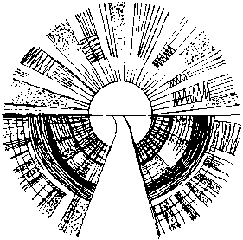
The Lord be with you, and with thy spirit.
Let us pray.
Lord have mercy upon us Christ, have mercy upon us.
Lord, have mercy upon us.

Our Father, which art in heaven, Hallowed be thy Name, Thy Kingdom come, Thy will be done, in earth as it is in heaven. Give us this day our daily bread; And forgive us our trespasses, As we forgive them that trespass against us; And lead us not into temptation, But deliver us from evil. Amen.

O Lord, shew thy mercy upon us.
And grant us thy salvation.
O Lord, save the Queen.
And mercifully hear us when we call upon thee.
Endue thy Ministers with righteousness.
And make thy chosen people joyful.
O Lord, save thy people.
And bless thine inheritance.
Give peace in our time, O Lord.
Because there is none other that fighteth for us but only thou, O God.
O God, make clean our hearts within us.
And take not thy Holy Spirit from us.

The Collect for the day
O God the King of glory, you have exalted your only Son Jesus Christ with great triumph to your kingdom in heaven: we beseech you, leave us not comfortless, but send your Holy Spirit to strengthen us and exalt us to the place where our Saviour Christ is gone before, who is alive and reigns with you, in the unity of the Holy Spirit, one God, now and for ever. Amen.
The Second Collect, for Peace
O God, who art the author of peace and lover of concord, in knowledge of whom standeth our eternal life, whose service is perfect freedom: defend us thy humble servants in all assaults of our enemies; that we, surely trusting in thy defence, may not fear the power of any adversaries, through the might of Jesus Christ our Lord. Amen.
The Third Collect, for Grace
O Lord our heavenly Father, almighty and everlasting God, who hast safely brought us to the beginning of this day: defend us in the same with thy mighty power; and grant that this day we fall into no sin neither run into any kind of danger, but that all our doings may be ordered by thy governance, to do always what is righteous in thy sight; through Jesus Christ our Lord. Amen.

Hymn
Jesus is worthy to receive
Honour and power divine;
And blessings, more than we can give,
Be, Lord, for ever thine.

Let all creation join in one
To bless the sacred name
Of him that sits upon the throne,
And to adore the Lamb.

Isaac Watts (1674-1748) (NEH349)

Come, let us join our cheerful songs
With angels round the throne;
Ten thousand thousand are their tongues
But all their joys are one.

‘Worthy the Lamb that died,’ they cry,
‘To be exalted thus;’
‘Worthy the Lamb,’ our lips reply,
‘For he was slain for us.’

Address
Helen Hamilton

Hymn
The joy of all who dwell above
the joy of all below
to whom he manifests his love
and grants his name to know

To them the cross, with all its shame
with all its grace is given
their name an everlasting name
their joy the joy of heaven

The head that once was crowned with thorns
is crowned with glory now
a royal diadem adorns
the mighty victor’s brow

The highest place that heaven affords
is his, is his by right
the King of kings and Lord of lords
He reigns in perfect light

The cross he bore is life and health
though shame and death to him
His people’s hope, his people’s wealth
their everlasting theme
Thomas Kelly (1769-1855) (NEH134)

Prayers of intercession
Lord, in your mercy,
hear our prayer.

... Merciful Father, accept these prayers for the sake of thy Son,
our Saviour Jesus Christ. Amen.
Hymn
His kingdom cannot fail,
He rules o’er earth and heaven;
The keys of death and hell
Are to our Jesus given:

He sits at God’s right hand,
Till all his foes submit,
And bow to his command,
And fall beneath his feet:

Charles Wesley (1707-88) (NEH443)

Rejoice, the Lord is King!
Your Lord and King adore;
Mortals, give thanks and sing,
And triumph evermore:

Lift up your heart, lift up your voice;
Rejoice, again I say, rejoice.

Jesus, the Saviour, reigns,
The God of truth and love;
When he had purged our stains,
He took his seat above:

The Blessing
God the Father, by whose love Christ was raised from the dead, open to we who believe the gates of everlasting life. God the Son, who in bursting the grave has won a glorious victory, give us joy as we share the Easter faith. God the Holy Spirit, who filled the disciples with the life of the risen Lord, empower us and fill us with Christ’s peace. And the blessing of God almighty, the Father, the Son and the Holy Spirit, be among us and remain with us, now and always. Amen.

Free refreshments are served in the Lady Chapel.
Please do join us!

To make an anonymous offertory donation to church,
please scan the QR below.
Thank you.

