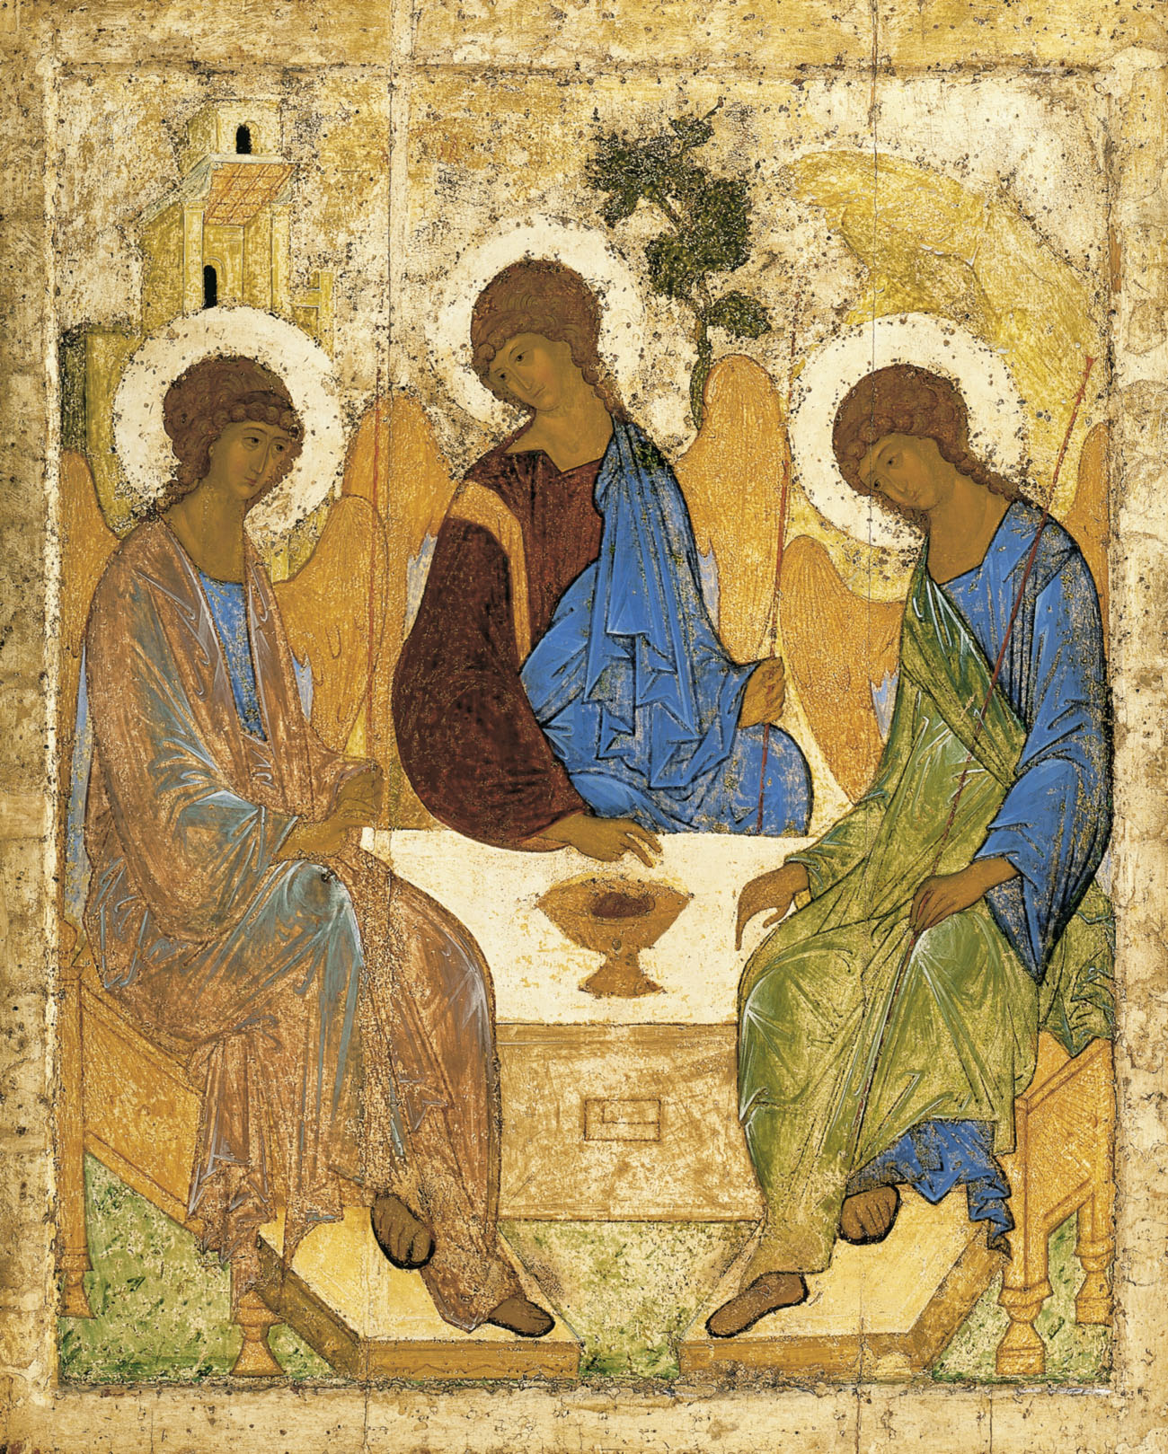
Holy Communion
Trinity Parish Church, Jersey
Presentation of Christ in the Temple
30th January, 2022

Welcome and Preparation

The Lord be with you.
All And also with you.

As we rejoice in the gift of this new day, so may the light of your presence, O God, set our hearts on fire with love for you.; now and for ever.
All Amen.

Processional Hymn

Fling wide the gates, unbar the ancient doors;
salute your king in his triumphant cause!

Now all the world belongs to Christ our Lord:
let all creation greet the living Word!

Who has the right to worship him today?
All those who gladly serve him and obey.

He comes to save all those who trust his name,
and will declare them free from guilt and shame.

Who is the victor glorious from the fight?
He is our king, our life, our Lord, our right!

Michael Perry (1942-1996) (SP11)
Based on Psalm 24 (A Song of the King’s Glory)

Prayer of Preparation

All Almighty God, unto whom all hearts be open, all desires known, and from who no secret are hidden: cleanse the thoughts of our hearts by the inspiration of your Holy Spirit, that we may perfectly love you, and worthily magnify your holy name; through Christ our Lord. Amen.

A Time of Confession

Jesus says, ‘I am the light of the world. Those who follow me shall not walk in darkness, but will have the light of life.’ Therefore in the light of Christ let us confess our sins.

All Most merciful God, Father of our Lord Jesus Christ, we confess that we have sinned in thought, word and deed. We have not loved you with our whole heart. We have not loved our neighbours as ourselves. In your mercy forgive what we have been, help us to amend what we are, and direct what we shall be; that we may do justly, love mercy, and walk humbly with you our God. Amen.
All sing
Lord have mercy, Lord have mercy, Lord have mercy.
Christ have mercy, Christ have mercy, Christ have mercy.
Lord have mercy, Lord have mercy, Lord have mercy.

May the God of love and power forgive you and free you from your sins, heal and strengthen you by his Spirit, and raise you to new life in Christ our Lord.
All Amen.

The Gloria

Please stand
Glory be to God on high, and in earth peace, good will towards men. We praise thee, we bless thee, we worship thee, we glorify thee, we give thanks to thee for thy great glory, O Lord God, heavenly King, God the Father almighty. O Lord, the only-begotten Son, Jesus Christ; O Lord God, Lamb of God, Son of the Father, that takest away the sins of the world, have mercy upon us. Thou that takest away the sins of the world, receive our prayer. Thou that sittest at the right hand of God the Father, have mercy upon us. For thou only art holy; thou only art the Lord; thou only, O Christ, with the Holy Ghost, art Most High, in the glory of God the Father. Amen.

The Collect

Almighty and ever-living God, clothed in majesty, whose beloved Son was at this time presented in the Temple, in substance of our flesh: grant that we may be presented to you with pure and clean hearts, by your Son Jesus Christ our Lord.
All Amen.

The Word of God

Malachi 3.1-5
See, I am sending my messenger to prepare the way before me, and the Lord whom you seek will suddenly come to his temple. The messenger of the covenant in whom you delight—indeed, he is coming, says the Lord of hosts. But who can endure the day of his coming, and who can stand when he appears?
For he is like a refiner’s fire and like fullers’ soap; he will sit as a refiner and purifier of silver, and he will purify the descendants of Levi and refine them like gold and silver, until they present offerings to the Lord in righteousness. Then the offering of Judah and Jerusalem will be pleasing to the Lord as in the days of old and as in former years.
Then I will draw near to you for judgement; I will be swift to bear witness against the sorcerers, against the adulterers, against those who swear falsely, against those who oppress the hired workers in their wages, the widow, and the orphan, against those who thrust aside the alien, and do not fear me, says the Lord of hosts.

This is the word of the Lord,
All Thanks be to God.

1 Corinthians 12:12-31a
For just as the body is one and has many members, and all the members of the body, though many, are one body, so it is with Christ. For in the one Spirit we were all baptized into one body—Jews or Greeks, slaves or free—and we were all made to drink of one Spirit.
Indeed, the body does not consist of one member but of many. If the foot were to say, ‘Because I am not a hand, I do not belong to the body’, that would not make it any less a part of the body. And if the ear were to say, ‘Because I am not an eye, I do not belong to the body’, that would not make it any less a part of the body. If the whole body were an eye, where would the hearing be? If the whole body were hearing, where would the sense of smell be? But as it is, God arranged the members in the body, each one of them, as he chose. If all were a single member, where would the body be? As it is, there are many members, yet one body. The eye cannot say to the hand, ‘I have no need of you’, nor again the head to the feet, ‘I have no need of you.’ On the contrary, the members of the body that seem to be weaker are indispensable, and those members of the body that we think less honourable we clothe with greater honour, and our less respectable members are treated with greater respect; whereas our more respectable members do not need this. But God has so arranged the body, giving the greater honour to the inferior member, that there may be no dissension within the body, but the members may have the same care for one another. If one member suffers, all suffer together with it; if one member is honoured, all rejoice together with it.
Now you are the body of Christ and individually members of it. And God has appointed in the church first apostles, second prophets, third teachers; then deeds of power, then gifts of healing, forms of assistance, forms of leadership, various kinds of tongues. Are all apostles? Are all prophets? Are all teachers? Do all work miracles? Do all possess gifts of healing? Do all speak in tongues? Do all interpret? But strive for the greater gifts. And I will show you a still more excellent way.

This is the word of the Lord,
All Thanks be to God.

Hymn
Be still, for the presence of the Lord,
the Holy One, is here;
come bow before Him now
with reverence and fear:
in him no sin is found -
we stand on holy ground.
Be still, for the presence of the Lord,
the Holy One, is here.

Be still, for the glory of the Lord
is shining all around;
He burns with holy fire,
with splendour he is crowned:
how awesome is the sight -
our radiant King of light!
Be still, for the glory of the Lord
is shining all around.

Be still, for the power of the Lord
is moving in this place:
He comes to cleanse and heal,
to minister his grace -
no work too hard for him.
In faith receive from him.
Be still, for the power of the Lord
is moving in this place.

David J Evans (b.1957) (SP173)

Gospel Reading

Hear the Gospel of our Lord Jesus Christ according to Luke;
All Glory to you O Lord.

Luke 2. 22-40
When the time came for their purification according to the law of Moses, they brought him up to Jerusalem to present him to the Lord (as it is written in the law of the Lord, ‘Every firstborn male shall be designated as holy to the Lord’), and they offered a sacrifice according to what is stated in the law of the Lord, ‘a pair of turtle-doves or two young pigeons.’
Now there was a man in Jerusalem whose name was Simeon; this man was righteous and devout, looking forward to the consolation of Israel, and the Holy Spirit rested on him. It had been revealed to him by the Holy Spirit that he would not see death before he had seen the Lord’s Messiah. Guided by the Spirit, Simeon came into the temple; and when the parents brought in the child Jesus, to do for him what was customary under the law, Simeon took him in his arms and praised God, saying, ‘Master, now you are dismissing your servant in peace, according to your word; for my eyes have seen your salvation, which you have prepared in the presence of all peoples, a light for revelation to the Gentiles and for glory to your people Israel.’
And the child’s father and mother were amazed at what was being said about him. Then Simeon blessed them and said to his mother Mary, ‘This child is destined for the falling and the rising of many in Israel, and to be a sign that will be opposed so that the inner thoughts of many will be revealed—and a sword will pierce your own soul too.’
There was also a prophet, Anna the daughter of Phanuel, of the tribe of Asher. She was of a great age, having lived with her husband for seven years after her marriage, then as a widow to the age of eighty-four. She never left the temple but worshipped there with fasting and prayer night and day. At that moment she came, and began to praise God and to speak about the child to all who were looking for the redemption of Jerusalem.
When they had finished everything required by the law of the Lord, they returned to Galilee, to their own town of Nazareth. The child grew and became strong, filled with wisdom; and the favour of God was upon him.

This is the Gospel of the Lord,
All Praise to you, O Christ.

Reflections – Angela Le Sueur

Let us declare our faith in God.

We believe,
All We believe in one God,
the Father, the Almighty,
maker of heaven and earth,
of all that is,
seen and unseen.
We believe in one Lord, Jesus Christ,
the only Son of God,
eternally begotten of the Father,
God from God, Light from Light,
true God from true God,
begotten, not made,
of one Being with the Father;
through him all things were made.
For us and for our salvation he came down from heaven,
was incarnate from the Holy Spirit and the Virgin Mary
and was made man.
For our sake he was crucified under Pontius Pilate;
he suffered death and was buried.
On the third day he rose again
in accordance with the Scriptures;
he ascended into heaven
and is seated at the right hand of the Father.
He will come again in glory to judge the living and the dead,
and his kingdom will have no end.
We believe in the Holy Spirit,
the Lord, the giver of life,
who proceeds from the Father and the Son,
who with the Father and the Son is worshipped and glorified,
who has spoken through the prophets.
We believe in one holy catholic and apostolic Church.
We acknowledge one baptism for the forgiveness of sins.
We look for the resurrection of the dead,
and the life of the world to come. Amen.

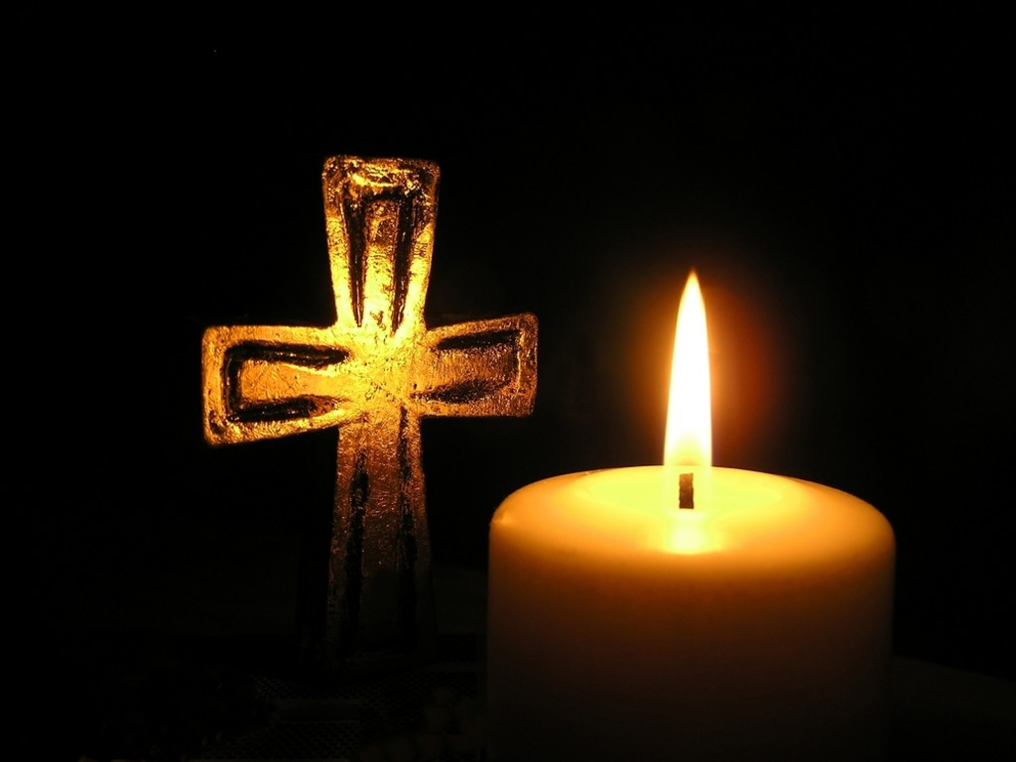
Prayers of Intercession

The response is:
Lord, in your mercy:
All hear our prayer.

Merciful Father,
All accept these prayers for the sake of your Son, our Saviour Jesus Christ.
Amen.

The Peace

In the tender mercy of our God, the dayspring from on high shall break upon us,
to give light to those who dwell in darkness and in the shadow of death, and to
guide our feet into the way of peace.
All And also with you.

Offertory Hymn

There is a collection plate near the door for after the service. You can also give electronically by scanning the QR on the back of this service sheet. Thank you.

Lead us, heavenly Father, lead us
o’er the world’s tempestuous sea;
guard us, guide us, keep us, feed us,
for we have no help but thee;
yet possessing every blessing,
if our God our Father be.

Saviour, breathe forgiveness o’er us:
all our weakness thou dost know;
thou didst tread this earth before us,
thou didst feel its keenest woe;
self denying, death defying,
thou to Calvary didst go.

Spirit of our God, descending,
fill our hearts with heavenly joy,
love with every passion blending,
pleasure that can never cloy:
thus provided, pardoned, guided,
nothing can our peace destroy.
James Edmeston 1791-1867 (NEH393)

Preparation of the Table

Blessed are you, Lord God of all creation; through your goodness we have this bread to set before you, which earth has given and human hands have made. It will become for us the bread of life.
All Blessed be God forever.

Blessed are you, Lord God of all creation; through your goodness we have this wine to set before you, fruit of the vine and work of human hands.
It will become for us the cup of salvation.
All Blessed be God forever.

Prayer of Consecration

The Lord is here.
All His Spirit is with us.
Lift up your hearts.
All We lift them to the Lord.
Let us give thanks to the Lord our God.
All It is right to give thanks and praise.

Blessed are you Lord God, our light and our salvation; to you be glory and praise for ever. From the beginning you have created all things and all your works echo the silent music of your praise. In the fullness of time you made us in your image, the crown of all creation.

You give us breath and speech, that with angels and archangels and all the powers of heaven we may find a voice to sing your praise:
All Holy, holy, holy, Lord God of hosts,
Heaven and earth are full of thy glory.
Glory be to thee, O Lord most high.
Blessed is he that cometh in the name of the Lord (repeated).
Hosanna in the highest, Hosanna in the highest, Hosanna,
Hosanna in the Highest.

How wonderful the work of your hands, O Lord. As a mother tenderly gathers her children, you embraced a people as your own. When they turned away and rebelled your love remained steadfast. From them you raised up Jesus our Saviour, born of Mary, to be the living bread, in whom all our hungers are satisfied. He offered his life for sinners, and with a love stronger than death he opened wide his arms on the cross.

On the night before he died, he came to supper with his friends and, taking bread, he gave you thanks. He broke it and gave it to them, saying: Take eat;
this is my body, which is given for you; do this in remembrance of me.

At the end of supper, taking the cup of wine, he gave you thanks, and said: Drink this, all of you; this is my blood of the new covenant, which is shed for you and for many for the forgiveness of sins. Do this, as often as you drink it, in remembrance of me.

Great is the mystery of faith:
All Christ has died, Christ is risen, Christ will come again.

Father, we plead with confidence his sacrifice made once for all upon the cross; we remember his dying and rising in glory, and we rejoice that he intercedes for us at your right hand.

Pour out your Holy Spirit as we bring before you these gifts of your creation; may they be for us the body and blood of your dear Son. As we eat and drink these holy things in your presence, form us in the likeness of Christ, and build us into a living temple to your glory.

Bring us at the last with all the saints to the vision of that eternal splendour for which you have created us; through Jesus Christ, our Lord, by whom, with whom and in whom, with all who stand before you in earth and heaven, we worship you, Father almighty, in songs of everlasting praise, singing:
All Blessing and honour and glory and power be yours for ever and ever. Amen.

Let us pray with confidence as our Saviour has taught us:
All Our Father; who art in heaven, hallowed be thy name; thy kingdom come;
thy will be done; on earth as it is in heaven. Give us this day our daily bread. And forgive us our trespasses, as we forgive those who trespass against us. And lead us not into temptation; but deliver us from evil.
For thine is the kingdom, the power and the glory, for ever and ever. Amen.

We break this bread to share in the body of Christ.
All Though we are many, we are one body, because we all share in one bread.

All O Lamb of God, that takest away the sins of the world, have mercy upon us.
O Lamb of God, that takest away the sins of the world, have mercy upon us.
O Lamb of God, that takest away the sins of the world, grant us thy peace,
Grant us thy peace.

Jesus is the Lamb of God who takes away the sin of the world.
Blessed are those who are called to his supper:
All Lord, I am not worthy to receive you, but only say the word, and I shall
be healed.

The Communion
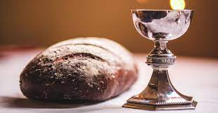

Please come forward to receive bread or a blessing.

Prayer after Communion

Lord, you fulfilled the hope of Simeon and Anna, who lived to welcome the Messiah: may we, who have received these gifts beyond words, prepare to meet Christ Jesus when he comes to bring eternal; life; through Jesus Christ our Lord.
All Amen.

All Father of all, we give you thanks and praise, that when we were still far
off you met us in your Son and brought us home. Dying and living, he declared your love, gave us grace, and opened the gate of glory. May we who share Christ’s body live his risen life; we who drink his cup bring life to others; we whom the Spirit lights give light to the world. Keep us firm in the hope you have set before us, so we and all your children shall be free, and the whole earth live to praise your name; through Christ our Lord. Amen.

Hymn
Praise to the Holiest in the height,
And in the depth be praise,
In all his words most wonderful,
Most sure in all His ways.

O loving wisdom of our God!
When all was sin and shame,
A second Adam to the fight
And to the rescue came.

O generous love! That he who smote
In Man for man the foe,
The double agony in Man
For man should undergo;

And in the garden secretly,
And on the cross on high,
Should teach his brethren and inspire
To suffer and to die.

Praise to the Holiest in the height,
And in the depth be praise,
In all his words most wonderful,
Most sure in all his ways.

J.H. Newman (1801-90) (NEH439)

The Blessing

Christ the Son of God, born of Mary, fill you with his grace to trust his promises and obey his will; and the blessing of God almighty, the Father, the Son and the Holy Spirit, be amongst you and remain with you always.

Go in the light and peace of Christ.
All Thanks be to God. Amen.

Refreshments are served for all in the Lady Chapel

To make an offertory donation to church,
please scan the QR below.
Thank you.

