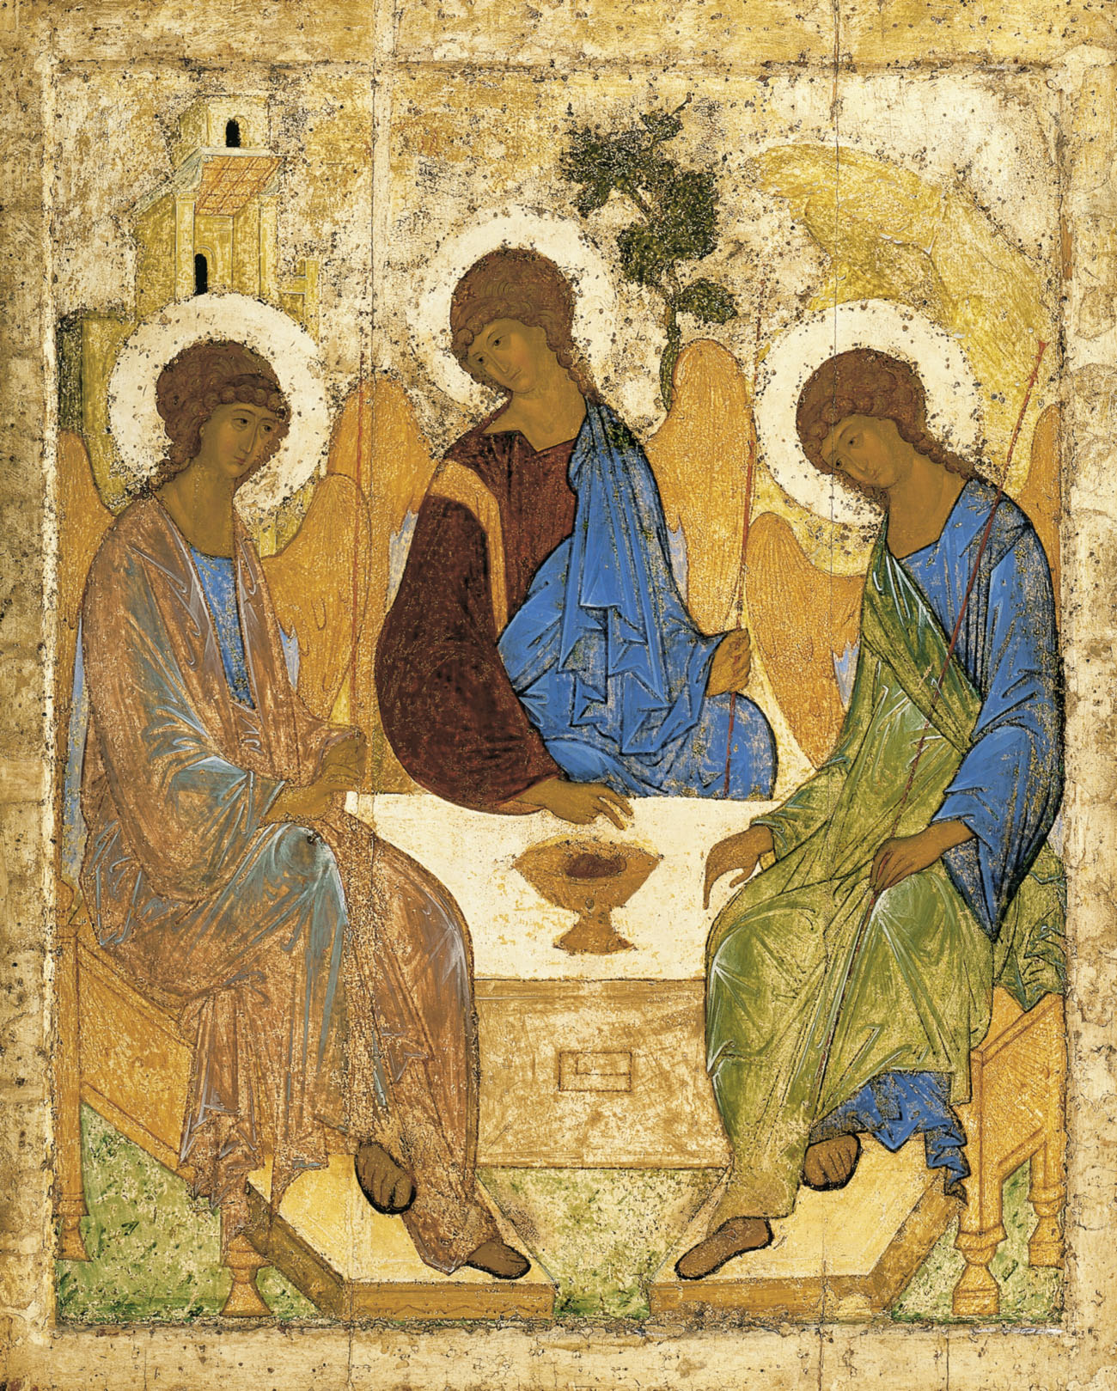

Holy Trinity Church, Jersey
Written Reports for the Annual General Meeting

Sunday 28th April, 2019

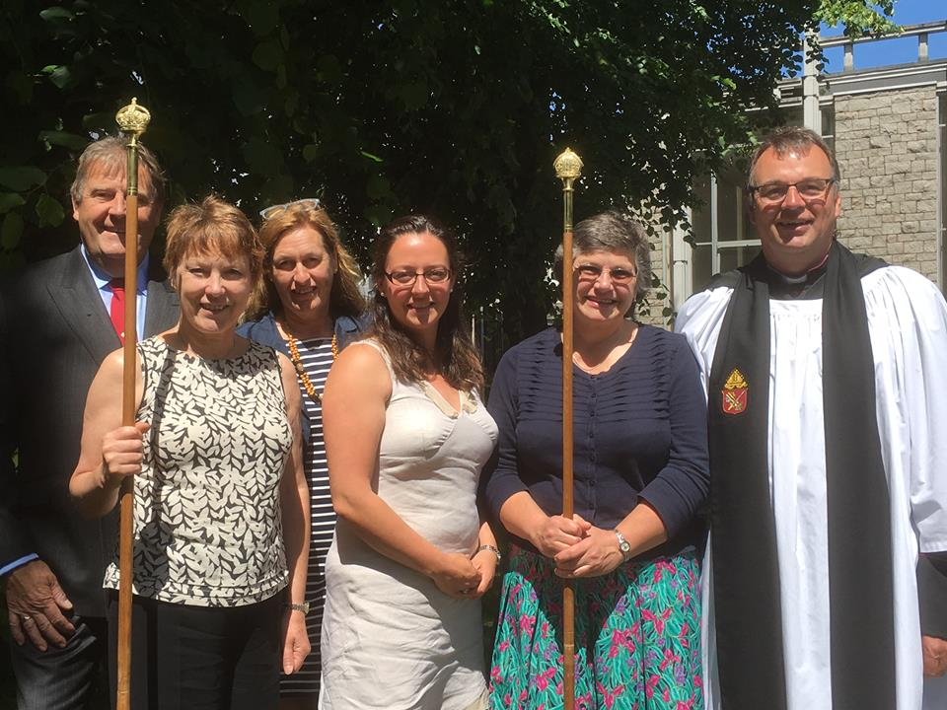
In recent years the Annual General Meeting of our Church has taken place immediately following the 11 am service, increasing the number of those able to attend, but bringing a time pressure to the agenda as people have needed to engage in the rest of their day. The purpose of this leaflet is to give you the opportunity to read and consider reports on the life of your church at your leisure.
The Rector and the Treasurer will give their reports in person to the meeting on Sunday 28th April. Copies of the accounts will also be available and thereafter online.

The Rector – Canon Geoff Houghton
Suffice it to say that for the Rectory family, these last twelve months have been the very worst of times. A cancer diagnosis for our son, Ben, and his death just before Christmas, were a heavy blow. However, Fran, Rebecca and I have been deeply moved by the immeasurable kindness and support of all across the congregation. Your friendship, care and patience have so eased the continuing journey. We thank you from the bottom of our hearts.
Fran and I are acutely aware that even within this congregation we are far from alone in experiencing the loss of a child, of whatever age, and just as you have prayed for us, so our prayers have been for you. Our lives have been changed for ever, and we acknowledge that those who have travelled closely with us have been touched and changed too, and bonds of Christian love have deepened and strengthened.
I would particularly like to thank Sue Le Gallais, Aynslie Le Brun and Liz De Gruchy for their tireless work, but acknowledge that they too were ‘standing on the shoulders of giants’. My gratitude also goes to the Reverends Robin Dupre and Peter Dyson amongst others who have led worship in my absence, and to our remarkable and inspiring Lay Readers, Helen Hamilton, Fleur Benest and Angela Le Sueur. The latter have had something of a baptism of fire, but I have returned to work to find they have truly flourished through the challenge.

Last year we embraced the concept of working with a Mission Action Plan that had three key elements: Knowing what makes us distinct, doing our core activity well, and actively looking to our future membership. I am deeply encouraged that despite my own adversity, our church community has attended to and made progress on each of these fronts. The quality of the preaching in this place continues to improve and we are both challenged and encouraged by the grace and understanding of the Gospels presented to us, giving us every opportunity to take these often counter cultural gospel values and priorities into our wider lives. Our core activity of worship continues to flourish and new opportunities for learning were offered in study groups for young and old in the seasons of Advent and Lent. The third commitment that we made, regarding looking to our future membership, took the most tangible form, with the employment of Liz De Gruchy to head up our families and children’s work from the beginning of last June.
Liz’s report (cf below) is remarkably understated. The trajectory of the work Liz is leading is tremendously encouraging, she is building a strong team around herself, making excellent contacts in the local school and nurseries, and her network of families grows ever larger. The fruits of this work is straightway evident to those who attend the 09.30 events, and most notably in the formation of a new congregation on the first Sunday of the month for the All Age Family Service that has been started. The networking in the community also led to two popular occasions when as church we offered afternoon tea in the sunshine at Maison Cabot.
The challenge to us as a congregation is to not rest on our laurels but to further invest in this work (£7,500 buys a day a week per annum), and to keep the momentum going forward.

I am very grateful to the Wardens and Parish for their working through of various building maintenance issues and our church looks splendid. In early January it was evident that we needed all the practical space we could muster for Ben’s funeral. The Dean gave a licence for the temporary removal of the pulpit. Such licences are valid for six months, and together with the churchwardens it was decided to use these months to consider how the space in the crossing works and feels without the pulpit in place, and to take soundings from the congregation. Five written responses have been passed to me to date with an even spread of opinion. A view that has also been shared by a number of people is that the newel post of the pulpit steps is missed as a hand hold for going up and down the chancel step. Inevitably, some feel more motivated than others to share their view, however the Wardens and I would very much like to hear from you. The consultation continues until early June when the pulpit will be reinstated, which will inevitably further stimulate the continuing conversation.
My thanks again for your extraordinary support over this last year, and for the part of each and everyone in making this community such a joy and privilege to serve.
Geoff.

Churchwarden’s Report
Your Churchwardens welcome this opportunity to extend their grateful thanks to everyone who has contributed to the life and work of Trinity Church in the past year.
Our thanks go to:
- Our Readers. Fleur and Angela were licensed by Bishop Trevor in June 2018 and, with Helen, have enhanced our worship with their sermons, leading of services and study group sessions, and their contributions to Children’s Ministry;
- Nick and the choir who continue to sing so beautifully every Sunday, as well as at weddings and funerals;
- Liz – now formally employed by the Church as Families and Children Co-ordinator - and her Children’s Ministry team: as a result of their vision, energy and dedication many families with young children have joined our church community and are discovering a fresh and exciting opportunity to grow in faith;
- The Reverend Robin Dupre for his ministry while the Rector was on sabbatical leave, and his continuing ministry through December and January;
- the Dean, the Very Reverend Mike Keirle, Reverend Peter Dyson and other clergy who have led worship at Trinity in the past year;
- our Connétable, Philip Le Sueur, for his continuing commitment to the Parish Church. With financial assistance from the Ratepayers it was possible to renovate the Parish War Memorial at the Lychgate, including the re-setting of the granite cobbles, in time for the 100th anniversary of the end of the Great War; hand rails have been installed at the steps of the West Door, and new lights have been fitted in the Nave and Choir Gallery. We also acknowledge the work done for the church by Nicky and Dawn in the Parish Hall office, and the work of the Parish foremen;
- Andrew for all the work he puts in preparing the Church accounts month by month;
- Sharon, Anna and, more recently Liz, who look after the church administration work.
The church doors are open to welcome congregation, friends and visitors every day of the year. Our thanks go to the many people who make this possible – to Beth who prepares the rotas for welcomers, readers, servers and intercessors, and to those who volunteer to do these duties at each service; to Eileen and Doreen who plan the flowers rotas, and to those who arrange, and water, flowers each week, and for the liturgical festivals; to Maite who cleans the church and Maggie who helps to clean the silver, and many others who quietly give of their time, talents and resources to ensure that all runs smoothly.
We are delighted to have Geoff and Fran back amongst us, their dedication to the church and the community enriches all our lives, and for that we thank them, and we give thanks to God.
In a year when we have all been touched by the tragedy of Ben’s untimely death, our heartfelt thanks go to you, the congregation, for your steadfast support of the Rectory family, the leadership team, and of one another through a time of great anxiety and sadness.
May God continue to bless our work.
Aynslie and Sue

Deanery Synod – Aynslie Le Brun
It has been a relatively quiet year on Deanery Synod. The main matter is that the Archbishop’s Commission chaired by Richard Chartres, former Bishop of London, will be visiting the Island in the middle of May and we have been invited to see them on Saturday 18th May. The purpose of the Commission is to determine the Channel Islands’ future relationship with the Church of England.
The Deanery continues to consider the best use of St Simon’s church. This is proving difficult due to planning restrictions and the condition of the building.
Work continues on updating the Canon Law, initially with respect to women bishops. This is particularly pressing with the retirement of Bishop Trevor, although he continues to have responsibility for the Channel Islands until the Archbishop’s Commission reports and its recommendations are implemented.
The Deanery, with the help of Andrew Le Brun has registered as a charity and has also updated its privacy notices in line with the requirements of GDPR.
The Deanery accounts showed a small deficit (as budgeted) for 2018. We are currently funding Giles Bartleman as curate at St Mark’s and will re-coup this funding when he has completed his training, when it is intended that Guernsey will take on a curate.
Safeguarding training is ongoing with most relevant church leaders completing their C1 and C2 training.
The Dean is planning his visitations to the parishes. He plans to visit 6 churches each year.
We currently have a vacancy at St Martin and Rev Mike Lange-Smith retires at the end of this month from Grouville, and the Dean has had to take responsibility for St Helier.
David Smith, the Deanery Executive Secretary, intends to retire in September and Steve Wilderspin, our Finance Committee Chairman, is hoping to stand down in the summer.

Readers’ Report – Fleur Benest
Helen, Angela and I would like to express our sense that it is a joy and a privilege to serve at Trinity Church. We all value the generous support and feedback with which the congregation responds to our efforts. I, as the newcomer to the team, am particularly thankful for the help, guidance and encouragement I receive from Angela and Helen.
Sometimes people from other churches say to me that Trinity is lucky to have three Readers, as though we had somehow eaten all the pies. I tell them it is not down to luck. Trinity has three Readers because Geoff has inspired and supported us.
Two highlights from the past year stand out for me and Angela. One was our glorious service of Licensing by Bishop Trevor, which was held at this church on June 9th, 2018. The main event was preceded by a sumptuous tea, organised by Sue, which catered for all the well-wishers, family and friends, including Helen, who joined us in our celebration. Having been Licensed here, we were fortunate to have been invited to attend Canterbury Cathedral for the Licensing of our English fellow students. Angela and I had the honour of addressing the congregation of the Cathedral during the service on September 16th, not something either of us had ever imagined doing.
Since then we have been working as part of the whole Trinity team, which we love to do.

Study Group and Taizé Services – Angela Le Sueur
Our thanks go to Helen for leading our Lent Study this year. This was taken from the ‘pilgrim’ series of Church of England material, discussing The Beatitudes. This has been very good, especially as it tied into the daily Lent book. All who attended have enjoyed the course, and we will be looking to use further material from the Pilgrim series at future sessions, so keep an eye open for the dates!
Some of you will have experienced one of the Taizé services I have led through the year, and, on Good Friday, we used Taizé music to help lead us through the Stations of the Cross.
Taizé is simply the name of a town in France. In 1940, a man known as Brother Roger founded a small community of Christians in Taizé. During this war torn era of France, Brother Roger sought to create a community of healing and refuge. The Taizé community, then, was born out of a vision to create a space for people to find God in the midst of brokenness. Hence, the name of the church in Taizé is the “Church of Reconciliation.”
I have led three Taizé services in the Lady Chapel, and these will be ongoing, quarterly. Usually held on the first Monday of the month, they begin at 20.00 and last approximately an hour. Taizé worship is quiet, reflective and is deeply peaceful and joyful. It encourages us to pray with the heart, and to wait in contemplation. It is beautiful in its simplicity and depth. Primarily, it is a channel for meditative prayer using simple melodies. By using just a few words they help to express a basic reality of faith, they can be quickly grasped, as the words are sung over may times. Meditative singing thus becomes a way of listening to God. They are an invitation to the Holy Spirit to move among us, and our community, filling us with God’s light and peace.

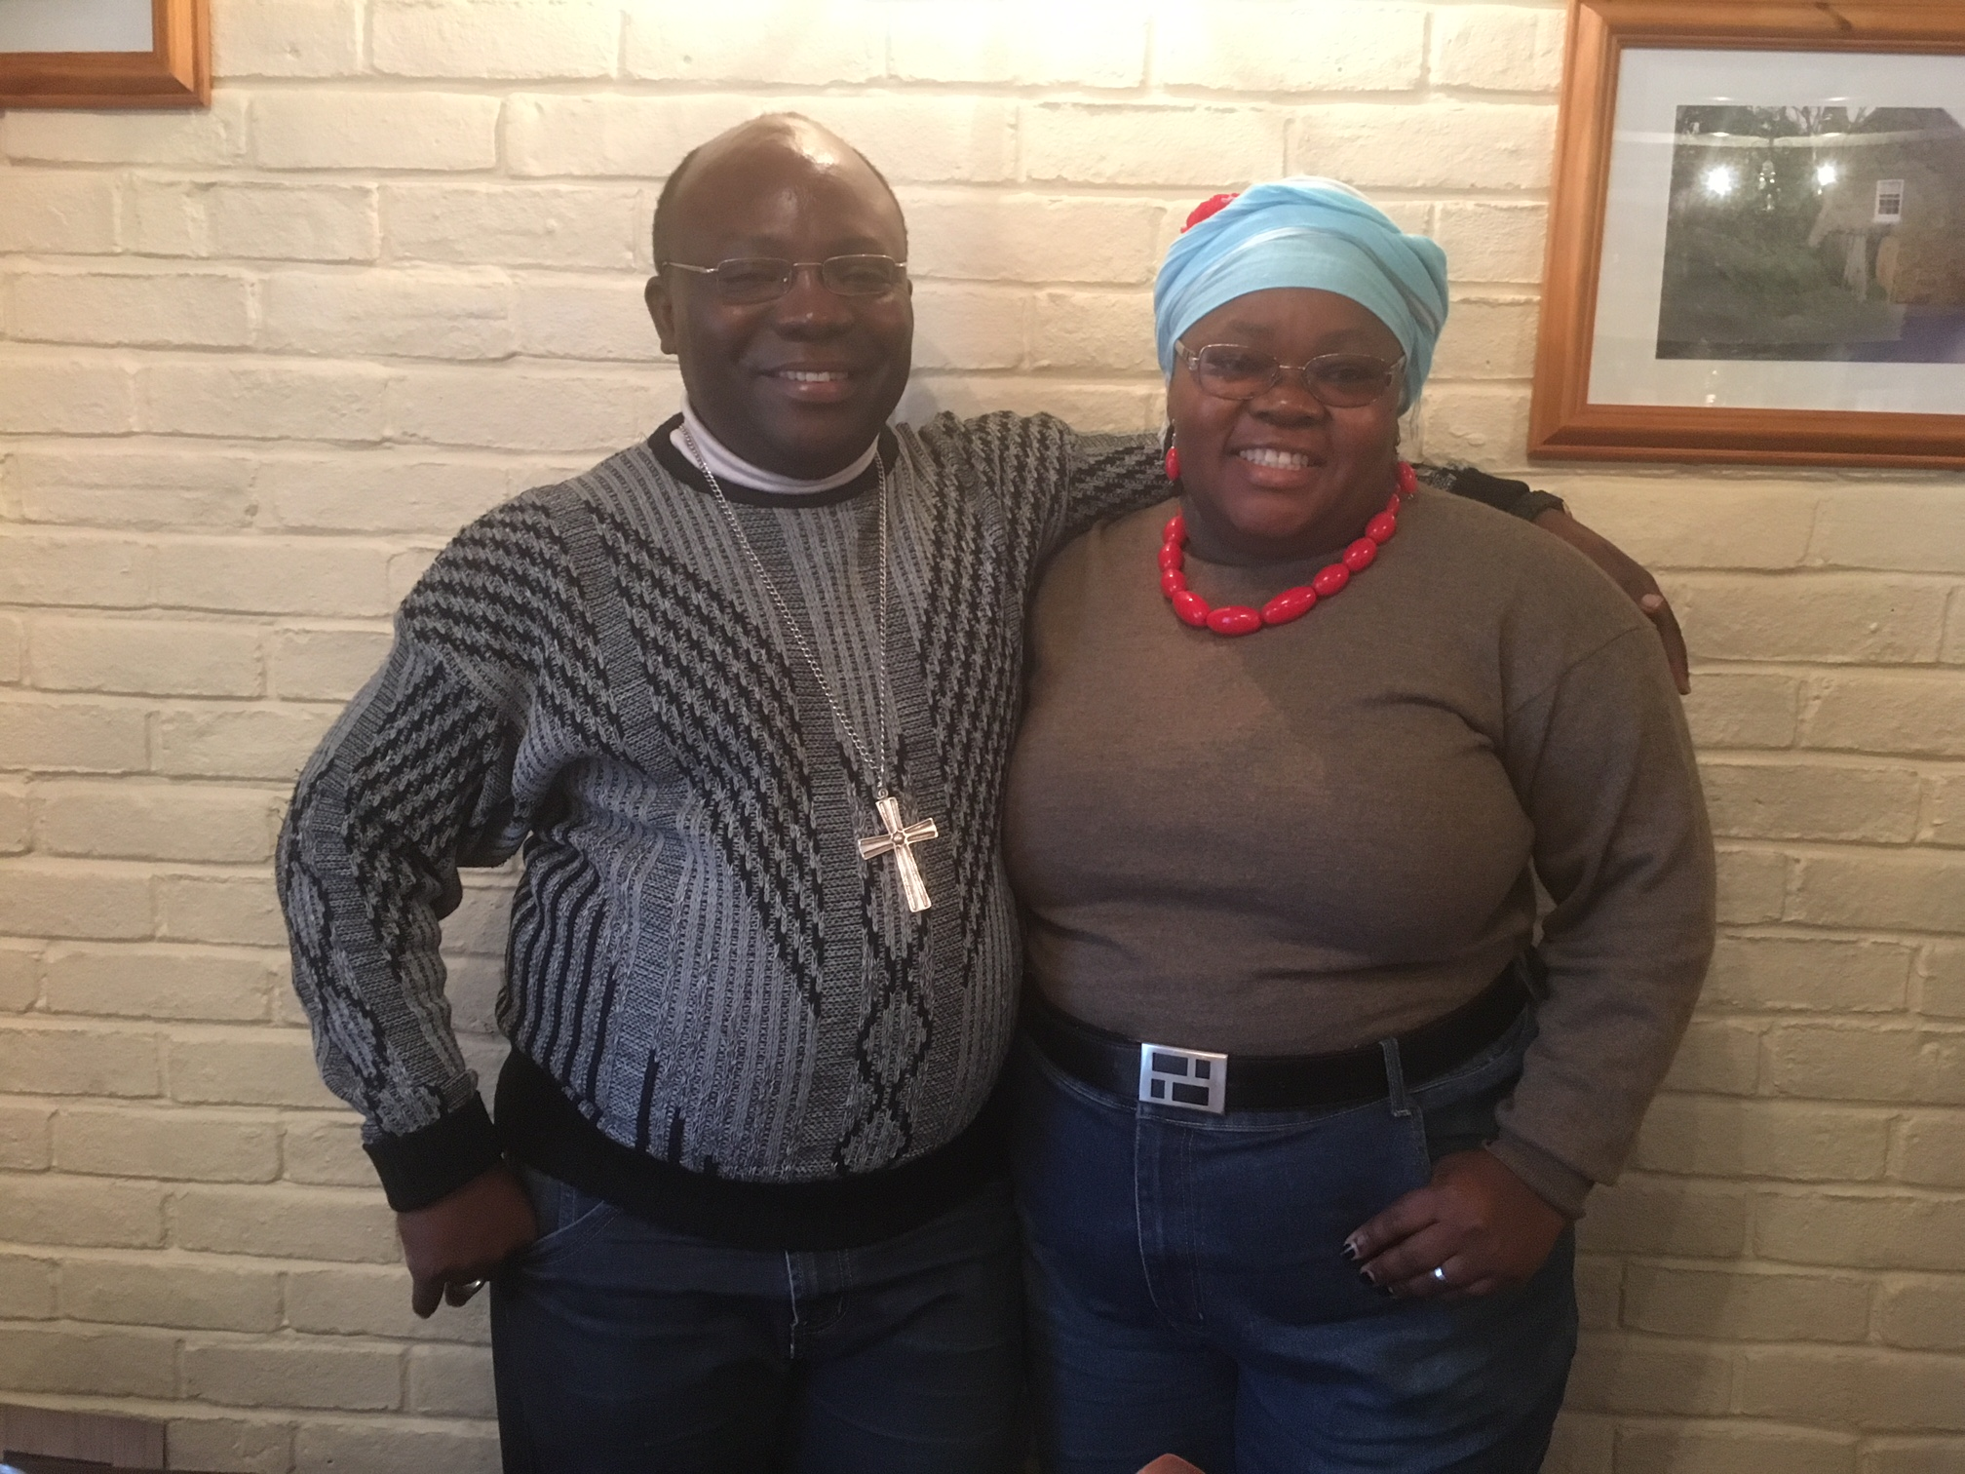
Church Link to the Anglican Church in Goma in the Democratic Republic of Congo – Janet Snart

Perhaps the best way to report on our Congo link is to share Bishop Desire’s recent correspondence with us:

Dear Canon Geoff,
Calvary greetings from the Anglican Goma diocese in the DRC. I am thrilled to hear the surprise and good news of Holy Trinity Church’s donation to my ministries through CMS Ireland that arrived to our account safely. As there was an urgent need for mission, this money was immediately withdrawn and used as follows:
1. $700 for half advance payment where we got 3 pieces of land in a rural area for a church project to set up school and church building for holistic mission. We will look for the remaining later and finish the debt to the owners. We pray that Jesus will enable us get this one by faith.
2. $60 buying of 3 sheetings to cover a school in a rural area where we have built a new school to help for Congo generation in education.
3. $ 40 transport for to Reverend involved to meet the land owners.
Total: $800.

I am heartedly thankful for your love and your good heart to investing in the Mission and to the Kingdom of God. Goma Diocese is now 28 months old and needs your prayers. But there is something to celebrate of what God is doing in our episcopal journey. He is marching daily with us and He has not abandoned us. I praise Him indeed and I value your increasing prayers towards us. Have a blessed ministry in Jesus' name.

Your loving brother from Africa,
Desire

Trinity Church Choir – Nick Cabot MBE
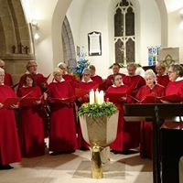
The choir has continued to support the main morning service throughout the past year as usual, providing music from many different centuries and of many different styles all to add to the worship which takes place here.
It has suffered more than usual from illness with four members, Pam and Marlene, Jennie and Doreen being seriously ill. John, due to his failing eye sight, has semi-retired from active duty but still helps us with the hymns, most of which he knows by heart. Ruth has retired from the sopranos due to a slowly worsening situation with her vocal chords – although we still hope that prolonged rest might effect a recovery.
We nevertheless, still have 26 members which is a very good number for a small Parish such as Trinity all of whom give up a large amount of time from their lives to support the funerals, weddings and services as necessary. May I take this opportunity to thank them, most sincerely, for their patience and forbearance in putting up with me for yet another year.

May I remind all that we are always open to members of the congregation (old or new) coming to join us – you will receive a warm welcome.

Children’s Ministry – Liz De Gruchy
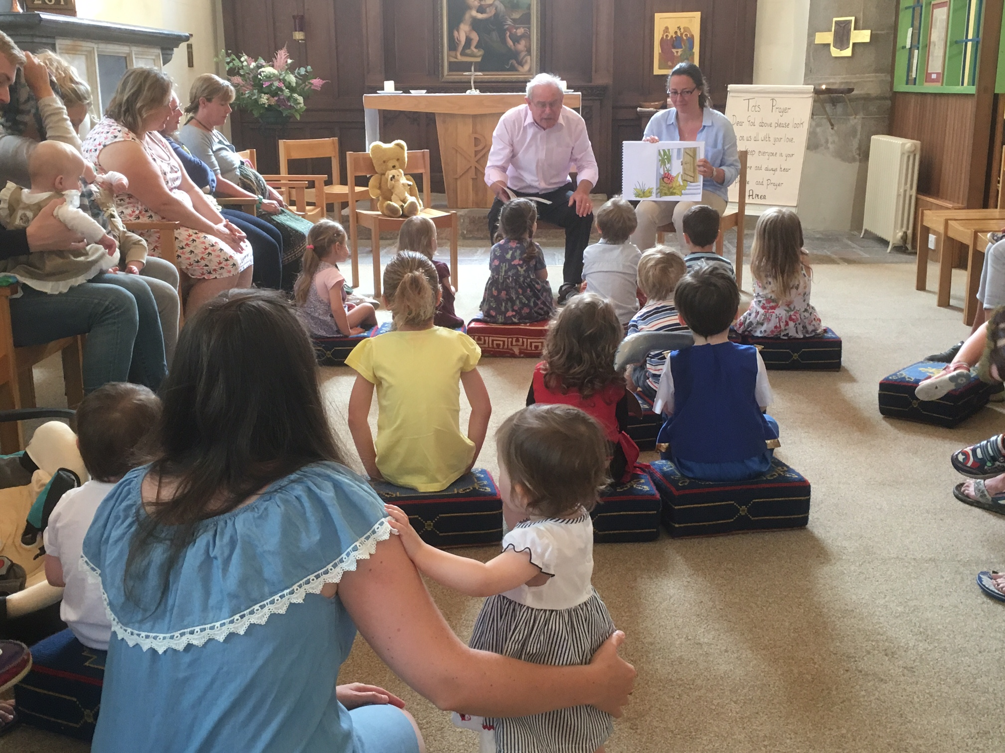
As you will have seen over the last year the Children’s work has and continues to grow steadily.

And not only within Church but in wider community too. I now go into Acorn Nursery and have contact time with some 20-30 pre school age children there. I also have contact with Trinity School Nursery and their Reception classes with some 40 children there. Both settings hear the key parts of our faith “love, care, nurture”, with these 3 points being reiterated each time by different stories and craft activities. The children remember the key points and have great delight in telling me what the story was last time I went in, which is only once every half term, so it clearly is memorable to them.

Since January I have been working very hard and closely with the Headteacher at Trinity Primary School to be able to work alongside the year 3’s to year 6’s children (7-10/11years old), helping with their Christian studies within their school curriculum. Looking at the different questions they are set and talking over them, helping the children answer the questions for themselves through group work, class discussions, and craft activities. At present I have contact once a school year (Spring Term) with these year groups but work is taking place to see if this can be increased.

As you will have seen through the different displays we have set up over the year and the different services and events that have and are taking place, the families and children’s work has really taken off. This is without mentioning the new “All Age Family Service” at 9:30 am on the first Sunday of each month. This began in February already regular attendance is circa 30. During the season of Lent we have been able to provide the older children with their own Lent Course looking at the Lord’s Prayer, and these youngster are seeing themselves as the nucleus of a new youth group!

One of the most popular events of the year is the traditional Sunday School Outing or Summer Treat, riding in the vintage lorries and enjoying a grand tea. Numbers were up for this event in 2018 and few can remember when last we needed so many lorries. Particular thanks to Winston Le Brun for organising the lorries and to Pam Warr for organising the tea.

I am hugely grateful to the wonderful team that works with me, there are brief reports from … Pam Warr (Parents and Tots) and Kath Hepworth (Junior Church) below.

Parents and Tots Service. Tots, Babies, Parents and Grandparents really enjoy their own special short service on the third Sunday every month in the Lady Chapel. The little ones fetch their own kneeler to sit on, then first listen to a Bible story with pictures, sometimes with puppets Gladys and Denzil. Then there's the special Tots' Prayer and a song with actions and dancing to the 'wiggle song'. Refreshments are enjoyed afterwards with biscuits made by parents. (PW)

Junior Church has developed a great deal over the last twelve months and the number of regular attendees continues to grow. As a team we plan ahead by looking at key events in the church calendar and then develop a scheme of work around themes that best suit the age and skill sets of the children. Activities include opportunities to discuss themes and are usually followed by a practical making session related to our discussions. Key events (Good Friday, Armistice, outdoor church and a Christmas Eve Nativity play) have been hugely successful and have been received positively as they merge the Tots and Junior church members as one large group. The growing of our church community at these events is noted by those who attend and the feedback received has been positive.
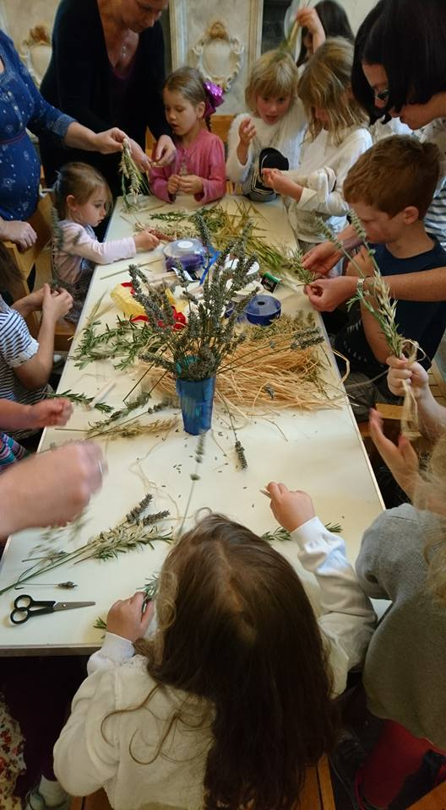
Our most recent project (a Lent Study Group) has enabled us to begin to establish a Youth Church of our oldest Junior church members. We have noted that as this work continues we are able to identify areas of particular interests to the members or indeed areas that require some more specific teaching or discussion points. (KH)

I personally would just like to say ‘thank you’ to everyone for your support in all the different ways you help out and embrace the children and make their parents and families feel so welcome here at Trinity.

Liz.

Safeguarding – Gill John
We are very fortunate to have such a diverse range of people who pass through the doors of our church or who receive ministry at home. The diversity also brings some vulnerabilities with it, particularly for the very young and not so young in our community. Ensuring their safety from harm and personal wellbeing lies at the heart of our safeguarding policies and procedures and we are guided in all things by the Diocesan Safeguarding Advisors and Rev Beverley Sproat our Deanery advisor. Those who work on behalf of the church with our more vulnerable groups are required to do regular training on the principles of safeguarding children and vulnerable adults. We are very conscious that time is precious for many of us and the thought of spending two or three hours at a course is not appealing, especially as many of us also do safeguarding training within health, education or voluntary work elsewhere. We are very grateful for all of those who give up their time to undergo this training which acts both as a safeguard for those we seek to protect, and, ultimately, us as a church.

Geoff and I remain the principle contacts for any concerns you might have about the wellbeing of anyone in our church community and are available for you to speak to about these matters via email or telephone. If you feel a matter is more urgent (e.g. immediate risk of harm) then please report incidents to the police or the safeguarding hub at Children’s Services.

