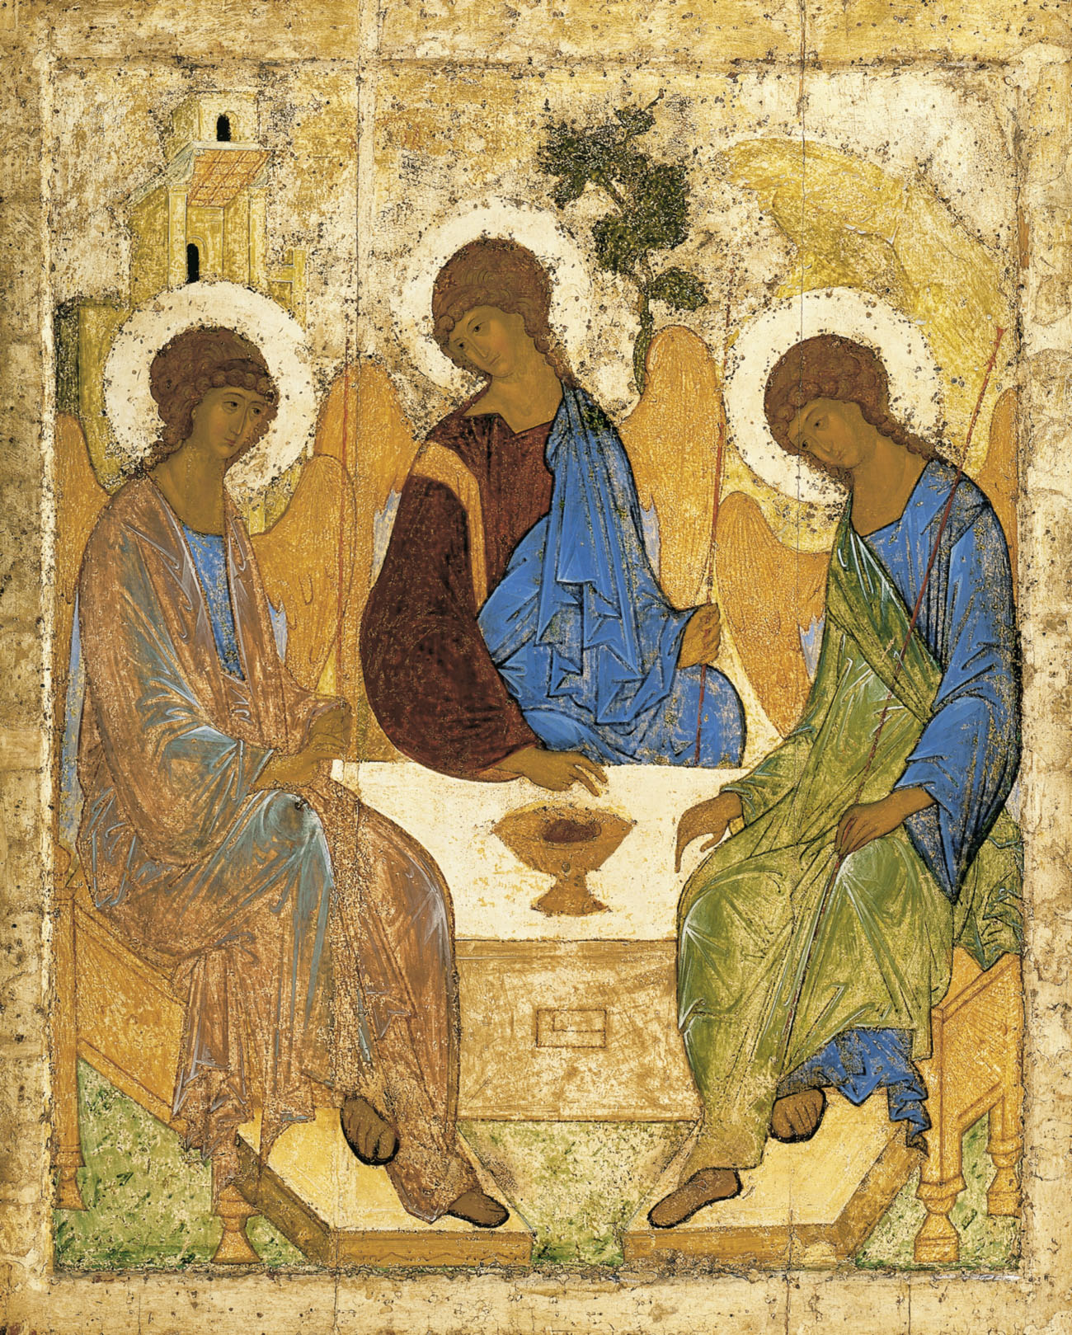
Morning Worship
from
Holy Trinity Church, Jersey

Fourth Sunday after Trinity. 27th June, 2021

Welcome and Preparation
The Lord of Glory be with you.
All The Lord bless you.

Heaviness may endure for a night:
All But joy comes in the morning.

God has been our refuge and our strength:
All A present help in time of trouble.

The night has passed, and the day lies open before us; let us pray with one heart and mind.

Silence is kept.

As we rejoice in the gift of this new day, so may the light of your presence, O God, set our hearts on fire with love for you.; now and for ever.
All Amen.

Hymn

Thine arm, O Lord, in days of old
was strong to heal and save;
it triumphed o’er disease and death,
o’er darkness and the grave:
to thee they went, the blind, the dumb,
the palsied and the lame,
the outcasts with their grievances,
the sick with fevered frame.

And lo, thy touch brought life and health,
gave speech and strength and sight;
and youth renewed and frenzy calmed
owned thee, the Lord of light:
and now, O Lord, be near to bless,
almighty as before,
in crowded street, by restless couch,
as by that ancient shore.

Be thou our great deliv’rer still,
thou Lord of life and death;
restore and quicken, soothe and bless,
with thine almighty breath:
to hands that work, and eyes that see,
give wisdom’s heav’nly lore,
that whole and sick, and weak and strong,
may praise thee evermore.

Edward Hayes Plumptre (1821-1891) (HON)

A Time of Confession

The sacrifice of God is a broken spirit, a broken and contrite heart God will not despise. Let us come to the Lord, who is full of compassion, and acknowledge our transgressions in penitence and faith.

We confess to you our selfishness and lack of love:
Lord, have mercy.
All Lord, have mercy.

We confess to you our fear and failure in sharing our faith:
Christ, have mercy.
All Christ, have mercy.

We confess to you our stubbornness and lack of trust:
Lord, have mercy.
All Lord, have mercy.

Almighty God, who forgives all who truly repent, have mercy upon you, pardon and deliver you from all your sins, confirm and strengthen you in all goodness, and keep you in life eternal; through Jesus Christ our Lord.
All Amen.

Thankfulness

Generous God, you gave us our voices, no two the same, no finer instruments with which to praise you.
All For these we thank you, Lord.

You gave us words and music, particular gifts with which we can wonder, or wound, bless or bore.
All For these we thank you, Lord.

And as your Church you have gathered us. In your community of common folk and complainers, prophets and puzzled people, you have made a place for us.
All For this we thank you, Lord.

So, let what we say and do, what we ponder and decide, be real for us and honest to you, and prepare us for the life of the world, in which you are also praised.
All Amen.

The Collect

O God, the protector of all who trust in you, without whom nothing is strong, nothing is holy: increase and multiply upon us your mercy; that with you as our ruler and guide we may so pass through things temporal that we lose not our hold on things eternal; grant this, heavenly Father, for our Lord Jesus Christ’s sake.
All Amen.

The Word of God

Psalm 130

Refrain: My soul waits for the Lord.

Out of the depths have I cried to you, O Lord;
Lord, hear my voice;
let your ears consider well the voice of my supplication.
If you, Lord, were to mark what is done amiss,
O Lord, who could stand?
But there is forgiveness with you,
so that you shall be feared.
Refrain: My soul waits for the Lord.

I wait for the Lord; my soul waits for him;
in his word is my hope.
My soul waits for the Lord,
more than the night watch for the morning,
more than the night watch for the morning.
Refrain: My soul waits for the Lord.

O Israel, wait for the Lord,
for with the Lord there is mercy;
With him is plenteous redemption
and he shall redeem Israel from all their sins.
Refrain: My soul waits for the Lord.

Father we commend to your faithful love those who are crying from the depths; help them to watch and pray through their times of darkness, in sure hope of the dawn of your forgiveness and redemption; through Jesus Christ our Lord.

All: Amen.

Mark 5.21-end
When Jesus had crossed again in the boat to the other side, a great crowd gathered round him; and he was by the lake. Then one of the leaders of the synagogue named Jairus came and, when he saw him, fell at his feet and begged him repeatedly, ‘My little daughter is at the point of death. Come and lay your hands on her, so that she may be made well, and live.’ So he went with him.
And a large crowd followed him and pressed in on him. Now there was a woman who had been suffering from haemorrhages for twelve years. She had endured much under many physicians, and had spent all that she had; and she was no better, but rather grew worse. She had heard about Jesus, and came up behind him in the crowd and touched his cloak, for she said, ‘If I but touch his clothes, I will be made well.’ Immediately her haemorrhage stopped; and she felt in her body that she was healed of her disease. Immediately aware that power had gone forth from him, Jesus turned about in the crowd and said, ‘Who touched my clothes?’ And his disciples said to him, ‘You see the crowd pressing in on you; how can you say, “Who touched me?” ’ He looked all round to see who had done it.But the woman, knowing what had happened to her, came in fear and trembling, fell down before him, and told him the whole truth. He said to her, ‘Daughter, your faith has made you well; go in peace, and be healed of your disease.’
While he was still speaking, some people came from the leader’s house to say, ‘Your daughter is dead. Why trouble the teacher any further?’ But overhearing what they said, Jesus said to the leader of the synagogue, ‘Do not fear, only believe.’ He allowed no one to follow him except Peter, James, and John, the brother of James. When they came to the house of the leader of the synagogue, he saw a commotion, people weeping and wailing loudly. When he had entered, he said to them, ‘Why do you make a commotion and weep? The child is not dead but sleeping.’ And they laughed at him. Then he put them all outside, and took the child’s father and mother and those who were with him, and went in where the child was. He took her by the hand and said to her, ‘Talitha cum’, which means, ‘Little girl, get up!’ And immediately the girl got up and began to walk about (she was twelve years of age). At this they were overcome with amazement. He strictly ordered them that no one should know this, and told them to give her something to eat.

This is the Word of the Lord,
All Thanks be to God.

Reflections – Angela Le Sueur

Hymn
Lay your healing hand upon us
Jesus, when we cry with pain
Bind our wounds with your compassion
Bring us back to health again

Hold us like a gentle mother
Heal the hurt we feel inside
Set us on our feet and make us
Strong to take life in our stride

With the confidence you give us
Give us your compassion too
So that we may offer others
Comfort, healing, strength from you

Then, whatever grief awaits us
As we learn your gentle ways
We will share your joyful Spirit
And for ever sing God’s praise
Alan Gaunt (b.1935) (SP138)

Let us declare our faith in God.

We believe,
All We believe in one God,
the Father, the Almighty,
maker of heaven and earth,
of all that is,
seen and unseen.
We believe in one Lord, Jesus Christ,
the only Son of God,
eternally begotten of the Father,
God from God, Light from Light,
true God from true God,
begotten, not made,
of one Being with the Father;
through him all things were made.
For us and for our salvation he came down from heaven,
was incarnate from the Holy Spirit and the Virgin Mary
and was made man.
For our sake he was crucified under Pontius Pilate;
he suffered death and was buried.
On the third day he rose again
in accordance with the Scriptures;
he ascended into heaven
and is seated at the right hand of the Father.
He will come again in glory to judge the living and the dead,
and his kingdom will have no end.
We believe in the Holy Spirit,
the Lord, the giver of life,
who proceeds from the Father and the Son,
who with the Father and the Son is worshipped and glorified,
who has spoken through the prophets.
We believe in one holy catholic and apostolic Church.
We acknowledge one baptism for the forgiveness of sins.
We look for the resurrection of the dead,
and the life of the world to come. Amen.

The Peace
Since we are justified by faith, we have peace with God through our Lord Jesus Christ, who has given us access to his grace. The peace of the Lord be with you.
All And also with you

Hymn

Sing, my soul, when hope is sleeping,
Sing when faith gives way to fears;
Sing to melt the ice of sadness,
Making way for joy through tears.

Sing, my soul, when sickness lingers,
Sing to dull the sharpest pain;
Sing to set the spirit leaping:
Healing needs a glad refrain.

Sing, my soul, of him who shaped me,
Let me wander far away,
Ran with open arms to greet me,
Brought me home again to stay.

Sing, my soul, when light seems darkest,
Sing when night refuses rest,
Sing thought death should mock the future:
What’s to come by God is blessed.
John L. Bell (b.1949) & Graham Maule (b.1958)

Prayers of Intercession

The response is:

Lord, in your mercy,
All hear our prayer.

We draw these and all our prayers together in the words of the Lord’s Prayer, saying,

All Our Father; who art in heaven, hallowed be thy name; thy kingdom come; thy will be done; on earth as it is in heaven. Give us this day our daily bread. And forgive us our trespasses, as we forgive those who trespass against us. And lead us not into temptation; but deliver us from evil. For thine is the kingdom, the power and the glory, for ever and ever.
Amen.

Merciful Father
All give us new life in you, accept our prayers and be with us always. Amen.

Hymn
Guide me, O thou great Redeemer,
Pilgrim through this barren land;
I am weak, but thou art mighty;
Hold me with thy powerful hand:
Bread of heaven,
Feed me till I want no more.

Open now the crystal fountain,
Whence the healing stream doth flow;
Let the fire and cloudy pillar
Lead me all my journey through:
Strong deliverer,
Be thou still my strength and shield.

When I tread the verge of Jordan,
Bid my anxious fears subside:
Death of death, and hell’s Destruction,
Land me safe on Canaan’s side:
Songs of praises,
I will ever give to thee.

William Williams (1717-91) (NEH368)

Closing Responses and Blessing

The Lord God almighty is our Father:
All he loves us and tenderly cares for us.
The Lord Jesus Christ is our Saviour;
All he has redeemed us and will defend us to the end.
The Lord, the Holy Spirit is among us:
All he will lead us in God’s holy way.
To God almighty, Father, Son and Holy Spirit,
be praise and glory today and for ever. Amen.

May God, whose Son revealed his glory at a wedding in Cana, bring you the blessings of his presence. May God, whose power turned water into wine, transform your lives and make glad your hearts.
May God, who works miracles in our lives, fill you with his Spirit, and change you day by day to reflect his glory, until that day when you see him face to face. And the blessing of God almighty, the Father, the Son, and the Holy Spirit, be with you now and always.
All Amen.

Go in the peace of Christ.
All Thanks be to God.

