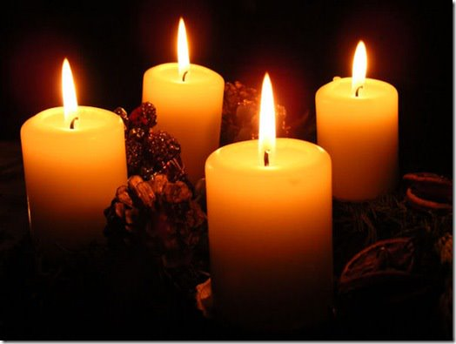
Morning Service
from Holy Trinity Church, Jersey

2nd Sunday of Advent
4th December 2022

Welcome and Preparation

We light the second of the Advent Candles: For the Prophets.

Lord Jesus, light of the world, the prophets said you would bring peace and save your people in trouble. Give peace in our hearts at Christmas and show all the world God’s love.

The Lord of Glory be with you.
All The Lord bless you.

Heaviness may endure for a night:
All But joy comes in the morning.

God has been our refuge and our strength:
All A present help in time of trouble.

The night has passed, and the day lies open before us; let us pray with one heart and mind.

Silence is kept.

As we rejoice in the gift of this new day, so may the light of your presence, O God, set our hearts on fire with love for you.; now and for ever.
All Amen.

Hymn

Advent candles tell their story
as we watch and pray,
longing for the Day of Glory,
‘Come, Lord, soon,’ we say,
pain and sorrow, tears and sadness,
changed for gladness on that Day.

Prophet voices loudly crying,
making pathways clear;
glimpsing glory, self-denying,
calling all to hear.
Through their message – challenged, shaken -
hearts awaken: God is near!

John, the Baptist, by his preaching
and the water poured,
brought to those who heard his teaching
news of hope restored:
‘Keep your vision strong and steady,
and be ready for the Lord’.

Mary’s gift beyond all telling
we recall today:
Son of God within her dwelling,
born to show the way.
Who could guess the final story?
- cross and glory; Easter Day.

Advent candles tell their story
on this Advent Day.
Those who waited for God’s glory:
they prepared the way.
Christ is with us: loving, giving,
in us living, here today!
Mark Earey (b.1965)(SP7)

A Time of Confession

The sacrifice of God is a broken spirit, a broken and contrite heart God will not despise. Let us come to the Lord, who is full of compassion, and acknowledge our transgressions in penitence and faith.

We confess to you our selfishness and lack of love:
Lord, have mercy.
All Lord, have mercy.

We confess to you our fear and failure in sharing our faith:
Christ, have mercy.
All Christ, have mercy.

We confess to you our stubbornness and lack of trust:
Lord, have mercy.
All Lord, have mercy.

Almighty God, who forgives all who truly repent, have mercy upon you, pardon and deliver you from all your sins, confirm and strengthen you in all goodness, and keep you in life eternal; through Jesus Christ our Lord.
All Amen.

Thankfulness

Generous God, you gave us our voices, no two the same, no finer instruments with which to praise you.
All For these we thank you, Lord.

You gave us words and music, particular gifts with which we can wonder, or wound, bless or bore.
All For these we thank you, Lord.

And as your Church you have gathered us. In your community of common folk and complainers, prophets and puzzled people, you have made a place for us.
All For this we thank you, Lord.

So, let what we say and do, what we ponder and decide, be real for us and honest to you, and prepare us for the life of the world, in which you are also praised.
All Amen.
The Collect

O Lord, raise up, we pray, your power and come among us, and with great might succour us; that whereas, through our sins and wickedness we are grievously hindered in running the race that is set before us, your bountiful grace and mercy may speedily help and deliver us; through Jesus Christ your Son our Lord, to whom with you and the Holy Spirit, be honour and glory, now and for ever.
All Amen.

Hymn
Jesus bids us shine,
First of all for Him;
Well He sees and knows it,
If our light grows dim.
He looks down from heaven
To see us shine,
You in your small corner,
And I in mine.

Jesus bids us shine
With a pure, clear light,
Like a little candle
Burning in the night.
In this world is darkness;
So let us shine,
You in your small corner,
And I in mine.

Jesus bids us shine,
Then, for all around;
Many kinds of darkness
In the world are found -
Sin, and want and sorrow;
So we must shine,
You in your small corner
And I in mine.
Susan Warner (1819-1885) (JP128)

The Word of God

Psalm 72. 1-7, 18-19

Refrain: The Lord is king; let the earth rejoice.

Give the king your judgements, O God, and your righteousness to the son of a king.
Then shall he judge your people righteously and your poor with justice.
May the mountains bring forth peace, and the little hills righteousness for the people.
May he defend the poor among the people, deliver the children of the needy and crush the oppressor.

Refrain: The Lord is king; let the earth rejoice.

May he live as long as the sun and moon endure, from one generation to another.
May he come down like rain upon the mown grass, like the showers that water the earth.
In his time shall righteousness flourish, and abundance of peace till the moon shall be no more

Refrain: The Lord is king; let the earth rejoice.

Blessed be the Lord, the God of Israel, who alone does wonderful things.
And blessed be his glorious name for every. May all the earth be filled with his glory. Amen. Amen.

Refrain: The Lord is king; let the earth rejoice.

May your kingdom come, O God, with deliverance for the needy, with peace for the righteous, with overflowing blessing for all nations, with glory, honour and praise for Christ, the only Saviour.
All: Amen.

Matthew 3. 1-12

In those days John the Baptist appeared in the wilderness of Judea, proclaiming, ‘Repent, for the kingdom of heaven has come near.’ This is the one of whom the prophet Isaiah spoke when he said, ‘The voice of one crying out in the wilderness: “Prepare the way of the Lord, make his paths straight.”’
Now John wore clothing of camel’s hair with a leather belt around his waist, and his food was locusts and wild honey. Then the people of Jerusalem and all Judea were going out to him, and all the region along the Jordan, and they were baptized by him in the river Jordan, confessing their sins.
But when he saw many Pharisees and Sadducees coming for baptism, he said to them, ‘You brood of vipers! Who warned you to flee from the wrath to come? Bear fruit worthy of repentance. Do not presume to say to yourselves, “We have Abraham as our ancestor”; for I tell you, God is able from these stones to raise up children to Abraham. Even now the axe is lying at the root of the trees; every tree therefore that does not bear good fruit is cut down and thrown into the fire.
‘I baptize you with water for repentance, but one who is more powerful than I is coming after me; I am not worthy to carry his sandals. He will baptize you with the Holy Spirit and fire. His winnowing-fork is in his hand, and he will clear his threshing-floor and will gather his wheat into the granary; but the chaff he will burn with unquenchable fire.’
This is the Word of the Lord,
All Thanks be to God.

Reflections – The Rector

Hymn
Mary, hail! Though afraid,
she believed, she obeyed.
In her womb God is laid,
till the time expected,
nurtured and protected:

Journey ends: where afar
Bethlem shines, like a star,
stable door stands ajar.
Unborn Son of Mary,
Saviour, do not tarry.

Ring, bells, ring, ring, ring!
Sing, choirs, sing, sing, sing!
Jesus comes, Jesus comes:
we will make him welcome.

F Pratt Green (b1903) (NEH10))

Long ago, prophets knew
Christ would come, born a Jew,
come to make all things new,
bear his people’s burden,
freely love and pardon.

Ring, bells, ring, ring, ring!
Sing, choirs, sing, sing, sing!
When he comes, when he comes,
who will make him welcome?

God in time, God in man,
this is God’s timeless plan:
he will come, as a man,
born himself of woman,
God divinely human:

Let us declare our faith in God.

We believe,
All We believe in one God,
the Father, the Almighty,
maker of heaven and earth,
of all that is,
seen and unseen.
We believe in one Lord, Jesus Christ,
the only Son of God,
eternally begotten of the Father,
God from God, Light from Light,
true God from true God,
begotten, not made,
of one Being with the Father;
through him all things were made.
For us and for our salvation he came down from heaven,
was incarnate from the Holy Spirit and the Virgin Mary
and was made man.
For our sake he was crucified under Pontius Pilate;
he suffered death and was buried.
On the third day he rose again
in accordance with the Scriptures;
he ascended into heaven
and is seated at the right hand of the Father.
He will come again in glory to judge the living and the dead,
and his kingdom will have no end.
We believe in the Holy Spirit,
the Lord, the giver of life,
who proceeds from the Father and the Son,
who with the Father and the Son is worshipped and glorified,
who has spoken through the prophets.
We believe in one holy catholic and apostolic Church.
We acknowledge one baptism for the forgiveness of sins.
We look for the resurrection of the dead,
and the life of the world to come. Amen.

The Peace

Since we are justified by faith, we have peace with God through our Lord Jesus Christ, who has given us access to his grace. The peace of the Lord be with you.
All And also with you

Hymn

Fling wide the gates, unbar the ancient doors;
salute your king in his triumphant cause!

Now all the world belongs to Christ our Lord:
let all creation greet the living Word!

Who has the right to worship him today?
All those who gladly serve him and obey.

He comes to save all those who trust his name,
and will declare them free from guilt and shame.

Who is the victor glorious from the fight?
He is our king, our life, our Lord, our right!

Michael Perry (1942-1996) (SP11)
Based on Psalm 24 (A Song of the King’s Glory)

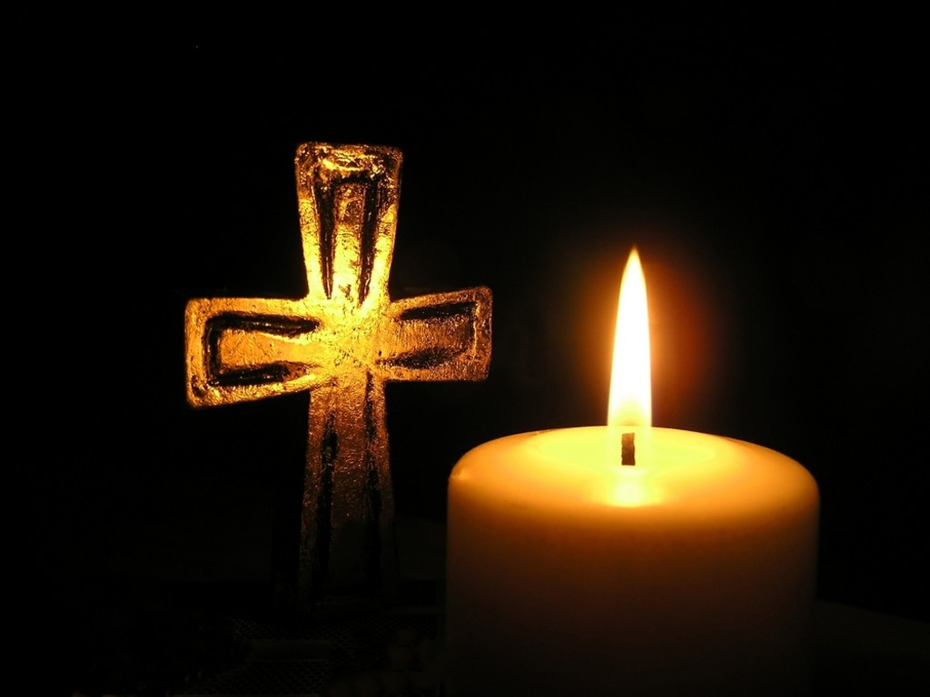
Prayers of Intercession

The response is:

Lord hear us,
All Lord, graciously hear us.

We draw these and all our prayers together in the words of the Lord’s Prayer, saying,

All Our Father; who art in heaven, hallowed be thy name; thy kingdom come; thy will be done; on earth as it is in heaven. Give us this day our daily bread. And forgive us our trespasses, as we forgive those who trespass against us. And lead us not into temptation; but deliver us from evil. For thine is the kingdom, the power and the glory, for ever and ever.
Amen.

Merciful Father
All give us new life in you, accept our prayers and be with us always. Amen.

Hymn

Hills of the north, rejoice,
Echoing songs arise,
Hail with united voice
Him who made earth and skies:
He comes in righteousness and love
He brings salvation from above

Isles of the Southern seas,
Sing to the listening earth,
Carry on every breeze
Hope of a world’s new birth:
In Christ shall all be made anew,
His word is sure, his promise true.

Lands of the east, arise,
He is your brightest morn,
Greet him with joyous eyes,
Praise shall his path adorn:
The God whom you have longed to know
In Christ draws near, and calls you now.

Shores of the utmost West,
Lands of the setting sun,
Welcome the heavenly guest
In whom the dawn has come:
He brings a never-ending light
Who triumphed o’er our darkest night.
Shout, as you journey on,
Songs be in every mouth,
Lo, from the North they come,
From East and West and South:
In Jesus all shall find their rest,
In him the sons of earth be blest.

Charles Edward Oakley (1832-65) (NEH7)

Closing Responses and Blessing

The Lord God almighty is our Father:
All he loves us and tenderly cares for us.
The Lord Jesus Christ is our Saviour;
All he has redeemed us and will defend us to the end.
The Lord, the Holy Spirit is among us:
All he will lead us in God’s holy way.
To God almighty, Father, Son and Holy Spirit,
be praise and glory today and for ever. Amen.

Christ the Sun of Righteousness shine upon you, scatter the darkness from before your path, and make you ready to meet him when he comes in glory; and the blessing of God almighty, the Father, the Son and the Holy Spirit, be amongst you and remain with you always.
All Amen.

Go in the peace of Christ.
All Thanks be to God.

Refreshments are served in the Lady Chapel.
Please do join us!

To make an anonymous offertory donation to church,
please scan the QR below, thank you.

CCl760416

