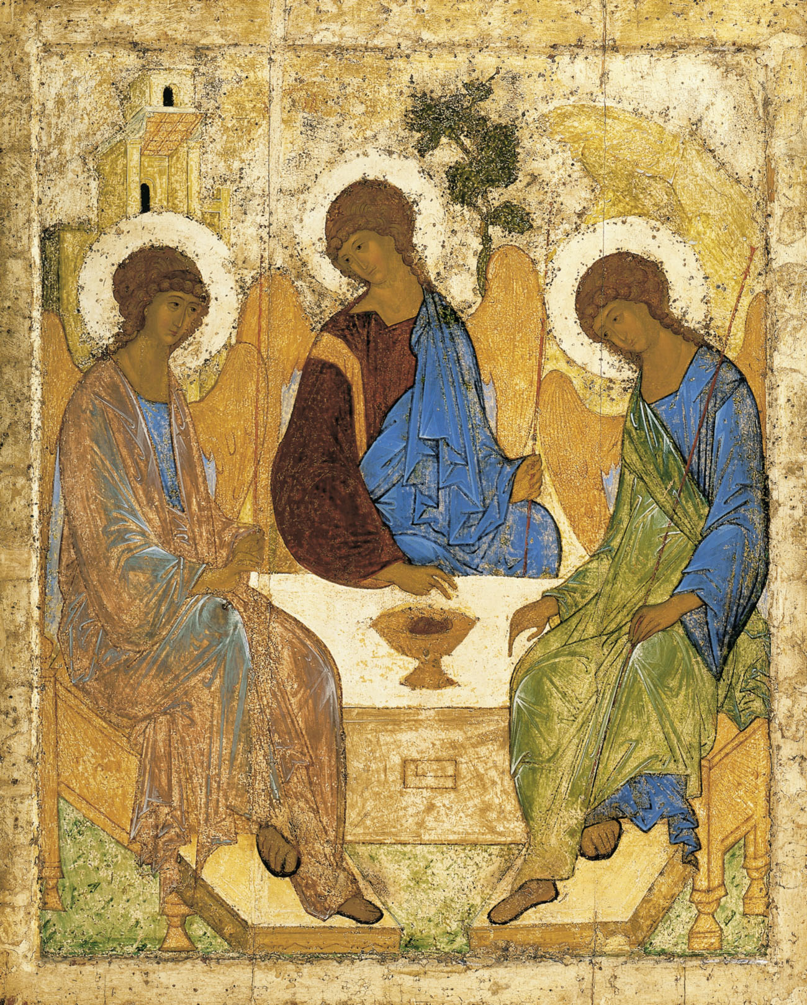
Holy Communion
Trinity Parish Church, Jersey
4th Sunday of Easter.
25th April, 2021

Welcome and Preparation

The Lord be with you.
All And also with you.

As we rejoice in the gift of the resurrection, so may the light of your presence, O God, set our hearts on fire with love for you.; now and for ever.
All Amen.

Hymn
As the deer pants for the water
So my soul longs after you.
You alone are my heart’s desire
And I long to worship you.

You alone are my strength, my shield,
To you alone may my spirit yield.
You alone are my heart’s desire
And I long to worship you.

I want you more than gold or silver,
Only you can satisfy.
You alone are the real joy-giver
And the apple of my eye.

You’re my Friend and you are my Brother.
Even though you are a king.
I love you more than any other,
So much more than anything.
Martin Nystrom,(B. 1956) based on Psalm 42:1-2 (SP259)

A Time of Confession

Let us come to the risen Lord, who is full of compassion, and acknowledge our transgressions in penitence and faith.
Lord Jesus, you raise us to new life.
Lord, have mercy.
All Lord, have mercy.
Lord Jesus, you forgive us our sins.
Christ, have mercy.
All Christ, have mercy.
Lord Jesus, you feed us through the living bread.
Lord, have mercy.
All Lord, have mercy.

May the God of love and power forgive you and free you from your sins, heal and strengthen you by his Spirit, and raise you to new life in Christ our Lord.
All Amen.

The Collect

Almighty Father, whose Son Jesus Christ is the resurrection and the life: raise us, who trust in him, from the death of sin to the life of righteousness, that we may seek those things which are above, where he reigns with you in the unity of the Holy Spirit, one God, now and for ever.
All Amen.

The Word of God

Acts 4.5-12
The next day their rulers, elders, and scribes assembled in Jerusalem, with Annas the high priest, Caiaphas, John, and Alexander, and all who were of the high-priestly family. When they had made the prisoners stand in their midst, they inquired, ‘By what power or by what name did you do this?’ Then Peter, filled with the Holy Spirit, said to them, ‘Rulers of the people and elders, if we are questioned today because of a good deed done to someone who was sick and are asked how this man has been healed, let it be known to all of you, and to all the people of Israel, that this man is standing before you in good health by the name of Jesus Christ of Nazareth, whom you crucified, whom God raised from the dead. This Jesus is “the stone that was rejected by you, the builders;
it has become the cornerstone.”
There is salvation in no one else, for there is no other name under heaven given among mortals by which we must be saved.’

This is the word of the Lord,
All Thanks be to God.

Gospel Reading

Hear the Gospel of our Lord Jesus Christ according to John;
All Glory to you O Lord.

John 10.11-18
‘I am the good shepherd. The good shepherd lays down his life for the sheep. The hired hand, who is not the shepherd and does not own the sheep, sees the wolf coming and leaves the sheep and runs away—and the wolf snatches them and scatters them. The hired hand runs away because a hired hand does not care for the sheep. I am the good shepherd. I know my own and my own know me, just as the Father knows me and I know the Father. And I lay down my life for the sheep. I have other sheep that do not belong to this fold. I must bring them also, and they will listen to my voice. So there will be one flock, one shepherd. For this reason the Father loves me, because I lay down my life in order to take it up again. No one takes it from me, but I lay it down of my own accord. I have power to lay it down, and I have power to take it up again. I have received this command from my Father.’

This is the Gospel of the Lord,
All Praise to you, O Christ.

A Report from the Rector

‘I bind unto Myself this Day’
The Northumbria Community

Let us declare our faith in God.

We believe,
All We believe in one God,
the Father, the Almighty,
maker of heaven and earth,
of all that is,
seen and unseen.
We believe in one Lord, Jesus Christ,
the only Son of God,
eternally begotten of the Father,
God from God, Light from Light,
true God from true God,
begotten, not made,
of one Being with the Father;
through him all things were made.
For us and for our salvation he came down from heaven,
was incarnate from the Holy Spirit and the Virgin Mary
and was made man.
For our sake he was crucified under Pontius Pilate;
he suffered death and was buried.
On the third day he rose again
in accordance with the Scriptures;
he ascended into heaven
and is seated at the right hand of the Father.
He will come again in glory to judge the living and the dead,
and his kingdom will have no end.
We believe in the Holy Spirit,
the Lord, the giver of life,
who proceeds from the Father and the Son,
who with the Father and the Son is worshipped and glorified,
who has spoken through the prophets.
We believe in one holy catholic and apostolic Church.
We acknowledge one baptism for the forgiveness of sins.
We look for the resurrection of the dead,
and the life of the world to come. Amen.
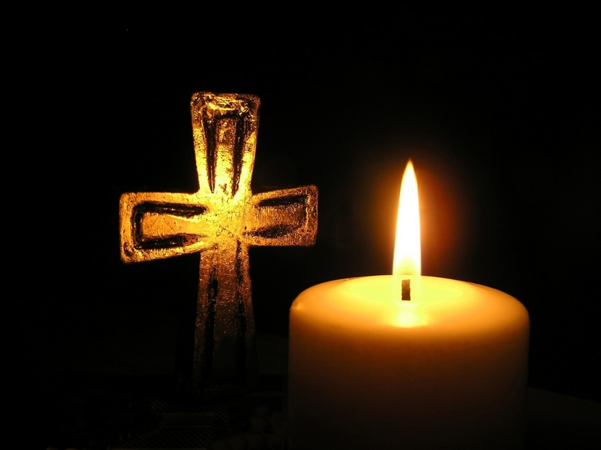
Prayers of Intercession

The response is:
Lord hear us,
All Lord, graciously hear us.

Merciful Father
All give us new life in you, accept our prayers and be with us always.
Amen.

The Peace
The risen Christ came and stood among the disciples and said, ‘Peace be with you.’ Then they were glad when they saw the Lord. Alleluia. The peace of the Lord be with you.
All And also with you

Preparation of the Table

Blessed are you, Lord God of all creation; through your goodness we have this bread to set before you, which earth has given and human hands have made. It will become for us the bread of life.
All Blessed be God forever.

Blessed are you, Lord God of all creation; through your goodness we have this wine to set before you, fruit of the vine and work of human hands.
It will become for us the cup of salvation.
All Blessed be God forever.

Prayer of Consecration

The Lord is here.
All His Spirit is with us.
Lift up your hearts.
All We lift them to the Lord.
Let us give thanks to the Lord our God.
All It is right to give thanks and praise.

Blessed are you Lord God, our light and our salvation; to you be glory and praise for ever. From the beginning you have created all things and all your works echo the silent music of your praise. In the fullness of time you made us in your image, the crown of all creation. You give us breath and speech, that with angels and archangels and all the powers of heaven we may find a voice to sing your praise:

All Holy, holy, holy Lord, God of power and might,
heaven and earth are full of your glory.
Hosanna in the highest.
Blessed is he who comes in the name of the Lord.
Hosanna in the highest.

How wonderful the work of your hands, O Lord. As a mother tenderly gathers her children, you embraced a people as your own. When they turned away and rebelled your love remained steadfast. From them you raised up Jesus our Saviour, born of Mary, to be the living bread, in whom all our hungers are satisfied. He offered his life for sinners, and with a love stronger than death he opened wide his arms on the cross. On the night before he died, he came to supper with his friends and, taking bread, he gave you thanks. He broke it and gave it to them, saying: ‘Take eat; this is my body which is given for you; do this in remembrance of me.’ At the end of supper, taking the cup of wine, he gave you thanks, and said: ‘Drink this, all of you; this is my blood of the new covenant, which is shed for you and for many for the forgiveness of sins. Do this, as often as you drink it, in remembrance of me.’

Great is the mystery of faith:
All Christ has died: Christ is risen: Christ will come again.

Father, we plead with confidence his sacrifice made once for all upon the cross; we remember his dying and rising in glory, and we rejoice that he intercedes for us at your right hand.
Pour out your Holy Spirit as we bring before you these gifts of your creation; may they be for us the body and blood of your dear Son.
As we eat and drink these holy things in your presence, form us in the likeness of Christ, and build us into a living temple to your glory.
Bring us at the last with all the saints to the vision of that eternal splendour for which you have created us; through Jesus Christ, our Lord, by whom, with whom and in whom, with all who stand before you in earth and heaven, we worship you, Father almighty, in songs of everlasting praise:
All Blessing and honour and glory and power be yours for ever and ever. Amen.

Let us pray with confidence as our Saviour has taught us:
All Our Father; who art in heaven, hallowed be thy name; thy kingdom come;
thy will be done; on earth as it is in heaven. Give us this day our daily bread. And forgive us our trespasses, as we forgive those who trespass against us. And lead us not into temptation; but deliver us from evil.
For thine is the kingdom, the power and the glory, for ever and ever. Amen.

We break this bread to share in the body of Christ.
All Though we are many, we are one body, because we all share in one bread.

All Lamb of God, you take away the sin of the world: have mercy on us.
Lamb of God, you take away the sin of the world: have mercy on us.
Lamb of God, you take away the sin of the world: grant us peace.

Jesus is the Lamb of God who takes away the sin of the world.
Blessed are those who are called to his supper:
All Lord, I am not worthy to receive you, but only say the word, and I shall
be healed.

The Communion
Please come forward to receive bread or a blessing.
Observe physical distancing at all times and remain standing to receive.

Prayer after Communion
Merciful Father, you gave your Son Jesus Christ to be the good shepherd, and in his love for us to lay down his life and rise again: keep us always under his protection, and give us grace to follow in his steps; through Jesus Christ our Lord.
All Amen.

All Father of all, we give you thanks and praise, that when we were still far
off you met us in your Son and brought us home. Dying and living, he declared your love, gave us grace, and opened the gate of glory. May we who share Christ’s body live his risen life; we who drink his cup bring life to others; we whom the Spirit lights give light to the world. Keep us firm in the hope you have set before us, so we and all your children shall be free, and the whole earth live to praise your name; through Christ our Lord. Amen.

Hymn
The King of love my Shepherd is,
Whose goodness faileth never;
I nothing lack if I am his
And he is mine for ever.

Where streams of living water flow
My ransomed soul He leadeth,
And where the verdant pastures grow
With food celestial feedeth.

Thou spread’st a table in my sight;
Thy unction grace bestoweth:
and O what transport of delight
from thy pure chalice floweth!

And so through all the length of days
Thy goodness faileth never;
Good Shepherd, may I sing thy praise
within thy house for ever.
Henry William Baker (1821-77) (NEH 457)

The Blessing

May God the Father; by whose love Christ was raised from the dead, open to you who believe the gates of everlasting life. God the Son, who in bursting the grave has won a glorious victory, give you joy as you share the Easter faith. God the Holy Spirit, who filled the disciples with the life of the risen Lord, empower you and fill you with Christ’s peace. And the blessing of God almighty, the Father, the Son and the Holy Spirit, be upon you and remain with you, now and always.
All Amen.

Go in the peace of the risen Christ. Alleluia! Alleluia!
All Thanks be to God. Alleluia! Alleluia!

