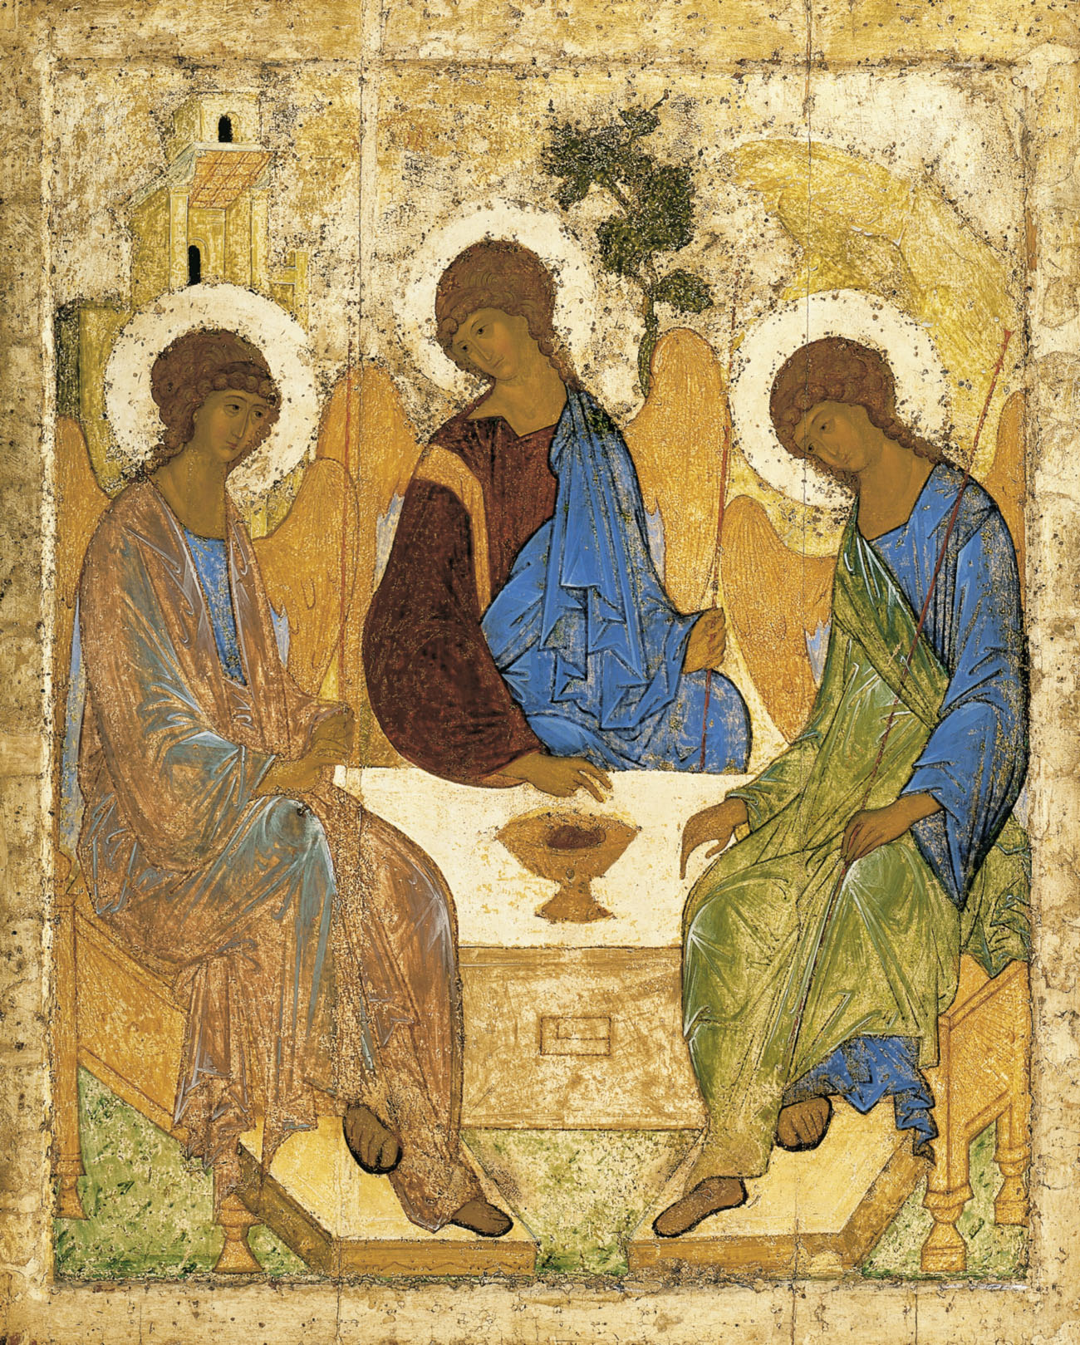
Holy Communion
Trinity Parish Church, Jersey
2nd Sunday of Trinity
13th June, 2021

Welcome and Preparation
The Lord be with you.
All And also with you.

As we rejoice in the gift of this new day, so may the light of your presence, O God, set our hearts on fire with love for you.; now and for ever.
All Amen.

Hymn
In the just reward of labour,
God's will is done;
In the help we give our neighbour,
God's will is done;
In our world-wide task of caring
for the hungry and despairing,
in the harvests we are sharing,
God's will is done.

For the fruits of all creation,
thanks be to God;
gifts bestowed on every nation,
thanks be to God;
For the ploughing, sowing, reaping,
silent growth while we are sleeping,
future needs in earth's safe-keeping,
thanks be to God.

For the harvests of the Spirit,
thanks be to God;
For the good we all inherit,
thanks be to God;
For the wonders that astound us,
for the truths that still confound us,
most of all, that love has found us,
thanks be to God.

Fred Pratt Green (1903-2000) (SP110)

A Time of Confession

Let us come to the risen Lord, who is full of compassion, and acknowledge our transgressions in penitence and faith.
Lord Jesus, you raise us to new life.
Lord, have mercy.
All Lord, have mercy.
Lord Jesus, you forgive us our sins.
Christ, have mercy.
All Christ, have mercy.
Lord Jesus, you feed us through the living bread.
Lord, have mercy.
All Lord, have mercy.

May the God of love and power forgive you and free you from your sins, heal and strengthen you by his Spirit, and raise you to new life in Christ our Lord.
All Amen.

The Collect

Lord, you have taught us that all our doings without love are nothing worth: send your Holy Spirit and pour into our hearts that most excellent gift of love, the true bond of peace and of all virtues, without which whoever lives is counted dead before you. Grant this for your only Son Jesus Christ’s sake.
All Amen.

The Word of God

Ezekiel 17.22-end
Thus says the Lord God: I myself will take a sprig from the lofty top of a cedar; I will set it out. I will break off a tender one from the topmost of I young twigs; I myself will plant it on a high and lofty mountain. On the mountain height of Israel I will plant it, in order that it may produce boughs and bear fruit, and become a noble cedar. Under it every kind of bird will live; in the shade of its branches will nest winged creatures of every kind. All the trees of the field shall know that I am the Lord. I bring low the high tree, I make high the low tree; I dry up the green tree and make the dry tree flourish. I the Lord have spoken; I will accomplish it.

This is the word of the Lord,
All Thanks be to God.

2 Corinthians 5.6-10,14-17
So we are always confident; even though we know that while we are at home in the body we are away from the Lord— for we walk by faith, not by sight. Yes, we do have confidence, and we would rather be away from the body and at home with the Lord. So whether we are at home or away, we make it our aim to please him. For all of us must appear before the judgement seat of Christ, so that each may receive recompense for what has been done in the body, whether good or evil. For the love of Christ urges us on, because we are convinced that one has died for all; therefore all have died. And he died for all, so that those who live might live no longer for themselves, but for him who died and was raised for them.
From now on, therefore, we regard no one from a human point of view; even though we once knew Christ from a human point of view, we know him no longer in that way. So if anyone is in Christ, there is a new creation: everything old has passed away; see, everything has become new!

This is the word of the Lord,
All Thanks be to God.

Hymn

Forth in thy name, O Lord, I go
my daily labour to pursue
Thee, only Thee, resolved to know
in all I think, or speak, or do

The task Thy wisdom hath assigned
O let me cheerfully fulfil
in all my works Thy presence find
and prove Thy acceptable will

Thee may I set at my right hand
whose eyes my inmost substance see
and labour on at Thy command
and offer all my works to Thee

For Thee delightfully employ
whate’er Thy bounteous grace hath given
and run my course with even joy
and closely walk with Thee to heaven
Charles Wesley (1707-88)(M/P)

Gospel Reading

Hear the Gospel of our Lord Jesus Christ according to Mark;
All Glory to you O Lord.

Mark 4.26-34
He also said, ‘The kingdom of God is as if someone would scatter seed on the ground, and would sleep and rise night and day, and the seed would sprout and grow, he does not know how. The earth produces of itself, first the stalk, then the head, then the full grain in the head. But when the grain is ripe, at once he goes in with his sickle, because the harvest has come.’
He also said, ‘With what can we compare the kingdom of God, or what parable will we use for it? It is like a mustard seed, which, when sown upon the ground, is the smallest of all the seeds on earth; yet when it is sown it grows up and becomes the greatest of all shrubs, and puts forth large branches, so that the birds of the air can make nests in its shade.’
With many such parables he spoke the word to them, as they were able to hear it; he did not speak to them except in parables, but he explained everything in private to his disciples.

This is the Gospel of the Lord,
All Praise to you, O Christ.

Sermon – Helen Hamilton

Let us declare our faith in God.

We believe,
All We believe in one God,
the Father, the Almighty,
maker of heaven and earth,
of all that is,
seen and unseen.
We believe in one Lord, Jesus Christ,
the only Son of God,
eternally begotten of the Father,
God from God, Light from Light,
true God from true God,
begotten, not made,
of one Being with the Father;
through him all things were made.
For us and for our salvation he came down from heaven,
was incarnate from the Holy Spirit and the Virgin Mary
and was made man.
For our sake he was crucified under Pontius Pilate;
he suffered death and was buried.
On the third day he rose again
in accordance with the Scriptures;
he ascended into heaven
and is seated at the right hand of the Father.
He will come again in glory to judge the living and the dead,
and his kingdom will have no end.
We believe in the Holy Spirit,
the Lord, the giver of life,
who proceeds from the Father and the Son,
who with the Father and the Son is worshipped and glorified,
who has spoken through the prophets.
We believe in one holy catholic and apostolic Church.
We acknowledge one baptism for the forgiveness of sins.
We look for the resurrection of the dead,
and the life of the world to come. Amen.

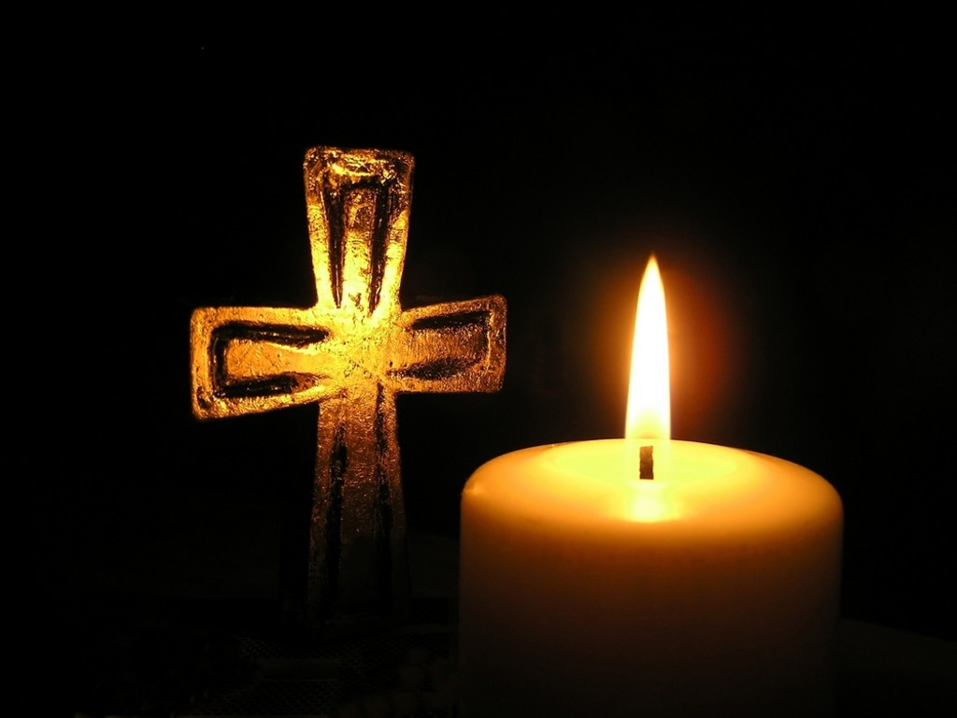
Prayers of Intercession

The response is:
Lord hear us,
All Lord, graciously hear us.

Merciful Father
All give us new life in you, accept our prayers and be with us always.
Amen.

The Peace
The risen Christ came and stood among the disciples and said, ‘Peace be with you.’ Then they were glad when they saw the Lord. Alleluia. The peace of the Lord be with you.
All And also with you

Hymn

We plough the fields and scatter
the good seed on the land
but it is fed and watered
by God’s almighty hand
He sends the snow in winter
the warmth to swell the grain
the breezes and the sunshine
and soft refreshing rain
All good gifts around us
are sent from heaven above
than thank the Lord, O thank the Lord,
for all His love

He only is the Maker
of all things near and far
He paints the wayside flower
He lights the evening star
the wind and waves obey Him
by Him the birds are fed
much more to us, His children
He gives our daily bread
All good gifts …

We thank You then, O Father
for all things bright and good
the seed-time and the harvest
our life, our health, our food
Accept the gifts we offer
for all Your loves imparts
we come now, Lord, to give you
our humble, thankful hearts
All good gifts …
Matthias Claudias 1740-1815

Preparation of the Table

Blessed are you, Lord God of all creation; through your goodness we have this bread to set before you, which earth has given and human hands have made. It will become for us the bread of life.
All Blessed be God forever.

Blessed are you, Lord God of all creation; through your goodness we have this wine to set before you, fruit of the vine and work of human hands.
It will become for us the cup of salvation.
All Blessed be God forever.

Prayer of Consecration

The Lord is here.
All His Spirit is with us.
Lift up your hearts.
All We lift them to the Lord.
Let us give thanks to the Lord our God.
All It is right to give thanks and praise.

Blessed are you Lord God, our light and our salvation; to you be glory and praise for ever. From the beginning you have created all things and all your works echo the silent music of your praise. In the fullness of time you made us in your image, the crown of all creation. You give us breath and speech, that with angels and archangels and all the powers of heaven we may find a voice to sing your praise:

All Holy, holy, holy Lord, God of power and might,
heaven and earth are full of your glory.
Hosanna in the highest.
Blessed is he who comes in the name of the Lord.
Hosanna in the highest.

How wonderful the work of your hands, O Lord. As a mother tenderly gathers her children, you embraced a people as your own. When they turned away and rebelled your love remained steadfast. From them you raised up Jesus our Saviour, born of Mary, to be the living bread, in whom all our hungers are satisfied. He offered his life for sinners, and with a love stronger than death he opened wide his arms on the cross. On the night before he died, he came to supper with his friends and, taking bread, he gave you thanks. He broke it and gave it to them, saying: ‘Take eat; this is my body which is given for you; do this in remembrance of me.’ At the end of supper, taking the cup of wine, he gave you thanks, and said: ‘Drink this, all of you; this is my blood of the new covenant, which is shed for you and for many for the forgiveness of sins. Do this, as often as you drink it, in remembrance of me.’

Great is the mystery of faith:
All Christ has died: Christ is risen: Christ will come again.

Father, we plead with confidence his sacrifice made once for all upon the cross; we remember his dying and rising in glory, and we rejoice that he intercedes for us at your right hand.
Pour out your Holy Spirit as we bring before you these gifts of your creation; may they be for us the body and blood of your dear Son.
As we eat and drink these holy things in your presence, form us in the likeness of Christ, and build us into a living temple to your glory.
Bring us at the last with all the saints to the vision of that eternal splendour for which you have created us; through Jesus Christ, our Lord, by whom, with whom and in whom, with all who stand before you in earth and heaven, we worship you, Father almighty, in songs of everlasting praise:
All Blessing and honour and glory and power be yours for ever and ever. Amen.

Let us pray with confidence as our Saviour has taught us:
All Our Father; who art in heaven, hallowed be thy name; thy kingdom come;
thy will be done; on earth as it is in heaven. Give us this day our daily bread. And forgive us our trespasses, as we forgive those who trespass against us. And lead us not into temptation; but deliver us from evil.
For thine is the kingdom, the power and the glory, for ever and ever. Amen.

We break this bread to share in the body of Christ.
All Though we are many, we are one body, because we all share in one bread.

All Lamb of God, you take away the sin of the world: have mercy on us.
Lamb of God, you take away the sin of the world: have mercy on us.
Lamb of God, you take away the sin of the world: grant us peace.

Jesus is the Lamb of God who takes away the sin of the world.
Blessed are those who are called to his supper:
All Lord, I am not worthy to receive you, but only say the word, and I shall
be healed.

The Communion
Please come forward to receive bread or a blessing.
Observe physical distancing at all times and remain standing to receive.

Prayer after Communion
Loving Father, we thank you for feeding us at the supper of your Son: sustain us with your Spirit, that we may serve you here on earth until our joy is complete in heaven, and we share in the eternal banquet with Jesus Christ our Lord.
All Amen.

All Father of all, we give you thanks and praise, that when we were still far
off you met us in your Son and brought us home. Dying and living, he declared your love, gave us grace, and opened the gate of glory. May we who share Christ’s body live his risen life; we who drink his cup bring life to others; we whom the Spirit lights give light to the world. Keep us firm in the hope you have set before us, so we and all your children shall be free, and the whole earth live to praise your name; through Christ our Lord. Amen.

Hymn
Hope of our calling: hope through courage won
by those who dared to share all Christ had done.
Saints of today, Christ’s banner now unfurled,
will bring his gospel to a waiting world.

Hope of our calling: hope with grace outpoured,
from death’s despair the gift of life restored;
our call to serve, to wash each other’s feet,
to bring Christ’s healing touch to all we meet.

Hope of our calling: hope by faith made bold
to sow God’s righteousness throughout the world;
bring peace from conflict, fruitfulness from weeds,
the kingdom’s harvest from the kingdom’s seeds.

Hope of our calling: Spirit-filled, unbound,
old joys remembered and new purpose found,
our call refreshed by sacrament and word,
we go in peace to love and serve the Lord.

Ally Barrett (b1975) (SP157)

The Blessing

As you continue on your way, may you know that God goes before you. By the strength of his Spirit, share your faith with the uncertain; share your love with the unlovely; share your presence with the lonely; and share God with everyone, just as God has shared himself with you, in the unfading blessing of Jesus Christ, our Lord and Saviour. And the blessing of God almighty, the Father, the Son, and the Holy Spirit, be with you now and always.
All Amen.

Go in the peace of Christ.
All Thanks be to God.

