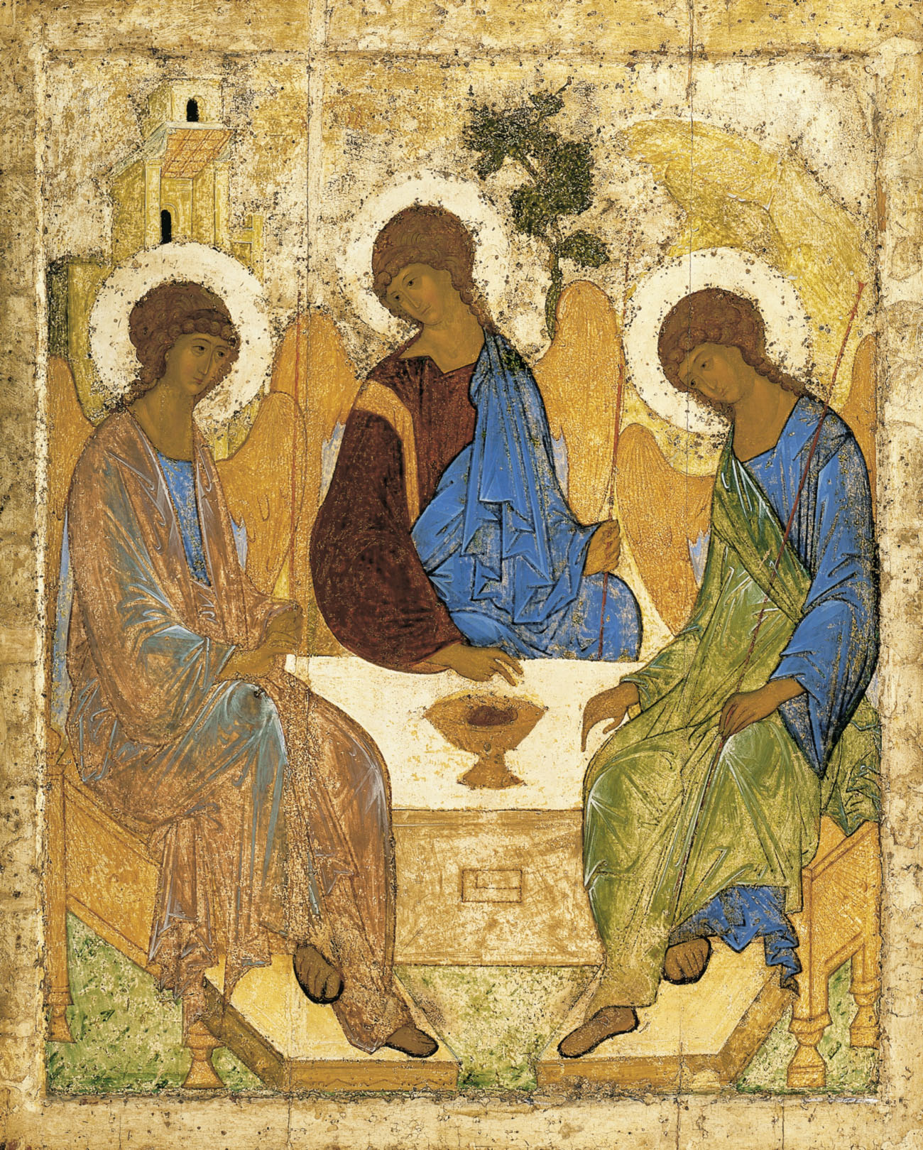

Holy Trinity Church, Jersey
Written Reports for the Annual General Meeting

Sunday 22nd April, 2018

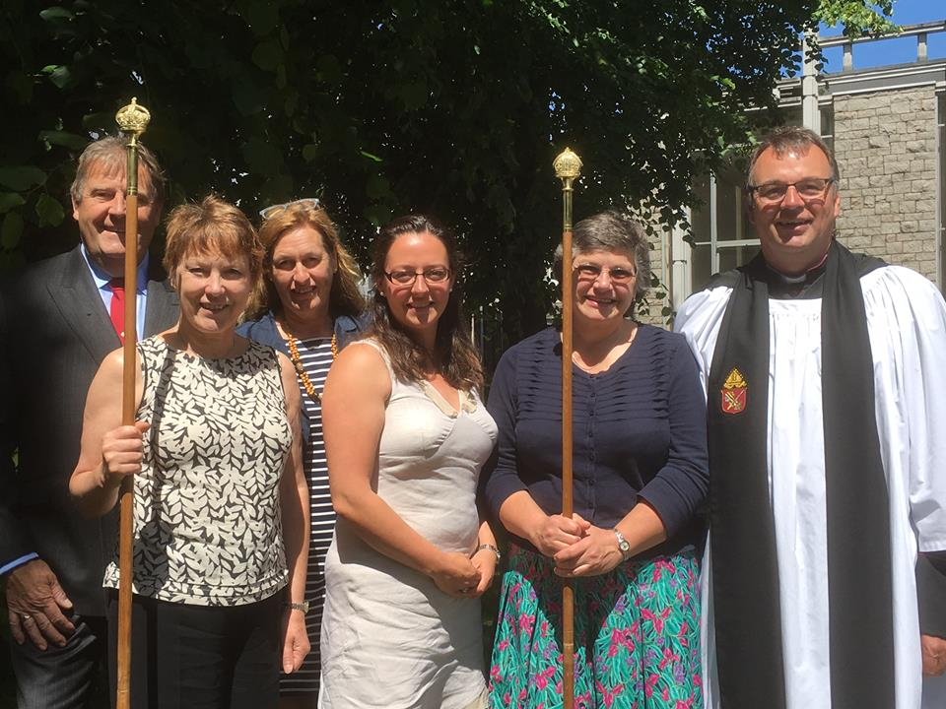
In recent years the Annual General Meeting of our Church has taken place immediately following the 11 am service, increasing the number of those able to attend, but bringing a time pressure to the agenda as people have needed to engage in the rest of their day. The purpose of this leaflet is to give you the opportunity to read and consider reports on the life of your church at your leisure in advance of the meeting.
The Rector and the Treasurer will give their reports in person to the meeting on Sunday 22nd April. Copies of the accounts will also be available and thereafter online.

Mission Action Planning – The Rector
Bishop Trevor has laid before his diocese, including the Channel Island Churches that are in his care, the challenge to intentionally plan how each church can grow in mission, and put those plans into action. ‘Mission Action Planning’ is a term originally devised in the Diocese of London some years ago and that has been shown across the wider church to be effective in growing churches both numerically and spiritually.
Responding to this call I gathered together a small working group to consider how we might engage with Mission Action Planning here at Trinity, they were: Nick Cabot, Andy Howell, Angela Le Sueur, Fleur Benest and Eric Vezie. Interesting and helpful conversations ensued which also crossed over into discussions with the Advisory Church Council, hopefully summarised in the following bullet points:
- Trinity Church is a thriving, well-attended and diverse congregation, central and inclusive in its ecclesiology. Sunday-by-Sunday we do many things well, and many already give generously of their time and talents.
- Most of the congregation who are fit and well are either in the work place, caring for parents and grandchildren or otherwise already committed in their use of time. There is virtually no slack in the time available to give to new projects and initiatives.
- There always has been and always will be a list of ‘good ideas’ we think someone (‘but not me…’ ) ought to be delivering. Mission Action Planning is not about making busy people busier or devising plans we cannot deliver and feel guilty about.
- Church growth is not about bolstering the comfortable routines of the past. Nostalgia is not what it used to be.
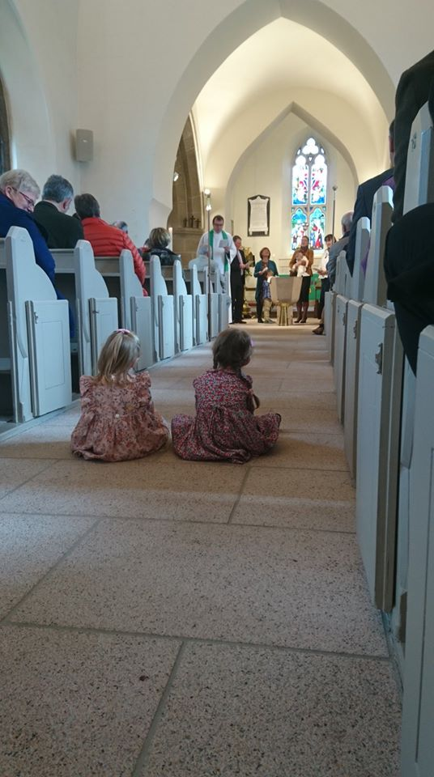
- Mission Action Planning is about identifying and working to our strengths, focusing on how we can do a few things well.
- Mission Action Planning is being open and attentive to what God is doing and to what is emerging - and reaching for the ‘low hanging fruit’ that is before us.

The group considering the possibilities were not short of practical ideas that could be considered. So a framework to give us a focus was proposed to give us three clear areas, based on the marks of a healthy organisation: a) Understanding what makes us distinct (a church not a golf or any other club …). b) Doing our core activity well. c) Actively looking to where its future customers /membership comes from (who will be in the pews in the future?). The use of this framework helped us identify three areas of our life together to intentionally plan and act upon to grow our church in mission.
- Understanding what makes us distinct: Trinity Church is a sociable and friendly place and much appreciated for that by many, however what makes us distinct is our rootedness in the Christian faith, our prayer together and the grace heard and received through the Gospel of Christ and the Sacraments shared. We are very fortunate, with the Licensing of Fleur Benest and Angela Le Sueur, to have four preachers on the team, each with different strengths and styles. Our intention is: to a) further encourage all those who preach in our church to continue growing in skill so that our church becomes renowned for its preaching and shares that gift more widely, and b) those who are theologically trained provide new opportunities and initiatives for all to deepen their faith through study and prayer.

- To do our core activity well: Sunday worship at Trinity is, within its tradition, something very special, not least thanks to the excellent music and the input from so many volunteers. However, where our faith finds form in social or community action is less focussed. What is clear is that countless individual members of the congregation are personally involved in a vast array of activities, from Meals on Wheels, Shelter, Overseas Aid, charitable Trusteeships and much more. Our intention is: a) to learn from one another of the charities we are involved in and their needs, stimulating a shared interest. b) Offer and organise events for groups such as residents of Maison Cabot and discern where we might practically help. c) Pro-actively re-engage with our overseas Church link through Bishop Desiree in the DRC.

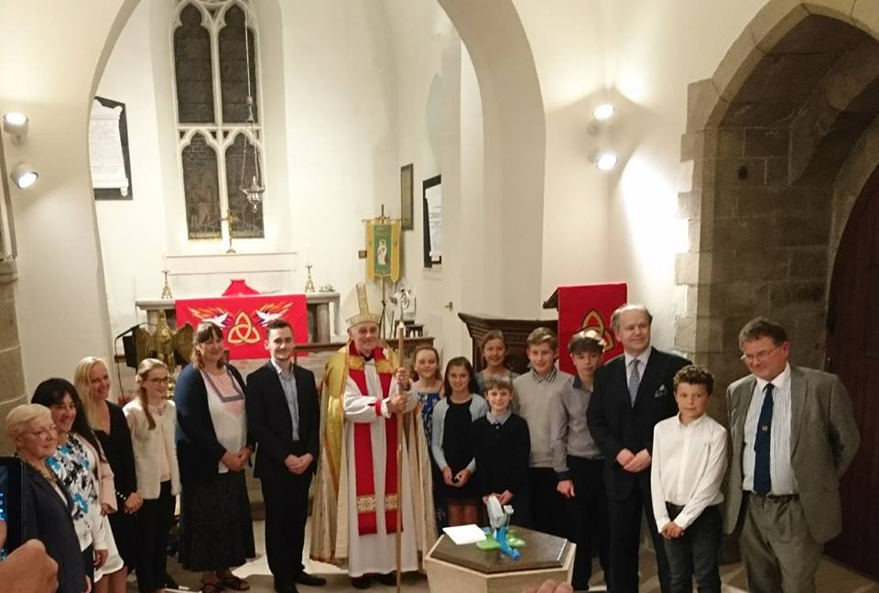
- Actively look to our future membership: We are all growing older and if the wonderful gift of faith is to continue burning brightly in this place for another eight centuries we need to welcome people to this place and share the Gospel in the wider community. By God’s grace there continue to be new faces amongst us and our congregation is numerically stronger than it looks because there is only about one third of our number here on any given Sunday. Where we have grown most significantly over the last three years is in our work with young children and their parents, principally taking place at 9.30 am twice a month. It is in a different form than traditional Sunday School, but the Lady Chapel and Chancel often throng with little ones. God has clearly blessed this work which has grown to a point of challenge – do we have the faith and trust to invest further in this work? We have someone who leads this work (eminently qualified in child care) and wants to do more but needs to earn a wage. This Church has money from the Rachel Mallet legacy that could be used – do we take a step of faith? Remembering the Parable of the Talents, do we invest? Our intention is to offer paid employment, two days a week, for a Families and Children’s Worker to give further impetus to this fast developing ministry to children and their parents at Trinity. This work would be in addition to the pro bono contribution of time alongside the rest of the team. (The commitment would be for three years at approximately £15,000 pa amounting to some £45,000k, less than half of the legacy.)
On paper this Mission Action Plan may look modest in ambition, but each of the three strands will create additional work for those in leadership and those who are able to get involved. And all that we do continually changes us, reforms us, and inevitably asks more questions of our priorities, our faith, and us. In three years’ time, our intention will be to revisit our Mission Action Plan to ask ‘where next?’

Deanery Synod – Aynslie Le Brun
2017 saw the beginning of a new triennium of the Deanery Synod with the representatives from Trinity being Aynslie Le Brun, Eileen Simmons and Andrew Le Brun. Through the Synod, Aynslie serves on the Finance Committee and Andrew is helping develop the understanding of how the new Charities Law will affect churches in the Island. Much of the Synod’s business is routine, but notable was the welcome of the new Dean, the Very Reverend Mike Keirle, and the Synod is enjoying his approach to leadership and collaboration. There are periodic reports that the long awaited Archbishop’s Commission that will help discern our future mainland relationships will come soon, but it now seems unlikely to begin before the autumn. Lastly, all the churches have been tasked to engage in Mission Action Planning – to plan and put into action our thinking on how we want to see our church grow in the future, and in due course to give account of these plans to the wider church.

Readers’ Training – Fleur Benest
If it were not for the support, interest and encouragement given to us by Geoff and our friends in the congregation, both Angela and I agree that we would not have been able to persevere. I wish to register my heart-felt thanks to everyone who has said words of encouragement and prayers for our endeavours in the Spirit.
Children often tally the time elapsing between the current day and a birthday or Christmas by the number of sleeps remaining. Angela and I are counting down the number of words still to be submitted before our Licensing. It was 21,500 at the end of November. Now it is 11,500. While the essay writing, with the necessary reading and other preparation is onerous, the practical work in Trinity and during our placements has been a joy. It reminds us what all the theory is leading us to. We look forward to offering to you all the fruits of your belief in us.

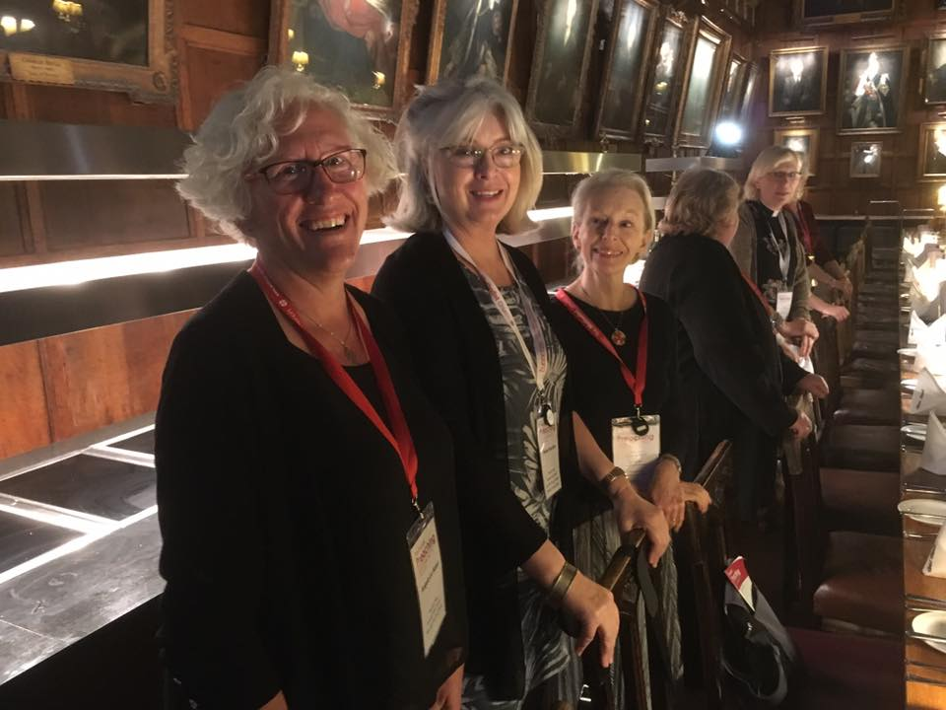

Church Link to the Anglican Church in Goma in the Democratic Republic of Congo – Janet Snart
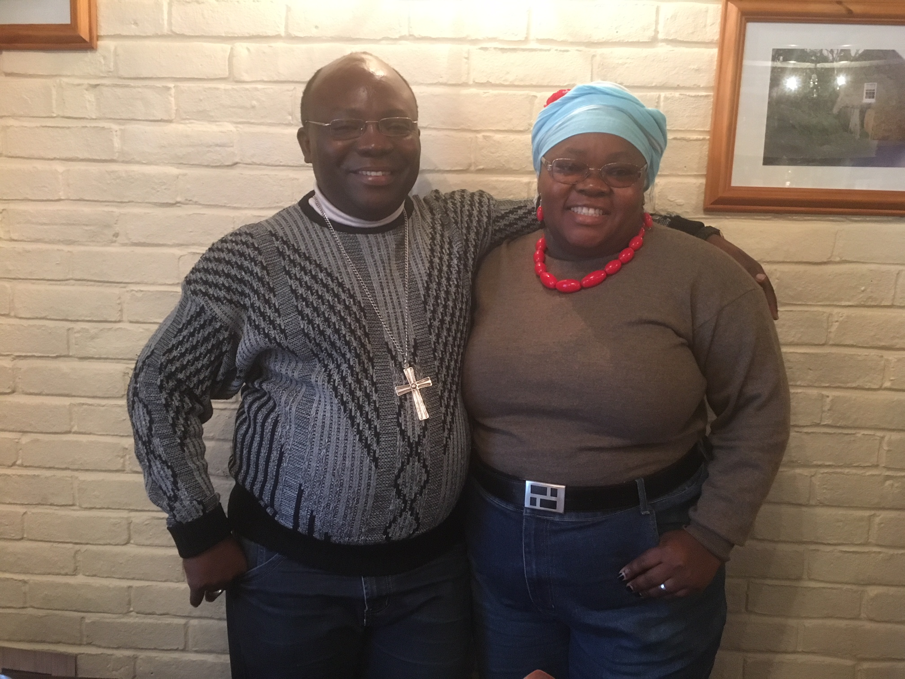
We were pleased when our lovely priest Desire was made a Bishop last year and we received photos of this remarkable occasion.
We thought that his duties as a Bishop in the Congo would occupy all his time, but no. In January he came to visit us, this time bringing his charming wife, who was greeted with pleasure by the people who came to have lunch with them, so now we know about their children, 4 of them, 2 girls and 2 boys, and that the oldest, a girl, is just starting university and her parents are concerned for her safety. In the shared conversations we took the opportunity to ask how we might continue to support him in his ministry in new, achievable ways. Bishop Desire agreed to give that some thought, and also extended an invitation to any who would wish to visit him in the DRC.

Trinity Church Choir – Nick Cabot MBE
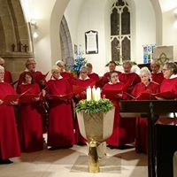
As with all choirs, but most particularly a church choir, our choir just permanently keeps going despite the usual (and sometimes not so usual) illnesses and vagaries of life which can sometimes make attendance difficult.
We have 26 members having ‘lost’ one bass, Arthur Hill, who has returned to his home Parish Church of St Saviour to assist with the formation of a choir at that church now that Reverend Peter Dyson has become the Rector. He and his wife, Pam, have been valuable members of our Church community and we shall miss them both.
As usual, the choir has done its very best to fulfil its duties during the past year and also managed to take the ‘Gallichan Shield’ at the Eisteddfod last November. May I take this opportunity to thank its members, most sincerely, for their patience and forbearance in putting up with me for yet another year.

Safeguarding – Gill John
We are very fortunate to have such a diverse range of people who pass through the doors of our church or who receive ministry at home. The diversity also brings some vulnerabilities with it, particularly for the very young and not so young in our community. Ensuring their safety from harm and personal wellbeing lies at the heart of our safeguarding policies and procedures and we are guided in all things by the Diocesan Safeguarding Advisors and Rev Beverley Sproat our deanery advisor. Those who work on behalf of the church with our more vulnerable groups are required to do regular training on the principles of safeguarding children and vulnerable adults. We are very conscious that time is precious for many of us and the thought of spending two or three hours at a course is not appealing, especially as many of us also do safeguarding training within health, education or voluntary work elsewhere. We are very grateful for all of those who give up their time to undergo this training which acts both as a safeguard for those we seek to protect, and, ultimately, us as a church.

Geoff and I remain the principle contacts for any concerns you might have about the wellbeing of anyone in our church community and are available for you to speak to about these matters via email or telephone. If you feel a matter is more urgent (e.g. immediate risk of harm) then please report incidents to the police or the safeguarding hub at Children’s Services.

Children’s Ministry – Liz De Gruchy
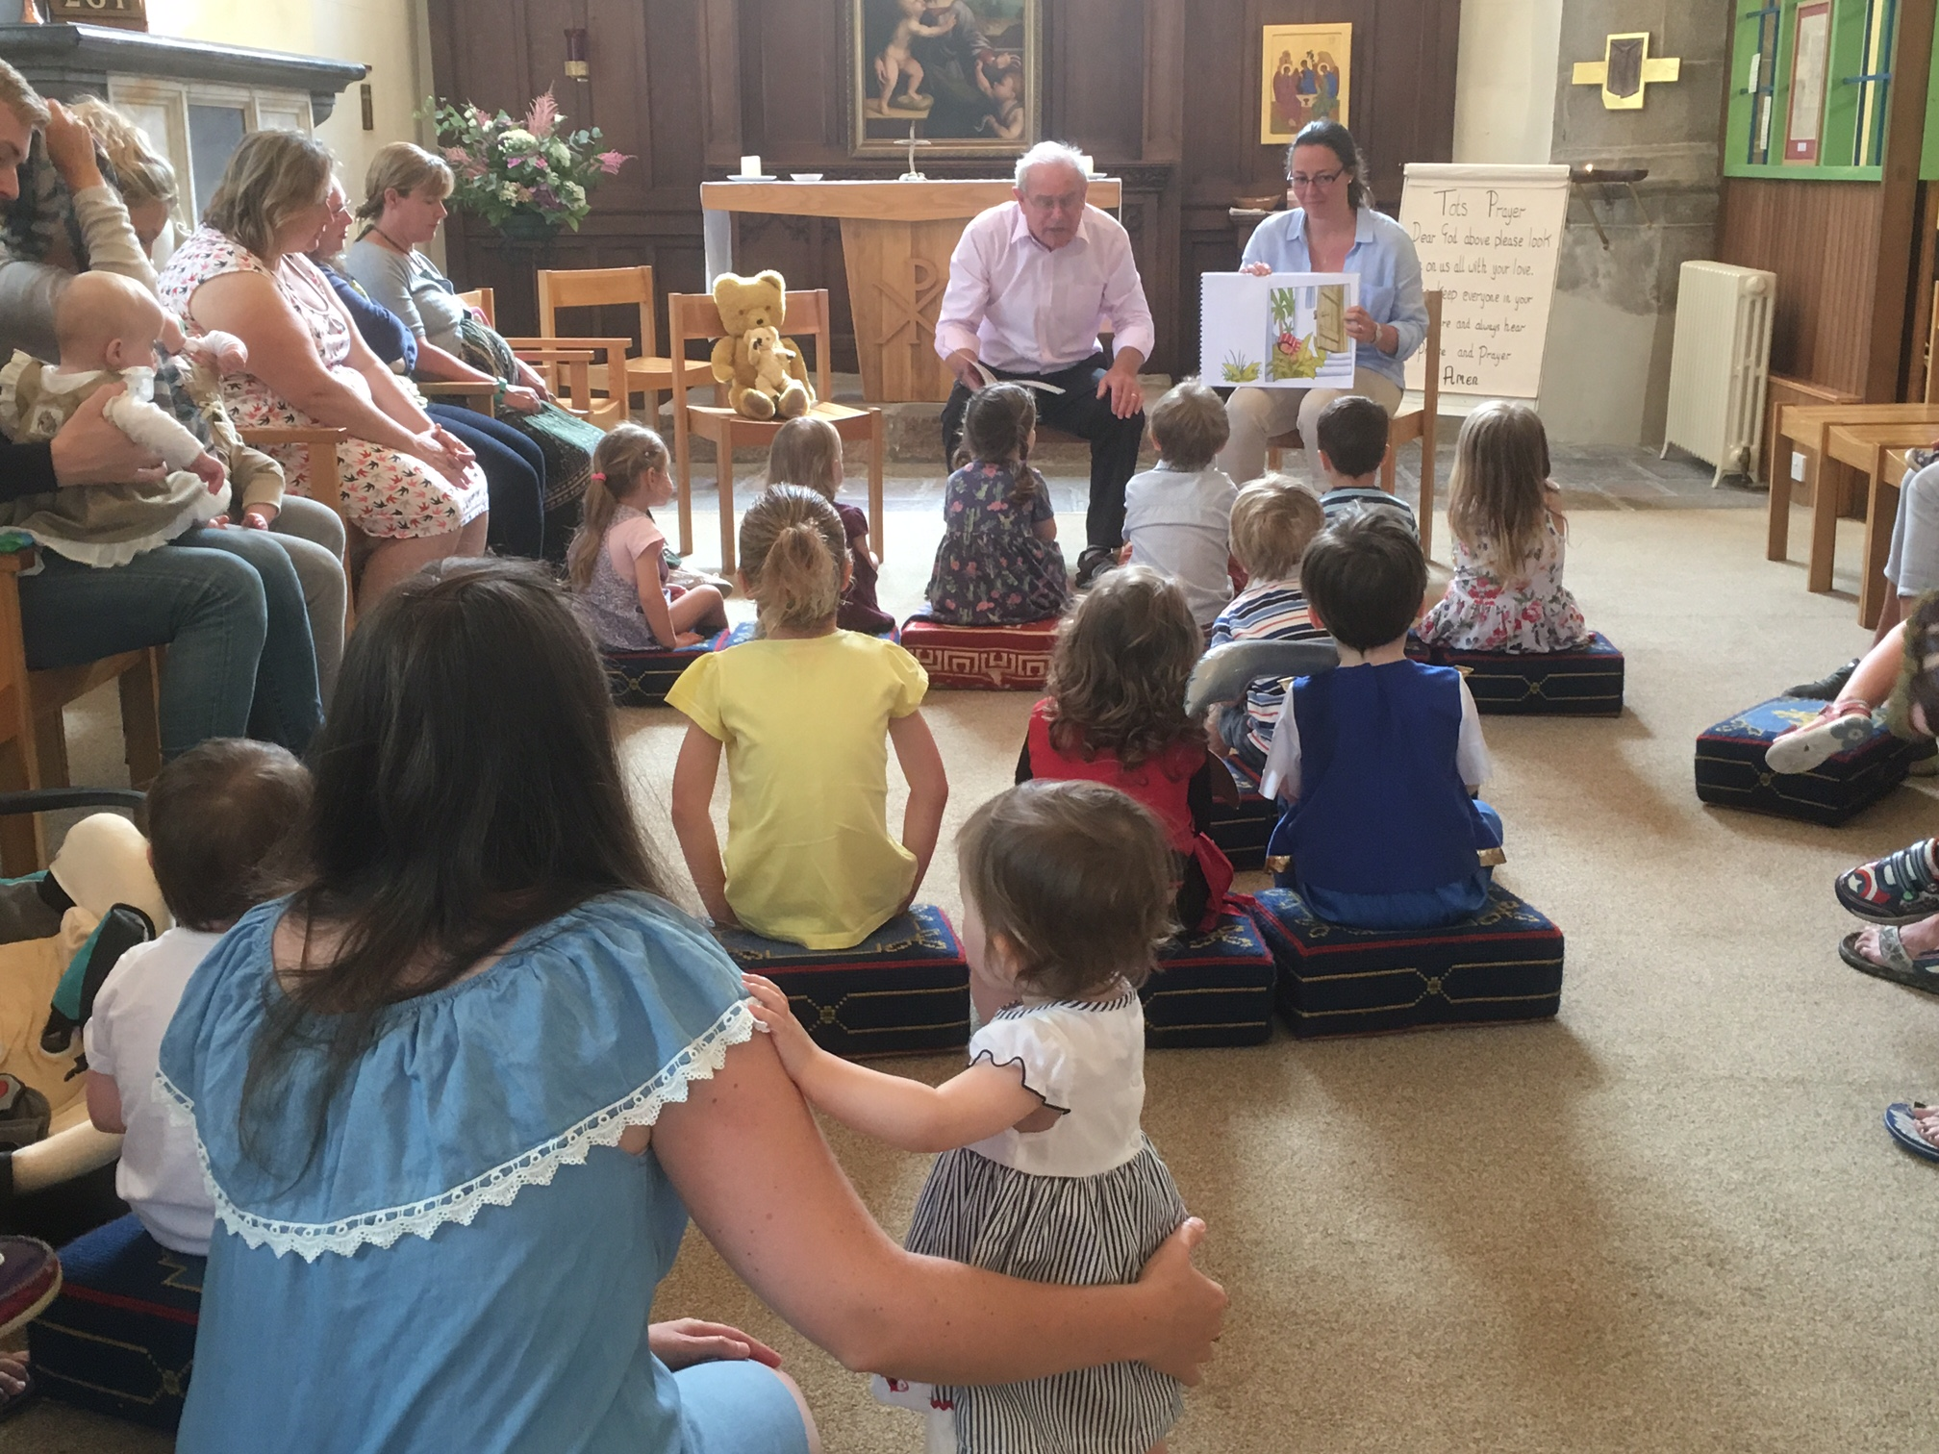
We have seen children’s work continuing to grow here in Trinity. Last summer we saw for the first time in 10 years five full lorries for the Sunday School Outing with some 90 plus young and young at heart enjoying themselves.

Each month we have two 9:30am services for different age groups. The 2nd Sunday of each month is the Juniors where they look at the different stories within the bible or the bible reading for that week followed by craft activities and prayer that links into the theme for that month.

The 3rd Sunday of each month is the Parents and Tots Service. Like the Juniors they also follow the events within the church calendar.
Each baby or child that is baptised at Church now gets a ‘Baptism Bear’ with their name on the scarf. They will then be invited to come back to church with their Baptism Bear for a Teddy Bears’ picnic in the summer.

There are so many different events that I can talk about that have happened over the year, but seeing 30 plus children on Good Friday morning learning about the Cross and then making Easter Gardens from both groups and also from visiting children has been one of the highlights for me this year.

We have some 65+ children and their familyies coming to church over these different groups, which is fantastic. Over the summer months and next year there are some truly wonderful events and activities planned so watch this space.

Different events that the different groups have taken part include:
Eisteddfod Bible Reading for older junior church members, in which they all got Bronze .
Eisteddfod Textiles – Junior church getting Gold.
Remembrance Sunday – Junior church looking at family members who have served their country. They made wreaths and joined in the main service.
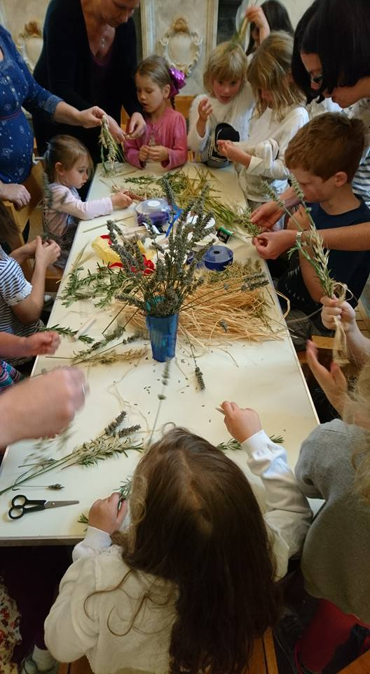
Mothering Sunday – both groups had members showing the wider church their song.

Events already planned for the summer term and over the summer holidays:
Beach Clean – Sunday 15th April, Teddy Bears’ Picnic for the little ones, Quiz/ Scavenger hut around the church for the Juniors, Church Lorry ride – 7th July, Beach picnic with a twist!, just to name a few things already planned.

I personally would just like to say ‘thank you’ to everyone for your support in all the different ways you help out and embrace the children and make their parents and families feel so welcome here at Trinity.

