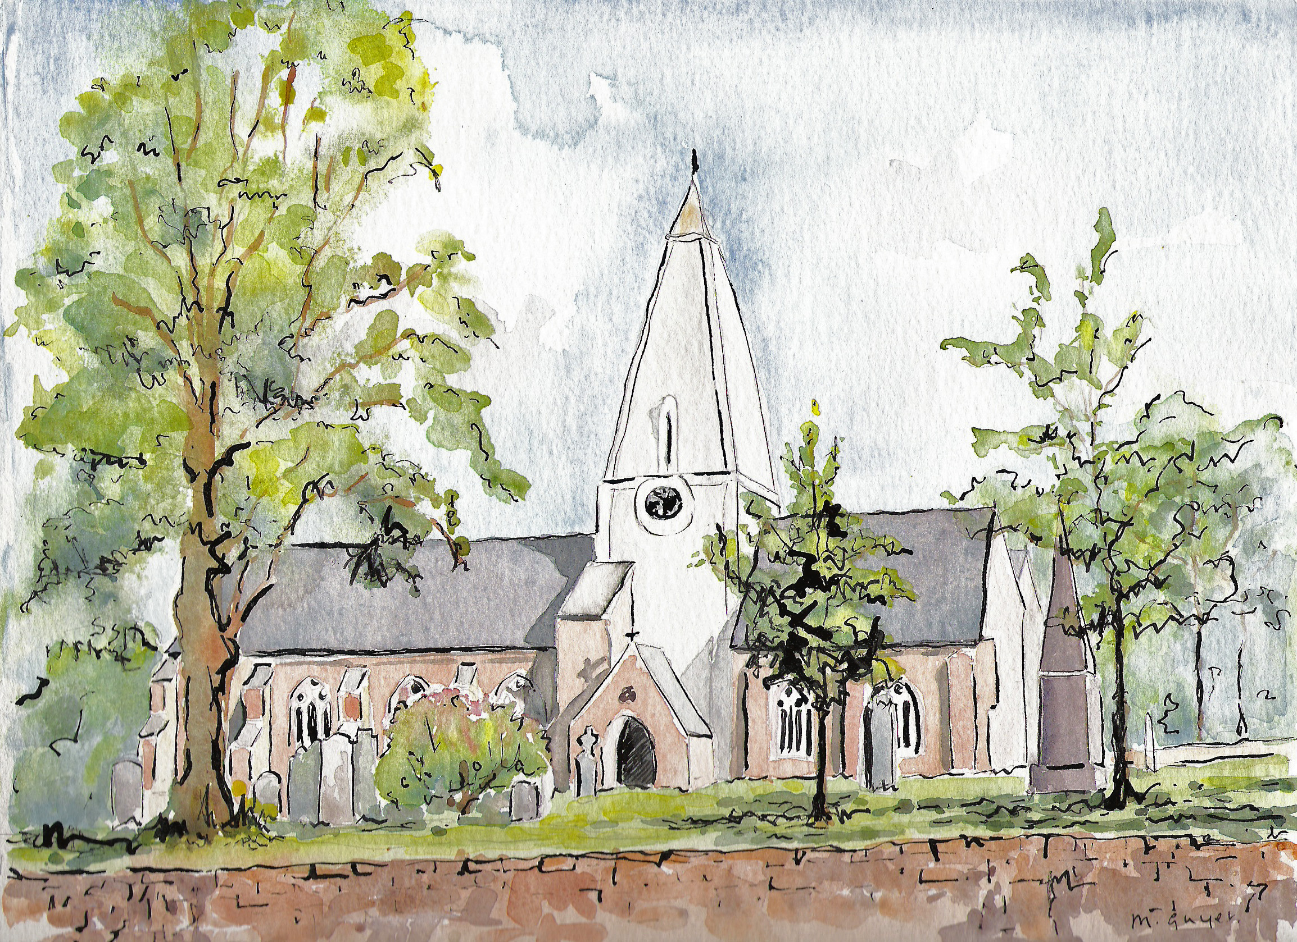
Matins
Holy Trinity Church, Jersey

21st August 2022
10th Sunday after Trinity

Processional Hymn
Trace, O Christ, salvation’s pattern,
God and sinner reconciled,
In an all-embracing story:
New creation, new-born child.
Word incarnate, world’s Redeemer,
Here in us your work repeat,
Signed and sealed your own for ever,
Till the pattern stands complete.

Christ our universal Saviour,
Nature’s poet, nature’s priest,
Through life’s troubled waters bring us
To the eucharistic feast,
Where rejoicing saint and sinner
Praise the Lord of time and space,
Father, Son and Holy Spirit,
Fount of being, source of grace.

Peter Baelz (1923-2000) (SP123)

Source and fount of all creation,
Pour your Spirit from above
On the bearers of your image,
Offspring of a human love.
Human hopes and human graces
Break beneath the weight of sin;
Fear and envy wrench asunder
World without and self within.

Human love is unavailing
Counter-weight to sin and strife;
Love of God alone can hold us
On the way that leads to life.
Praised be God, whose Son our Saviour
Human nature has restored,
Living, dying, raised in glory,
To the likeness of its Lord.

Welcome and notices

Words of introduction and invitation
Beloved, we are come together in the presence of almighty God and of the whole company of heaven to offer unto him through our Lord Jesus Christ our worship and praise and thanksgiving; to make confession of our sins; to pray, as well for others as for ourselves, that we may know more truly the greatness of God’s love and shew forth in our lives the fruits of his grace; and to ask on behalf of all men such things as their well-being doth require.
Wherefore let us sit or kneel in silence, and remember God’s presence with us now.…
Let us humbly confess our sins to Almighty God.
Almighty and most merciful Father; we have erred, and strayed from thy ways like lost sheep. We have followed too much the devices and desires of our own hearts. We have offended against thy holy laws. We have left undone those things which we ought to have done; and we have done those things which we ought not to have done; and there is no health in us. But thou, O Lord, have mercy upon us, miserable offenders. Spare thou them, O God, which confess their faults. Restore thou them that are penitent; according to thy promises declared unto mankind in Christ Jesu our Lord. And grant, O most merciful Father, for his sake; That we may hereafter live a godly, righteous, and sober life, to the glory of thy holy Name. Amen.

Grant, we beseech thee, merciful Lord, to thy faithful people pardon and peace, that they may be cleansed from all their sins, and serve thee with a quiet mind; through Jesus Christ our Lord. Amen.

Our Father; who art in heaven, hallowed be thy name; thy kingdom come; thy will be done; on earth as it is in heaven. Give us this day our daily bread. And forgive us our trespasses, as we forgive those who trespass against us. And lead us not into temptation; but deliver us from evil. For thine is the kingdom, the power and the glory, for ever and ever. Amen.

O Lord, open thou our lips.
And our mouth shall show forth thy praise.
O God, make speed to save us.
O Lord, make haste to help us. (stand)
Glory be to the Father, and to the Son; and to the Holy Ghost;
As it was in the beginning, is now, and ever shall be; world without end. Amen.
Praise ye the Lord;
The Lord’s name be praised.

The Venite
O come, let us’ sing unto the’ Lord: let us heartily rejoice in the’ strength of’ our sal’vation.
Let us come before his’ presence with’ thanksgiving: and shew ourselves’ glad in’ him with’ psalms.
For the Lord is a’ great’ God: and a great’ King above’ all’ gods.
In his hand are all the’ corners of the’ earth: and the strength of the’ hills is’ his’ also.
The sea is his, and’ he’ made it: and his hands pre’pared the’ dry’ land.
O come, let us worship, and’ fall’ down: and kneel be’fore the’ Lord our’ Maker.
For he is the’ Lord our’ God: and we are the people of his pasture, and the’ sheep of’ his’ hand.
Glory be to the Father, and’ to the’ Son: and’ to the’ Holy’ Ghost;
As it was in the beginning, is now and’ ever’ shall be: world without ‘end’. A’men.

Psalm 71, verses 1-6

- In thee O Lord have I put my trust, let me never be put to confusion : but rid me and deliver me in thy righteousness, incline thine ear unto me and save me.
- Be thou my strong hold whereunto I may always resort : thou hast promised to help me, for thou art my house of defence and my castle.
- Deliver me O my God out of the hand of the ungodly : out of the hand of the unrighteous and cruel man.
- For thou O Lord God art the thing that I long for : thou art my hope even from my youth.
- Through thee have I been holden up ever since I was born : thou art he that took me out of my mother’s womb, my praise shall be always of thee.
- I am become as it were a monster unto many : but my sure trust is in thee.

Glory be to the Father, and ‘to the ’Son: and’ to the’ Holy’ Ghost; As it was in the beginning, is now and ’ever’ shall be: world without ‘end’. A’men.

The First Lesson
The first lesson is taken from Hebrews chapter 12, verses 18-end

You have not come to something that can be touched, a blazing fire, and darkness, and gloom, and a tempest, and the sound of a trumpet, and a voice whose words made the hearers beg that not another word be spoken to them. (For they could not endure the order that was given, ‘If even an animal touches the mountain, it shall be stoned to death.’ Indeed, so terrifying was the sight that Moses said, ‘I tremble with fear.’)But you have come to Mount Zion and to the city of the living God, the heavenly Jerusalem, and to innumerable angels in festal gathering, and to the assembly of the firstborn who are enrolled in heaven, and to God the judge of all, and to the spirits of the righteous made perfect, and to Jesus, the mediator of a new covenant, and to the sprinkled blood that speaks a better word than the blood of Abel.
See that you do not refuse the one who is speaking; for if they did not escape when they refused the one who warned them on earth, how much less will we escape if we reject the one who warns from heaven! At that time his voice shook the earth; but now he has promised, ‘Yet once more I will shake not only the earth but also the heaven.’ This phrase ‘Yet once more’ indicates the removal of what is shaken—that is, created things—so that what cannot be shaken may remain. Therefore, since we are receiving a kingdom that cannot be shaken, let us give thanks, by which we offer to God an acceptable worship with reverence and awe; for indeed our God is a consuming fire.
….
Here ends the First Lesson.

Benedicite 1-18
O all ye Works of the Lord’ bless ye the’ Lord:
O ye Angels of the Lord’ bless ye the’ Lord:
O ye Heavens’ bless ye the’ Lord: praise him and’ magnify’ him for’ ever.
O ye Waters that be above the Firmament’ bless ye the’ Lord:
O all ye Powers of the Lord’ bless ye the’ Lord:
O ye Sun and Moon’ bless ye the’ Lord: praise him and’ magnify’ him for’ ever.
O ye Stars of Heaven’ bless ye the’ Lord:
O ye Showers and Dew’ bless ye the’ Lord:
O ye Winds of God’ bless ye the’ Lord: praise him and’ magnify’ him for’ ever.
O ye Fire and Heat’ bless ye the’ Lord:
O ye Winter and Summer’ bless ye the’ Lord:
O ye Dews and Frosts’ bless ye the’ Lord: praise him and’ magnify’ him for’ ever.
O ye Frost and Cold’ bless ye the’ Lord:
O ye Ice and Snow’ bless ye the’ Lord:
O ye Nights and Days’ bless ye the’ Lord: praise him and’ magnify’ him for’ ever.
O ye Light and Darkness’ bless ye the’ Lord:
O ye Lightnings and Clouds’ bless ye the’ Lord:
O let the Earth’ bless the’ Lord: yea let it praise him and’ magnify’ him for’ ever.
Glory be to the Father, and’ to the’ Son: and’ to the’ Holy’ Ghost
As it was in the beginning, is now and’ ever’ shall be: world without ‘end’. A’men.

The Second Lesson
The second lesson is taken from Luke, chapter 13 verses 10-17
Now he was teaching in one of the synagogues on the sabbath. And just then there appeared a woman with a spirit that had crippled her for eighteen years. She was bent over and was quite unable to stand up straight. When Jesus saw her, he called her over and said, ‘Woman, you are set free from your ailment.’ When he laid his hands on her, immediately she stood up straight and began praising God. But the leader of the synagogue, indignant because Jesus had cured on the sabbath, kept saying to the crowd, ‘There are six days on which work ought to be done; come on those days and be cured, and not on the sabbath day.’ But the Lord answered him and said, ‘You hypocrites! Does not each of you on the sabbath untie his ox or his donkey from the manger, and lead it away to give it water? And ought not this woman, a daughter of Abraham whom Satan bound for eighteen long years, be set free from this bondage on the sabbath day?’ When he said this, all his opponents were put to shame; and the entire crowd was rejoicing at all the wonderful things that he was doing.
…
Here ends the Second Lesson.

Benedictus
Blessed be the Lord’ God of’ Israel: for he hath’ visited and re’ deemed his’ people;
And hath raised up a mighty sal’ vation’ for us: in the’ house of his’ servant’ David;
As he spake by the mouth of his’ holy’ Prophets: which have been’ since the’ world be’ gan;
That we should be saved’ from our’ enemies: and from the’ hands of’ all that’ hate us;
To perform the mercy promised’ to our’ forefathers: and to re’ member his’ holy’ Covenant;
To per’form the’ oath: which he’ sware to our’ fore father’ Abraham;
That he would give us, that we being delivered out of the’ hand of our’ enemies: might’ serve him with’ out’ fear;
In holiness and’ righteousness be’ fore him: all the’ days of’ our’ life. And thou Child shalt be called the’ Prophet of the’ Highest: for thou shalt go before the face of the Lord’ to pre’ pare his’ ways;
To give knowledge of salvation’ unto his’ people: for the re’ mission’ of their’ sins,
Through the tender mercy of’ our’ God: whereby the day-spring’ from on’ high hath’ visited us;
To give light to them that sit in darkness, and in the’ shadow of’ death: and to guide our feet’ into the’ way of’ peace.
Glory be to the Father, and’ to the’ Son: and’ to the’ Holy’ Ghost;
As it was in the beginning, is now and’ ever’ shall be: world without’ end’. A’men.
The Apostles' Creed
I believe in God the Father almighty, maker of heaven and earth; and in Jesus Christ, his only Son our Lord, who was conceived by the Holy Ghost, born of the virgin Mary, suffered under Pontius Pilate, was crucified, dead and buried. He descended into hell. The third day he rose again from the dead; he ascended into heaven, and sitteth on the right hand of God the Father almighty. From thence he shall come to judge the quick and the dead. I believe in the Holy Ghost, the holy catholic Church, the communion of saints, the forgiveness of sins, the resurrection of the body, and the life everlasting. Amen.
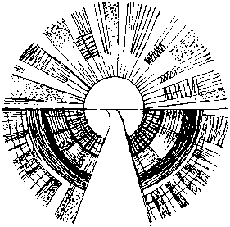
The Lord be with you, and with thy spirit.
Let us pray.

Lord have mercy upon us Christ, have mercy upon us.
Lord, have mercy upon us.

Our Father, which art in heaven, Hallowed be thy Name, Thy Kingdom come, Thy will be done, in earth as it is in heaven. Give us this day our daily bread; And forgive us our trespasses, As we forgive them that trespass against us; And lead us not into temptation, But deliver us from evil. Amen.
O Lord, shew thy mercy upon us.
And grant us thy salvation.
O Lord, save the Queen.
And mercifully hear us when we call upon thee.
Endue thy Ministers with righteousness.
And make thy chosen people joyful.
O Lord, save thy people.
And bless thine inheritance.
Give peace in our time, O Lord.
Because there is none other that fighteth for us but only thou, O God.
O God, make clean our hearts within us.
And take not thy Holy Spirit from us.

The Collect for the day
Let your merciful ears, O Lord, be open to the prayers of your humble servants; and that they may obtain their petitions make them to ask such things as shall please you; through Jesus Christ our Lord. Amen.
The Second Collect, for Peace
O God, who art the author of peace and lover of concord, in knowledge of whom standeth our eternal life, whose service is perfect freedom: defend us thy humble servants in all assaults of our enemies; that we, surely trusting in thy defence, may not fear the power of any adversaries, through the might of Jesus Christ our Lord. Amen.
The Third Collect, for Grace
O Lord our heavenly Father, almighty and everlasting God, who hast safely brought us to the beginning of this day: defend us in the same with thy mighty power; and grant that this day we fall into no sin neither run into any kind of danger, but that all our doings may be ordered by thy governance, to do always what is righteous in thy sight; through Jesus Christ our Lord. Amen.

Hymn
I want you more than gold or silver,
Only you can satisfy.
You alone are the real joy-giver
And the apple of my eye.

You’re my Friend and you’re my Brother.
Even though you are a king.
I love you more than any other,
So much more than anything.

Martin Nystrom,(B. 1956)
based on Psalm 42:1-2 (SP259)

As the deer pants for the water
So my soul longs after you.
You alone are my heart’s desire
And I long to worship you.

You alone are my strength, my shield,
To you alone may my spirit yield.
You alone are my heart’s desire
And I long to worship you.

Address
Helen Hamilton

Hymn
Let the people praise thee, Lord
Be by all that live adored
Let the nations shout and sing
Glory to their saviour King
At thy feet their tributes pay
And thy holy will obey

God of mercy, God of grace,
Show the brightness of thy face
Shine upon us, Saviour, shine
Fill thy Church with light divine
And thy saving health extend
Unto earth’s remotest end.

Let the people praise thee, Lord
Earth shall then her fruits afford
God to man his blessing give
Man to God devoted live
All below, and all above
One in joy, and light, and love.
H. F. Lyte (1793-1847) (NEH366)

Prayers of intercession

Lord, in your mercy, hear our prayer.

... Merciful Father, accept these prayers for the sake of thy Son,
our Saviour Jesus Christ. Amen.

Hymn
I am the Vine whose branches grow
united in one root;
who dwell in me, and I in them,
shall live and bear much fruit.

I am the Resurrection life,
the power of God whereby
whoever truly trusts in me
shall live and never die.

I am the Light whose brightness shines
on every pilgrim’s way,
and brings to evil’s darkest place
the glorious light of day.

I am the Well from whose fresh springs
life-giving water flows
and on each side the tree of life
with leaves for healing grows.

I am the Way, the Truth, the Life,
and truth shall set you free
to seek and find the way of life
and live that life in me.

Robert Willis (b. 194) ( SP281)

The Blessing
May God give to you and to all those you love his comfort and his peace, his light and his joy, in this world and the next. And the blessing of God almighty, the Father, the Son and the Holy Spirit, be among you and remain with you, now and always. Amen.

Free refreshments are served in the Lady Chapel.
Please do join us!

To make an offertory donation to church,
please scan the QR.
Thank you.

